Person Centered Planning
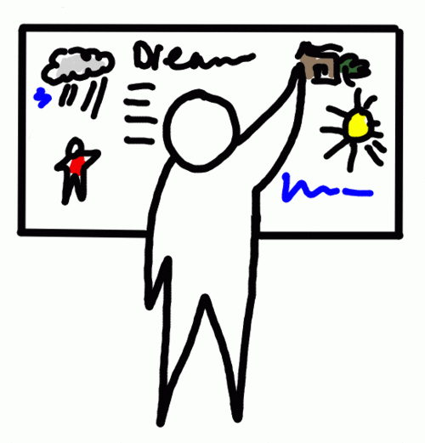
- Future planning regarding school, moving out of home, planning for necessary supports and living arrangements.
- Skill development, specifically related to the wishes of the individual and the family.
- Plans are reviewed on an as needed basis.
- This is an Outcome based model of planning

