Lunch & Learn
Script for: Credit Issues – Fact vs. Fiction
Approximate Length: 30-45 Minutes with Questions

Note to Presenter: Feel free to adjust the presentation by adding or subtracting information that applies to your skill set and company offerings, or even changing the Title! Our Lunch & Learn programs are “Ready to Present” or “Customizable”.

References: We offer several charts to assist you with this presentation. Charts and Guidelines should NOT be shared with your audience. These resources are meant for your reference only to guide you in answering questions. Charts, Checklists and Guidelines are updated frequently and contain details that a novice may find confusing. If you pass these out, you run the risk of having old information with your referral sources, and that can turn into a contract based on outdated information. Not good!

You can find these under “Charts & Checklists”, category “Universal”.
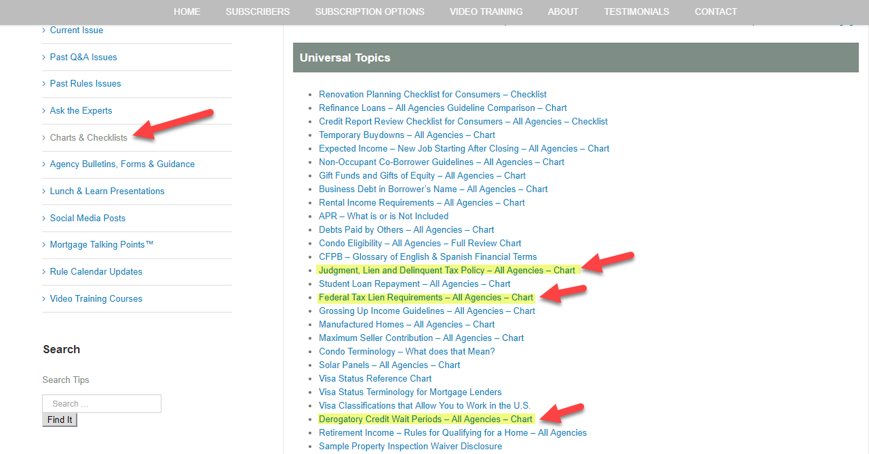

Further Reference:
We suggest that you type into our search bar ”bankruptcy”, “collections”, “judgments”, “liens”, “late payments”, and read through the recent questions and articles on these subjects. This helps to fill in your knowledge gaps and prepares you for the questions you may be asked.

Handouts – To accompany this course, we have under “Mortgage Talking Points™” category “Applies to Credit” the following:

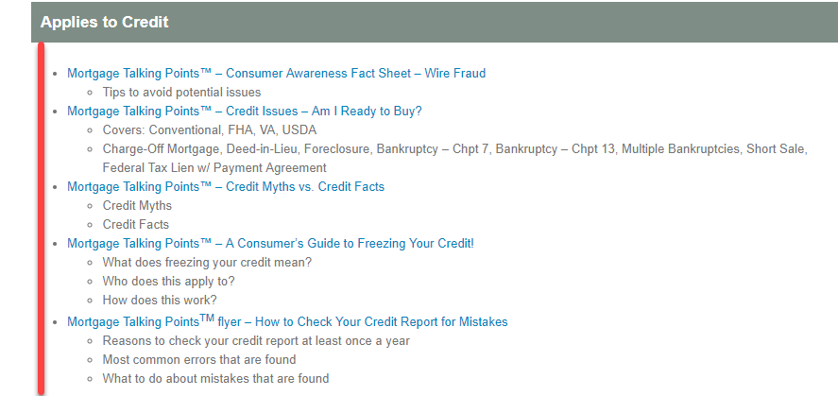

Feel free to hand these out to your referral sources or consumers as you believe to be appropriate.

Script Tip: Scripts are meant to be used as a guide for talking points and not to be read to your audience. Make sure that you understand the talking points and put this script into your own words. Be sure to add your Information, logos, NMLS # and Other Company Required Disclaimers to your presentation. Also, check your company overlays. We base our Lunch & Learn programs on agency requirements, and some lenders overlay requirements that may be different from the information in our presentation.

Embellish and make this presentation your own. Your audience will love hearing your “real life” stories and how you solved those problems using the information you are presenting. Those stories in addition to the presentation will help position you as the “go to” mortgage person in your community.

Add a Slide: We recommend that you add a slide near the end that talks about how you help your client’s achieve credit success. There are many different approaches and systems used by lenders, so be sure to use this opportunity to communicate how you help clients who are credit challenged become homeowners! To add a slide just click “duplicate” a slide that is similar to the one you want to create, then add your own content.

Slide One:
Hello everyone, my name is [your name] with [your company] and I thank you for attending today’s session on Credit Issues - Fact vs. Fiction. Today I’d like to clear up some of the confusion on credit issues that borrowers may face. Whether clients are ready to buy today or just need some coaching in this area, chances are good that if your client is willing to work through the issue, we can help them get back on track.

Slide Two:
I think that one of the most important messages I can deliver today is that a credit score is nothing to be ashamed of. Life happens and we deal with it. This is why good counsel regarding credit issues is important upfront. What we don’t want is a client paying too much in mortgage interest over a credit issue that can be worked through – because, as we know, credit will directly affect a client’s rate or even their ability to qualify. It’s not just about “can they get a loan?” It’s more about, “can we give them strategies or tools to get them the best loan and rate for their situation?”

Slide Three:
When lenders assess the rate, they are looking at the perceived risk. That is why interest rate is a reflection of risk. This is not based on guesses. The agencies and investors purchasing mortgage loans statistically study loan performance, which leads to what is considered the level of risk on a particular client.

Generally, the lower the credit score, the higher the rate. Conversely, the higher the credit score, the lower the interest rate. Our goal is to help our client go into the loan process with the best score possible, as this will yield them a lower rate. It’s amazing how one little tweak may result in a few points to their credit score that vastly improves the client’s rate. And when we are talking about a rate that may be with the client for many years, we want to get them the best rate possible for their situation!

We also know that conventional loan programs tend to be stricter on credit issues, whereas those loans with government guaranties tend to offer more leniency. That does not mean that someone with a credit issue should go with a government-sponsored program. Sometimes the conventional programs are better. It depends on all of the criteria of the loan.

It’s also important to note that there are people who can lend no matter what the credit issue. Hard money lending is high-cost and should be avoided on long-term debt.

Slide Four:
Most clients wonder what affects their credit score because some of the evidence they see makes no sense. Credit score algorithms are closely guarded by the credit bureaus, so even the best mathematicians would not be able to figure it out. However, we do know some of the main factors affecting a score.

Although all of these are important, next to each category, I’ve given you an indicator of the impact on the score.

For instance, we know that Bankruptcy and Foreclosure are big credit issues and therefore have a high impact.
How much credit is utilizated is factored in as well. Credit Utilization is the % of credit outstanding/owed vs. the amount of credit available. [Note to Presenter: This might be a good time to use a whiteboard or paper chart to show the example. It adds more interest to your audience]. An example of this is a client with $50,000 of available lines of credit, like credit cards. The client has outstanding balances of $5000. This means they are using 10% of their available credit. The “sweet spot” for credit scoring is somewhere between 20%-30% utilization so in this case the adverse effect on the client is low.

However, if that same client had outstanding balances of $25,000 then their utilization would be 50% and that would likely have a larger impact on their score. This is why closing an account that you don’t use can elevate your utilization rate!

Other items with a good amount of impact are the payment history on the credit, closing accounts which we just mentioned and opening new accounts.

Finally, the credit mix and age of credit play an important role as well. As you can see there is no “checklist” per se’ for any of us to follow, but we do have some clues and other tools to assist the client. [Note to Presenter: If you use tools like rapid rescore, this is a good time to quickly mention how those help your clients improve their score and thereby improve their rate]

Slide Five:
One of the questions I get asked a lot is “Why isn’t my online score, like Credit Karma the same as yours?” This question is similar to the question of why the Zillow estimate isn’t the same as the appraisal. Online tools like Credit Karma are using a scoring method known as Vantage and lenders use FICO. These are different companies with different algorithms assessing credit. This means that they rate credit differently, and that is why they are not the same. As a lender we have to use the credit scoring method required by our agencies and investors and FICO is the industry standard.

Slide Six:
What is a lender looking for? Basically, they want to see that the financial profile of the client demonstrates a good probability that the borrower can repay the debt.

If there was an issue, was it due to a life event such as divorce, health issues, loss of job or just basic financial mismanagement? Lenders are human too, so they know that bad stuff can happen to anyone. In fact, many of them have been through bad times as well, so they get it. On the other hand, financial mismanagement might be another story. Was the person young and didn’t understand how silly decisions could affect their credit profile, so they fixed it and are now on track? Or, do they have a consistent history of not paying attention to their bills and when they need to be paid?

This is why lenders will look at how long it has been since the issue or issues occurred. The longer the better for both their credit score and the lender. They also evaluate whether or not the client was able to re-establish their credit and get back on track.

This journey of evaluating the credit history of the client determines risk, which ultimately is a determiner of the rate for the borrower.

Slide Seven:
Next, let’s take a look at the credit issues we typically run into. As you can imagine, we run into just about every type of credit issue in lending. I’m going to talk about each of these in a bit more detail, but here are the highlights.

Real estate related credit issues such as foreclosure, loan modification, short sales and deed in lieu are many of the credit and legal issues we all became familiar with after the real estate meltdown. Bankruptcy, Judgments, liens, and collections or charge-offs may happen due to life events, or financial mismanagement. The circumstances behind these will define how the lender will view them. Of course, the underwriters will consider late payments and even consistent overdrafts in checking accounts. And then finally, I will review how federal obligations vs. civil obligations affect the loan as well.

I’m going to discuss the biggest issues first and then work down through the smaller ones.

Slide Eight:
The toughest credit issues to deal with are those where real estate is involved because this is the type of loan a client is applying for. The circumstances behind the issue, along with the amount of time between the event and the application, all come into play with these types of credit issues.

To review, I’m going to quickly go through how the lender defines each one.

In a foreclosure the lender takes back the house. So now the lender owns the home and the lender is responsible for it. Chances are good the client has not been making payments for a while, which means that they lost that income stream along with having to pay for taxes and insurance that may be in arrears. It becomes a lender’s REO or Real Estate Owned and must go on the market. This involves fixing up the house for sale, keeping it maintained, and hiring someone to sell it. Believe it or not, lenders lose money on a foreclosure if there is not at least 30% equity, which many homes do not have.

Modifications are people who are trying to get back on track and have worked out an arrangement with the servicing company to pay back the lender on modified terms of the loan. This can mean many things such as a reduction in the payment, rate or even principal. If the client had a modification, the lender looks at why and whether they paid back the modification as agreed upon.

Now I’m sure most of you are familiar with the short-sale as many of you have had to deal with this issue if you listed or sold property during the recession. Home prices dropped substantially, but amounts owed did not, which left a lot of people in a catch-22 situation. They needed or wanted to move but couldn’t because they owed more than the house was worth. For many, this meant a short sale. In this case the lender will accept a reduced sales price and write off the difference, or even file a deficiency judgment against the borrower for the deficit between what was owed and what the home sold for. Fortunately, many lenders charged off the difference, but the borrower still faced tax consequences on a charged off amount, so this was not always a clean break.

A deed in lieu is when the lender takes back the home but does not foreclose on it. Essentially the owner signs the house back over to the lender.

If any of your clients have faced these issues, it is not terminal. Depending on the circumstances, the wait time can be as little as 2 years, depending on the loan program. While this may mean a temporary wait to purchase, time goes by a lot faster than people think.

Slide Nine:
Bankruptcy may include real estate but is most associated with having too much debt. Again, this could be caused by a life event or financial mismanagement or a little of both. The bottom line with bankruptcies is that the lender is reviewing the time frame from dismissal or discharge, and whether the borrower has re-established their credit along with why it happened.

There are two personal types of bankruptcy. One is a Chapter 13, which is a repayment plan for the client so that the debt they have can be paid back, but in a more manageable way given their financial ability. The negotiation is court ordered for both the client and lender.

Chapter 7 is a “start over” bankruptcy. It means all debts included in Chapter 7 do not have to be paid back and the client has a clean slate to start from. This generally occurs when the client establishes with the courts that they do not have the ability to pay back the debts owed.
Once a bankruptcy is dismissed or discharged, the client’s wait time for a mortgage is generally 1-2 years for a Chapter 13 or 2-4 years for a Chapter 7. This is dependent on program type and the reason for the bankruptcy.
Now where things really start to fall apart are multiple bankruptcies. Most lenders know that something can happen to blow up your life at least once. Yet when it happens more than once, they tend to investigate it a little further and understandably may be more concerned. So, the wait time may be as little as none or up to 7 years.

Slide Ten:
A Judgment is when a court has ruled in favor of the lender or person requesting the judgment and the borrower must repay the debt. This can be lump-sum arrangements or more generally monthly payments until the debt is satisfied.

A Lien is a debt filed against a person or property which gives the person filing the lien the right to a possession of the property until the debt is satisfied. For instance, you are likely familiar with mechanic’s liens which is a security interest in the title to a property for the benefit of those who have supplied labor or materials that improve the property.

Programs differ regarding whether or not judgments or liens must be paid prior to closing. Some require it like conventional programs, and others will allow them with a payment agreement and evidence of payments being made.

The biggest issue that a borrower may face is that if a lender will allow the judgment or lien, they will most likely require that creditor to subordinate or go below the priority of the mortgage lien. Some lien or judgment holders will subordinate to the mortgage loan, and some will not.

The lender will also look at the type of lien.

For instance, a Federal or Government lien will always be in a higher position than a mortgage lien, so lenders do not like this for clear reasons. If the property was foreclosed upon, the person in first lien position gets paid first. This means that federal or government tax liens get first priority since they will rarely subordinate to the lender. An example of this is unpaid property taxes or unpaid income tax where a lien has been filed.

There is one interesting note that the investors have offered some flexibility on for those who owe income taxes, and these are federal tax agreements that have not been filed as a lien. If a person owes income tax and they are not able to pay the full amount at the time it is due, but they also do not want to have a lien filed against them, they are able to formulate a repayment plan. If this is in place, then the lender will allow it with varying guidelines depending on the program.

Slide Eleven:
Other types of derogatory credit are collections, charge-offs, or disputes. These types of credit issues can cover many things such as car loans, medical bills or credit cards, just to name a few.

Lender requirements vary as to whether or not something needs to be paid prior to closing, based on the type of collection, and amount of the collection. [Presenter, if you have examples of this from your own business use them here.]

A Charge-off is when a lender had deemed the debt non-collectible, so the lender writes it off. A charge-off is technically a closed debt, but the Lender will want a letter of explanation to determine the circumstances for the charge off.

Slide Twelve:
Because mortgage lenders request bank statements, they are going to see the payment patterns of a person’s checking account. So even though there may not be any reported credit issues, an underwriter could look at the amount of overdrafts in a checking account. This may demonstrate financial behaviors that are problematic, or even add to the borrower’s debt if they are paying back an overdraft account.

Another concern is the amount of late payments on any account. Of course, the credit report shows a person’s payment history on reported debt, but many times that is not reported correctly. This is why it is so important to have a client talk with me first so that we can clear up any mistakes or issues before the home shopping process begins. It is also a good chance to help our clients build a plan to improve their credit prior to buying a home.

Slide Thirteen:
The last topic I want to cover today is extenuating circumstances, because this is a question I get asked a lot. Doesn’t it seem like that in life – no one is exempt from sudden or significant events that just hit you out of nowhere?

As a lender, I have seen some situations that would break your heart and others that make you just shake your head. The people that approve our mortgage loans have also seen it or perhaps even experienced it in their lives too.

The first thing I tell clients is that if you have a credit issue, let’s not be ashamed. We have all made bad decisions or faced tough challenges, and this too can pass.

When a lender is looking at credit, they want to make sure that there was a reason other than “I didn’t feel like paying my bills, or decided to go on vacation vs. paying my bills”. So extenuating circumstances are those times that we call a “life event” such as medical issue, death in the family or loss of a job.

It’s important for everyone to understand that these things can happen to any one of us and that working with me puts them in the “no judgment” zone. We brush ourselves off, explain what happened, and show a lender how that was a blip on our radar screen. All is good now, all was good prior to the event, and all will be fine after they give you the loan.

The bottom line on all credit issues is that they can be complex, and meeting with the lender first is in everyone’s best interest. You can count on me to be the person who takes the time to walk your client through their situation without fear, shame or judgment.

Slide Fourteen:

I want to thank all of you for attending today’s session and I hope that I provided some good take-aways for you today. Please feel free to ask me any questions now, or just pull me aside and we can talk privately.

[Note to presenter: After you answer questions, immediately set a date with the person in charge for the next lunch and learn. This is your time to take advantage of the good feelings in the room. Your goal is to do at least one per month, so at the end of each session, set the next one!]

