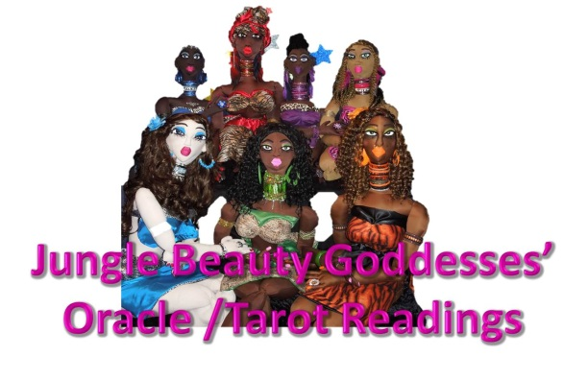
https://www.youtube.com/user/AuthentikBeautyBlogs
https://www.authentikbeautymagazine.com/
https://twitter.com/georgesturges

When you choose to participate in any reading, your subconscious is guiding you to help you bring forth unconscious beliefs, ideas, feelings, and thoughts that are sometimes below the surface of your conscious awareness.
You are using your intuition to connect the cards to your life experiences to give the cards meaning. The meaning comes from your intuition not the oracle / tarot card reader.
Do not ask questions that are yes or no because you are a multi-dimensional being with infinite possibilities. There are unlimited, controllable, and uncontrollable variables that determine an outcome of any event.
A reading does not predict the future because you shape your future every moment with your behavior, thoughts, feelings, and words. I want you to use your readings as an intuitive tool to assist you to the destiny of your dreams.
I created this worksheet for personal use only. All rights Reserved.
Use no more than 3 oracle / tarot readings per goal.
Dr. Cassandra George Sturges, MA, MA

What is the Name of the Reading ______________________________________________________________________
Oracle / Tarot Reader Name:
______________________________________________________________________
What is the Name of the Reading ______________________________________________________________________
Oracle / Tarot Reader Name:
______________________________________________________________________
What is the Name of the Reading ______________________________________________________________________
Oracle / Tarot Reader Name:
______________________________________________________________________

What is your primary goal at this time? What are you looking to achieve? What do you ultimately want to accomplish?
_______________________________________________________________________________________________________________________________________________________________________________________________________________________________________________________________
List 3 to 5 issues in your life that you are concerned about below. Know that any of these issues may be addressed in your reading.
1.________________________________________________________________________________________________________________________________________________________________________________________________________________
2.________________________________________________________________________________________________________________________________________________________________________________________________________________
3.________________________________________________________________________________________________________________________________________________________________________________________________________________
4.________________________________________________________________________________________________________________________________________________________________________________________________________________
5.________________________________________________________________________________________________________________________________________________________________________________________________________________
What resonated with you in this reading?
__________________________________________________________________________________________________________________________________________________________________________________________________________________________________________________________________________________________________________________________________________________________________________________________________________________________________________________________________________________________________________
What did not resonate with you?
__________________________________________________________________________________________________________________________________________________________________________________________________________________________________________________________________________________________________________________________________________________________________________________________________________________________________________________________________________________________________________

What do you need to do to benefit from this reading? What changes do you need to make? What actions are you going to take in the next 3 days?
__________________________________________________________________________________________________________________________________________________________________________________________________________________________________________________________________________________________________________________________________________________________________________________________________________________________________________________________________________________________________________

Which chakra should you focus on to help you align with your overall goals?
__________________________________________________________________________________________________________________________________________________________________________________________________________________________________________________________________________________________________________________________________________________________________________________________________________________________________________________________________________________________________________

Which area of your home should you make changes to –to help you align with your goals?
__________________________________________________________________________________________________________________________________________________________________________________________________________________________________________________________________________________________________________________________________________________________________________________________________________________________________________________________________________________________________________

What items can possibly aid you in achieving your goal. Write them down below. Give yourself a deadline as to when you will acquire these items. __________________________ A goal without a deadline is a dream.
Gemstones, Crystals, Oils, Candles, Herbs, Meditation, Scripting, incense, Mantras, Affirmations, Books, Teas, Sprays
__________________________________________________________________________________________________________________________________________________________________________________________________________________________________________________________________________________________________________________________________________________________________________________________________________________________________________________________________________________________________________

Four /4 Week Plan
Week 1 I am grateful for_________________________________________________________________
I made these changes to shape my future
__________________________________________________________________________________________________________________________________________________________________________________________________________________________________________________________________________________________________________________________________________________________________________________________________________________________________________________________________________________________________________

Week 2 I am grateful for_________________________________________________________________
I made these changes to shape my future
__________________________________________________________________________________________________________________________________________________________________________________________________________________________________________________________________________________________________________________________________________________________________________________________________________________________________________________________________________________________________________
Week 3 I am grateful for_________________________________________________________________
I made these changes to shape my future
__________________________________________________________________________________________________________________________________________________________________________________________________________________________________________________________________________________________________________________________________________________________________________________________________________________________________________________________________________________________________________

Week 4 I am grateful for_________________________________________________________________
I made these changes to shape my future
__________________________________________________________________________________________________________________________________________________________________________________________________________________________________________________________________________________________________________________________________________________________________________________________________________________________________________________________________________________________________________

30 Day Check in after implementing the changes, these are the results of how I have made productive changes in my life by taking action:
______________________________________________________________________________________________________________________________________________________________________________________________________________________________________________________________________________________________________________________________________________________________________________________________________________________________________________________________________________________________________________________________________________________________________________________________________________________________________________________________________________________________________________________________________________________________________________________________________________________________________________________________________________________________________________________________________________________________________________________________________________________________________________________________________________________________________________________________________________________________________________________________________________________________________________________________________________________________________________________________________________________________________________________________________________________________________________________________________________________________________________________________

