Learning G.R.A.C.E., Inc. - Spring and Summer Update!
Cultural Awareness

In support of our mission in the area of cultural awareness, Learning G.R.A.C.E., Inc. sponsored Nadia
Pierre at Studio 28 a dance studio. She received dance lessons including ballet and tap. Nadia is shown
here picture with Janice Toussaint during the ‘A Father’s Love’ dance recital held at Jefferson High School
in June.

Living In The Real World Summer Enrichment Camp
June 22-24, 2015
Yes we did enrich the lives of youth during our Living In the Real World Summer Enrichment Camp! Topics presented:
- Junior Achievement Economics for Success: the youth went on a Self-Knowledge Treasure Hunt to identify which career fields they might enjoy. The first step in the education and career planning process the youth completed as skills and interest assessments to identify career pathways, related occupations and plans of study. Based on their results they identified the job that most match their interest and did research to determine education requirements and salary ranges. Presenters: Jada & Kayla Kennedy (Bright Future Community Service Hours)
- Reality Check an online financial literacy activity: the youth answered questions based on the type of lifestyle they want to live (housing, type of car, etc.) and based on their responses they were provided the annual income they must earn to live that lifestyle. This exercise also identified the type of jobs that would meet the necessary income requirements. Presenters: Jada & Kayla Kennedy
- The Hour of Code is an introduction to computer science, designed to demystify code and show youth that anybody can learn the basics of coding. President Obama supports the Hour of Code initiative. Introducing youth to computer science will help students to have a foundation for success in any 21st century career path. Presenters: John Kennedy & Rhonda Reeves
- The Rachel Project: Karina Strong the Executive Director spoke to the youth to bring awareness of Human Trafficking – especially the exploitation of young people. They were provided a list of clues to help identify possible trafficking victims and how and when to respond if they think someone is a victim of trafficking.
- PeopleSmart: in support of our mission in the area of Life Skills, we presented a PeopleSmart curriculum How to Mistake Friendliness for Friendship. We want the youth to learn the difference between friendliness and being a friend. There is a difference! Presenter: Nina Thomas
- Surviving High School - A Guidance Counselor Viewpoint: Alicia Owens a High School Guidance Counselor gave the youth the lowdown on what it will take to be successful in high school which included graduation requirements, ways to track their progress to ensure graduation and how to prepare for college.
- Money Habitudes: A financial literacy card game which helped the youth to talk about money, understand financial psychology and explain their money personality type. Presenter: Stephanie Carmichael
- To help them to organize themselves and ensure high school success Rhonda Reeves presented ‘One Note’ digital software to show the youth how to create a digital portfolio to track assignments, research projects, activities etc.
Other activities included: Mavis Beacon a ‘Keyboarding’ activity to bring awareness of the need for keyboarding skills in preparation for test taking and writing online. Hillsborough County Fire Rescue Public Education presented hands only CPR and Fire Safety. The youth prepared PowerPoint presentations to present to the group what they learned during the camp – the presentations were creative and awesome! We ended on a sweet note with an ‘Ice Cream Social’ with make your own ice cream sundaes with ice cream and toppings from Cold Stone Creamery!
Many thanks to our lunch providers: Monday - McDonalds (Caspers Company); Tuesday – Publix and Alessi Bakery; Wednesday Pizza Party – Dr. Wilnetta Sweeting.

Many, many thanks to: Rhonda Reeves, John Kennedy, Jada Kennedy, Kayla Kennedy, Karina Strong, Nina Thomas, Alicia Owens, Hillsborough County Fire Rescue (Myesha Johnson) and the Learning G.R.A.C.E., Inc. board members. It would not have been a success without you!

LIVING IN THE REAL WORLD SUMMER ENRICHMENT CAMP
SPONSORED BY: LEARNING G.R.A.C.E. Inc.
 | 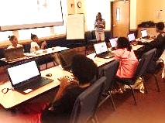 | 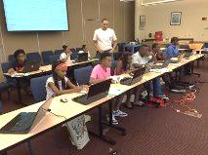
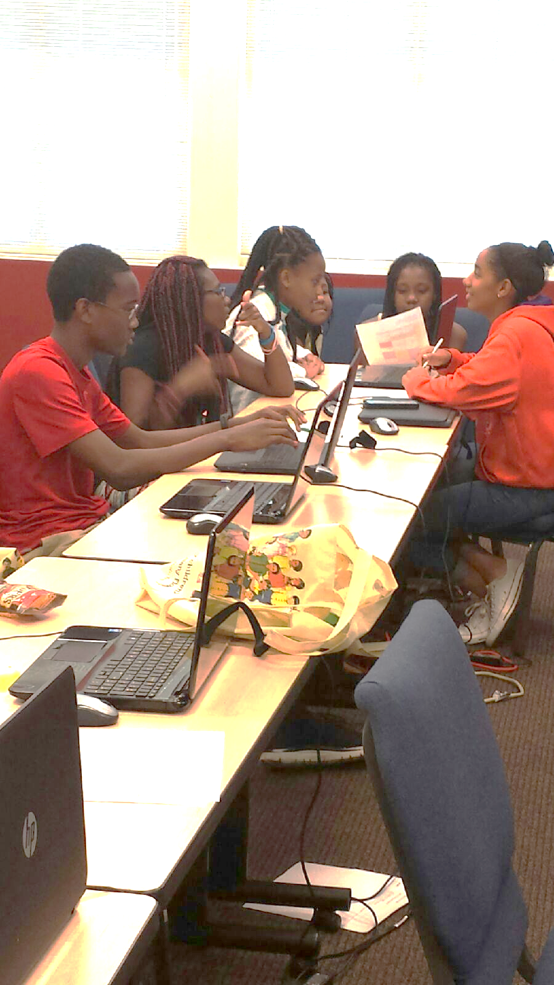 | 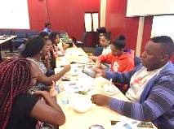 | 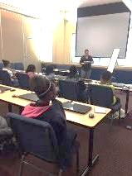
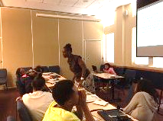

Photographs from the “Real World Enrichment Summer Camp” displaying a few of the many activities that were provided for the participants during the 3-day camp. The students really and a good time having an opportunity to learn transferable skills that will help broaden their academic focus during their summer break from school. Sincere thanks to our loyal supporters for helping to make a difference in the lives of many students in the Tampa Bay area.
“Living In the Real World”
Enrichment Summer Camp”

