Category:
Measuring devices
Product Code: | 27328
Name: | TAPE HEIGHT MEASURE

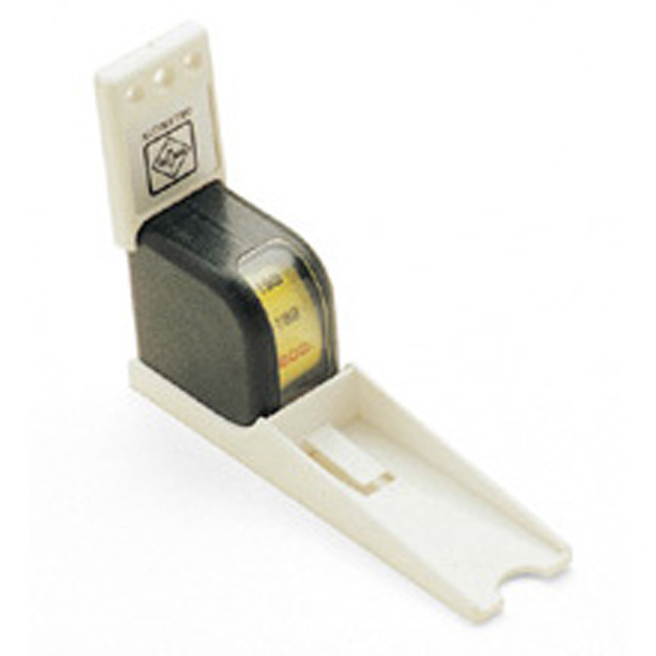
Product Description
Clear scale 0-200 cm.
Easily secured to a wall.

