OneVision. Supplements

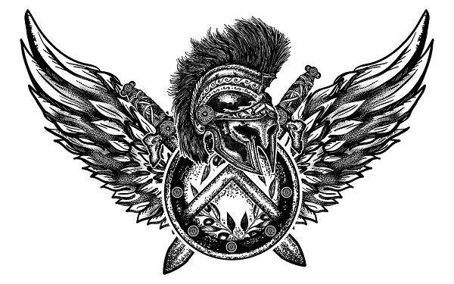



OVS CASEIN PROTEIN

OVS | Premium Quality Laboratory Tested CASEIN dosed at 31.64g Protein per serve includes high potency Grass Fed Milk Protein Isolate, Concentrate and Iceland Sea Minerals as the core building blocks to help you Recover faster than ever before. Research has proven that OVS CASEIN is one of the most effective supplements to help with recovery and reduce muscle breakdown while you sleep. Several studies have shown it helps boost muscle growth, along with many other health benefits. Here at OVS, we use premium quality ingredients and strict production standards across our entire products range for those seeking and demanding only the best in sports nutrition and supplementation.

THE OVS DIFFERENCE.

What is casein protein?

OVS CASEIN protein as well as Whey Protein is sourced from pasture-fed cows and is considered the king of all high-quality protein sources due to its peptide bond structure. Casein makes up approximately 80% of total milk protein and contains a chain of amino acids called beta-casein which give it a slower release in the body than Whey Protein. OVS CASEIN is very high in protein, low in fats and carbohydrates and tastes great!

Stage 3 Deep Sleep

Sleep stages are not the same as sleep cycles. During each night, you go through four phases of sleep: Stages 1-4 (REM is Stage 3). It has been shown that most human growth hormone is released in stage 3 (Deep Sleep Stage), and supplying your muscles with Casein protein during this period will aid muscle recovery, strength and growth. If you need fast acting protein, consider supplementing with our Whey Protein Isolate.

The benefits of a Casein protein supplement at night

Casein protein, which is slow digesting and high in BCAAs (5 grams per serve), EAAs, and minerals, provides a perfect night time snack for after-workout sustenance. Casein also has less fat than other proteins, providing clean energy when paired with carbohydrates or foods rich with fiber. Lab-tested and proven.

Our CASEIN Protein Suppliers

We source our casein from Glanbia Nutritionals (Ireland), the world leader in dairy products, to ensure we receive only grass-fed, laboratory-tested casein.

The Science.

**Study 1:** <https://www.ncbi.nlm.nih.gov/pubmed/9405716/>

Though the speed of protein digestion and amino acid absorption from the gut has a major effect on whole body protein anabolism, the speed at which one organism absorbs individual proteins will also affect how quickly these substrates reach muscle cells.

**Study 2:** <https://www.ncbi.nlm.nih.gov/pmc/articles/PMC3905294/>

The ability to form clots makes casein protein excellent for delivering amino acids into the bloodstream. These sustained slow releases ensure nutrients reach the body at a steady pace and maintain appetite.

THE OVS DIFFERENCE

In order to ensure utmost customer satisfaction, we pride ourselves on a service that is based on high-end products. We are able to keep our quality high because we rely on three cornerstones: tailored manufacturing, raw ingredient traceability, and laboratory tested supplements. Our business is committed to maintaining the strictest quality control standards and we ensure all of our products are 100% exact to specification.

Directions & Ingredients

Directions

Mix one heaped scoop (40 grams) with water and consume one hour before bedtime.

Ingredients

Grass Fed Milk Protein Isolate, Grass Fed Milk Protein Concentrate, Iceland Sea Minerals (Lithothamnion species, E296, E330), Flavouring, Sucralose , Chocolate flavours include organic and alkalised Cacao.

Raw contains no flavours, sweetener, or cacao.



