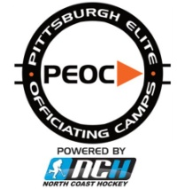 PITTSBURGH ELITE OFFICIATING CAMPS
2015 ADVANCED CAMP
JUNE 5 – 7 . CENTER ICE ARENA – DELMONT, PA

TEAM ASSIGNMENTS
TEAM BLACK | TEAM GREY | TEAM ORANGE
Ackerman, Chad | Heidemann, Samuel | Morton, Brian
Beymer, Greg | Hinz, David | Pascanik, Mike
Bilski, Jason | Klinkhammer, Nick | Pavlecic, Jacob
Bilski, Matt | Lazarro, Nicholas | Rahenkamp, James
Bilski, Rich | Leff, Greg | Resnik, Chris
Cope, Dan | McCambridge, Cameron | Sparrow, Frank
Frederickson, Neil | McCrary, Aaron | Trego, Michael
Hastings, Mark | Morgan, Robert | Yerkovich, Riley

CUPCAKE CUP GAME SCHEDULE
Day | Home Team | Visiting Team | Officiating Team
Friday | Team Black | Team Grey | Team Orange
Saturday | Team Grey | Team Orange | Team Black
Sunday | Team Orange | Team Black | Team Grey

________________________________________________________________________________________

2015 PEOC ADVANCED CAMP – PRESENETED BY WPHOA
