INTRODUCTION
This test panel is a rapid direct binding test device for the visual detection of the antibody to human immunodeficiency virus (HIV), hepatitis B surface antigen (HBsAg) and Hepatitis C (HCV) antibody in serum, as an aid in the diagnosis of HIV, hepatitis B and hepatitis C infection. Infection of any of the three viruses can be detected with a single test panel.
The test is based on the principle of sandwich immunoassay. Monoclonal and polyclonal antibodies are employed to identify HIV antibody, HBsAg and HCV antibody specifically.
This one step test is very sensitive and only takes about 10-20 minutes. Test results are to be read visually without the need of any special instrument.

SPECIMEN COLLECTION
The test works best on fresh samples. Collect blood into a container without anticoagulant. Allow the blood to clot and separate the serum from the clot. Use the serum for testing.

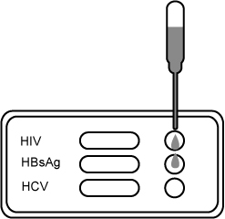
If the specimen cannot be tested on the day of collection, store the serum specimen in a refrigerator or freezer. Bring the specimens to room temperature before testing. Do not freeze and thaw the specimen repeatedly.

TEST PROCEDURE
- Let the sealed pouch and the specimen come to room temperature before testing.
- When you are ready to begin testing, open the sealed pouch by tearing along the notch on the pouch. Remove the test panel from the pouch.
- Draw 0.2ml (about 4 drops) sample into the pipette, and dispense it into one sample well on the panel. Repeat this process and dispense samples to the other sample wells. For HIV, after adding the sample, add about 2-3 drops (100μL) of diluents provided into the sample well. Use the dropper bottle provided, not the sample pipette.
- Wait 10-20 minutes and read the results. Do not read results after 30 minutes.

INTERPRETATION OF RESULTS
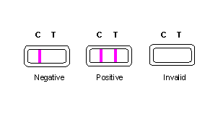Read the results for HIV, HBsAg and HCV in the corresponding result window. Interpret the test results separately according to the illustration as shown below:

- Negative: Only one colored band appears on the control (C) region. No apparent band on the test (T) region. This indicates a negative result.

- Positive: In addition to a pink coloured control (C) line, a distinct pink colored line also appears in the test (T) region. This indicate a positive result. More specific testing method is recommended to reach a clinical conclusion.

- Invalid: A total absence of color in both control region and testing band region is an indication of procedure error and/or test reagent deterioration. Repeat the test with a new test panel.

STORAGE AND STABILITY
The test kit can be stored at room temperature (18 to 30°C) in the sealed pouch to the date of expiration. The test kit should be kept away from direct sunlight, moisture and heat.

PRECAUTION
- For in vitro diagnostic use only.
- Do not use test kit beyond expiry date.
- The test device should not be reused.

Latest revision 09.05.2011

ATLAS LINK, INC USA Headquarters:
No. 811 Zeyang Plaza, No.166 Fushi Road 10758-A Ambassador Drive
Shijingshan Dist., Beijing 100043, China MANASSAS, VA 20109 USA
Tel: 86-10-88909112 Fax: 86-10-88909115 Tel: 703-3663851

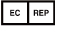
CIRIANO GLOBAL S.L. (UNILATEX GROUP)
CIF: B50927532 C/Blancas 4-6, 1 B Oficina 1
50001 Zaragoza Spain
Tel: 34-976910399

