Oklahoma World Organization of China Painters, Inc.
August 26, 2015
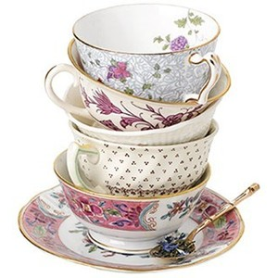

Dear China Painters,
Hope you have had a wonderful summer and have painted a teacup and saucer, mug or stein to enter in a contest at the September 19, 2015 board meeting at The World Organization of China Painters Museum.

Itinerary / Board Meeting
of Oklahoma World Organization of China Painters, Inc
9:30 am Coffee and donuts
10:00 am The board meeting will begin
We will be discussing several important items of interest, please plan on coming to this meeting. All current club presidents, past Oklahoma State Presidents, and current Board members really need to attended.
12:00 pm The Oklahoma Teachers Club is serving a barbeque lunch. Cost $7.00.
Lunch Menu
Barbeque beef sandwich Potato Salad
Cold Slaw Baked Beans
Chips Dessert

1 pm There will be four (4) demonstration the groups can rotate through.
This is a fund raiser. The cost is $ 5.00 for all four demonstrations.

Jody Cook will give tips on painting on bisque;
Sarah Gomez will give tips on using your I-pad, (bring your own I-pad)
Le Yeattes will demonstrate how to paint a Watermelon and
Anita Kantowski will demonstrate the Lace Ladies.

You will be able to see all four demonstrations. This should be a lot of fun.

Do plan on registering for the April 8, 9, and 10 Wonderland of China Painting Retreat to be held at the Crown Plaza in Tulsa. The registration fee of $280.00 is for a three day seminar, and includes your piece of porcelain to paint, the firing of your piece, three lunches and the reception. Register now so you may get your first choice of teacher.
Due to popular request, the subject for Susan Thumm’s seminar has been changed to a Pears and a Bird. Paula White’s seminar will be a Light House Scene. Cherryl Meggs will be painting Wild Roses on a tray with a modern design and Ann Zitterkopf will be painting Violets and scrolls with embellishments on a box.
The drawing for the FREE seminar for the April 2016 Wonderland of China Painting Retreat will be held at the January 16, 2016 Board Meeting. Tickets will be on sale at the September 19, 2015 Board Meeting . They are being sold for $6.00 a piece of 3 tickets for $15.00.
Come and Support your organization!
Susan Owen, President
Oklahoma World Organization of China Painters, Inc
E-mail: sl_owen@sbcglobal.net

