
Quicking Biotech Co., Ltd.
No.1998, South Yanggao Road, Shanghai, China. Tel: 86-21-5094 7188
CA-125 RAPID TEST

COMMON NAME
CA-125 Rapid Test Kit
PACKING SIZE
1 cassette / pouch, 20 pouches / box
INTENDED USE
For the qualitative detection of the ovarian cancer antigen CA-125 concentration in human serum.
PRINCIPLE
Sandwich method immunochromatographic assay
KIT COMPONENTS
20 pouches of CA-125 cassette
One product insert
STORAGE AND STABILITY
Store at room temperature (2-30°C). Don’t freeze. Shelf life is 18 months.
SAMPLE REQUIREMENT
Clean serum, undiluted. If precipitate exists in the sample, please do centrifugation before use.
TEST PROCEDURE
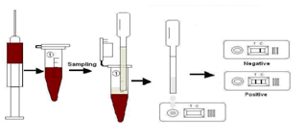
1) Reading carefully the instructions before use.
2) Allow all kit components and specimen to reach room temperature prior to testing.
3) Remove the test device from the foil pouch prior to use.
4) Place the test device horizontally, Drop 3 drops of the specimen into “S” hole.
5) Interpret test results in 10-15 minutes. Do not interpret after 20 minutes. 40 U/mL and above is considered as positive result.
INTERPRETATION OF THE RESULT
- Positive: The presence of two bands in both C zone and T zone.
- Negative: only one band appears in C zone.
- Invalid: No visible band appear in C zone, no matter if there is band in T zone. Please repeat the testing for a valid result.
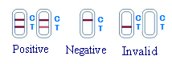
PRECAUTIONS
1) For best results, strict adherence to these instructions is required.
2) Do not open or remove test kit from their individually sealed pouches until immediately before their use.
3) Do not reuse test kit.
4) All reagents must be at room temperature before running the assay.
5) Do not use reagents beyond the stated expiration date marked on the package label.
LIMITATION
1) This Test is for in-vitro diagnostic use only.
2) For more accuracy of diagnosis, additional follow-up testing using other medical methods is recommended.

Quicking Biotech Co., Ltd.
No. 1998, South Yanggao Road,
Shanghai, 200125 China.
Tel: +86-21-5094 7188
Fax: +86-21-5094 7186
Website: www.quicking.cn

