McArdle’s Disease ... also knows as Glycogen Storage Disease Type V (GSPD V), Phosphorylase Deficiency, and Myophosphorylase Deficiency
- Is a rare, inherited muscle disease that causes severe muscle pain and cramping, & an individual can get support from Muscular Dystrophy Groups if they have this disease
- It is caused by a missing or non-functioning enzyme needed to make glucose for energy. The body is unable to product an enzyme known as phosphorylase or myophosphorylase, which is needed to break down glycogen, the stored form of sugar. Without the enzyme, glycogen can’t be used to product energy during exercise.
- While this condition imposes significant physical limitations, it is not directly life-threatening, and with proper precautions and lifestyle management, people who have McArdle’s Disease can live healthy, active lives
- Because their muscles cannot properly metabolize energy, individuals with McArle’s disease may experience fatigue and failure during strenuous activities like jogging, swimming or even walking. These episodes can result in painful cramping
How Skeletal Muscles Normally Contract | A McArdle’s Disease Model
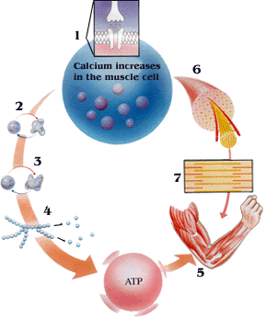 | 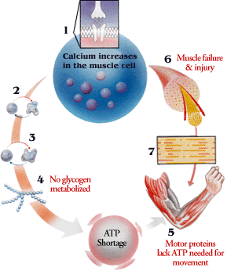
1. Acetylcholine is released from a motor nerve. This causes an entry of calcium into the muscle cell. | 1. Acetylcholine is released from a motor nerve. This causes an entry of calcium into the muscle cell.
2. Calcium activates phosphorylase kinase – the first protein kinase | 2. Calcium activates phosphorylase kinase – the first protein kinase
3. Phosphorylase kinase phosphorylates phosphorylase, which is activated | 3. Phosphorylase kinase phosphorylates phosphorylase, which is missing or otherwise non-functional
4. Glycogen is broken to glucose. This is used to generate ATP | 4. Glycogen is unable to be broken down, creating glucose (and ATP) shortage.
5. The muscle works and requires energy in the form of ATP | 5. Motor proteins attach to muscle fibers require ATP for movement.
6. The muscle contains muscle cells | 6. Muscles stop responding in absence of ATP .
7. Contractile proteins in the muscle are activated by calcium | 7. Because ATP is required to both contract and relax muscles, injury can occur.
Symptoms of McArdle’s Disease:

Premature Exhaustion ... The body’s response to the inability of glycogen to metabolize within muscle to glucose for energy is an abrupt feeling of exhaustion or fatigue, with an increase in heart rate.

Muscle Failure ... During particularly strenuous activities like carrying heavy objects, the failure of glycogen metabolism to provide glucose for energy quickly robs of the energy they need, and the fuel to power continued contractions is gone. Similar to the "wall" that marathon runners may hit after depleting their muscle’s glycogen stores, someone experiencing this cannot move any more, regardless of effort.

Cramping (rhabdomyolysis) ... A complication of the muscle failure associated with McArdle’s disease are electrically-silent contractures which are painful and may involve significant damage to muscle tissue.

Myoglobinuria (dark urine) ... As a result of damage to muscle tissue, proteins like creatine kinase and myoglobin enter the blood stream and are passed as urine, which may be darkened from the iron-containing proteins. Myoglobinuria has induced renal dysfunction in some individuals with McArdle’s disease, which is why failure and cramping episodes require medical attention.

Fixed Weakness ... Possibly owing to the muscle damage caused by rhabdomyolysis, fixed muscle weakness has been observed in some patients who find it difficult to improve their physical strength as a result.

The Second Wind ... The second wind phenomenon has been observed in clinical studies, presenting as a feeling of improved energy levels and relief from pain accompanied by a more normal heart rate following a "warm up" period. This second wind does not completely relieve failure symptoms for intense exercise, but does appear to offer relief for moderate intensity activities like walking or biking.

Natural Health Support

Everyone, regardless of the disorder they experience would find benefit from healthy lifestyle, healthy diet and healthy supplementation (such as soy protein or Shaklee 180 Smoothees ... AND ... Vitalizer
- Because this disease affects muscles, bowel parastalic action may be sluggish, Herb-Lax may be very beneficial to support functional wellness in this system

Specific supplements have proven beneficial to individuals:
- CoQHeart for cellular energy support
- Vivix for repair of cellular tissue
- VitalMag to help reduce muscle cramping
- Alfalfa to reduce pain and cramping
- Optimal Vitamin D3 to support calcium absorption
- Physique and the Leucine in Shaklee 180 Smoothees may prove very beneficial

