Altrusa International
Foundation
of Meredith, NH, Inc.
P.O Box 760
Meredith, NH 03253
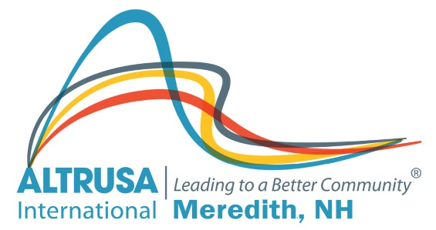

SCHOLARSHIP

This scholarship is geared to the “non-traditional” student twenty-three years of age and older, as of March 1, 2022. Scholarships are intended for the following:

- Applicants living or working in one of the following towns: Laconia, Meredith, Moultonborough, Center Harbor, New Hampton, Holderness or Sandwich.

- Individuals upgrading their job skills or acquiring skills for job entry. (For example, but not limited to - LNA programs, re-certification programs, cosmetology programs.)

- Candidates enrolled for a minimum of three college credits at an accredited facility.

- Graduate students.

The Altrusa Scholarship Committee will select candidates to be interviewed. Funds will be granted directly to the school/college. The scholarship will be payable for the first semester.

IF YOU WOULD LIKE TO DOWNLOAD AN ELECTRONIC COPY OF THE SCHOLARSHIP APPLICATION, PLEASE VISIT THE ALTRUSA WEBSITE at www.altrusameredithnh.org/ or SEND AN EMAIL TO: cynthia.c.day@gmail.com@metrocast.net
DEADLINE FOR APPLICATIONS IS THURSDAY, MARCH 31, 2022.

INCOMPLETE APPLICATIONS WILL NOT BE CONSIDERED. ALL MATERIAL MUST BE TYPED OR CLEARLY PRINTED.

