4th Annual Good Neighbor Days
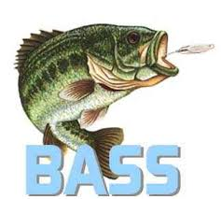
Bass Bag Contest!
Attention GND Fishermen/Fisherwomen!

Saturday, June 22nd
Registration at 7:00 AM
Contest Runs from 8:00 AM – Noon
Howard Lake Lions Park

“Largest Bass Bag” Category

Basic Rules
4 Bass Bag limit per boat.

$10/per person entry fee for those wishing to participate. (We are running this on the “Honor System”; for those who have chosen not to enter and are in the same boat, please follow the rules.)

We are running this on the “Honor System”, for persons entered in the Bass Bag we ask everyone to be honest and fair. If you are not entered in the Bass Bag portion, we ask you to NOT contribute your fish to the boat’s bag, (should you not have entered the category and others in the boat have).

100% payback of prize money.

Pays for 3 places.

This is our 3rd year trying out this category, feedback welcome.

Big Bass can be entered in both categories, single largest, and then it can be added back into the Bass Bag, (standard fishing contest rules still apply in the GND contest).

Be mindful of the health of Bass in live wells, if mortality is an issue, we can weigh the individual fish and then add it back to the boat’s overall weight. We ask everyone to help protect our resources and protect it for future generations.

Please do not argue with the individuals weighing fish; they have the final “say”. The scale and container will be used to weigh all the fish, equally.

