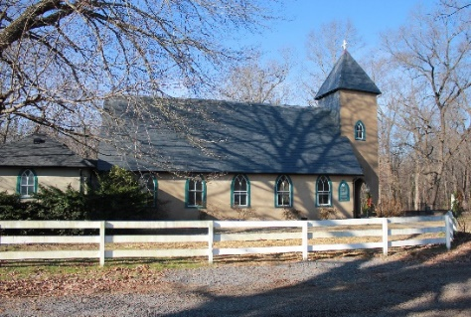
Grace Church Lane
Grace Episcopal Church
Casanova, Virginia 20139
e-mail: gracechurchcasanova@gmail.com website: www.gracechurchcasanova.org

Easter’s Impact
On Easter Day we were able to experience as gathered church the awesome retelling of the great and glorious news of God’s raising Jesus from death. Within a week or if you follow John’s sequence, by Easter afternoon the story is not just about Jesus but shifts to his Easter impact on the community.
The Grace family is an Easter community. We do not just believe that something happened that has changed the way we understand all reality; we become that something as we embody, in our common life, Easter Hope.
St Paul says our life is hidden with Christ in God. So, we not only believe Easter we live it. I was so proud of our vestry’s efforts to make Easter more intentional: Gift bags for children, letters of invitation, beautiful flowers, courageous soloists.
I actually had a conversation about baptism after Easter service... if that baptism happens it is because a Christian invited a friend to hear the story and by doing so, she lived Easter reality for a friend.
So, let’s embrace the story so that, like the first Christians, we become the story! Alleluia Christ is Risen and so are we in Him!
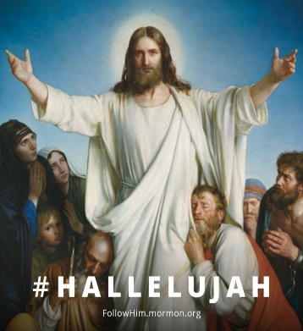
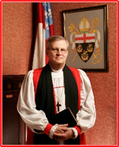
Bishop Ted

AN UPDATE FROM YOUR DISCERNMENT COMMITTEE
We remain hopeful that we will soon have a candidate(s) to shepherd our little churches. As soon as we receive contact from a candidate, we will need to submit the candidate for Diocesan review before we may begin our interview. There is a lot of “buzz” around, so optimistically speaking, we are hopeful that it will not be as long as it has been! We ask for your fervent prayers and lots of patience!
optimism

Sincere love and blessings,
Judy Ball, Pat Williams, Kathlene Bilger, Linda Winslow, Tom Bilger, & Mary Neal
Your Discernment Committee (DC) aka Search Committee

SENIOR WARDEN’S REPORT – APRIL 2021
Dear Grace Family,
Gratefully, the COVID-19 numbers were low enough that we were permitted to exercise our approved plan to worship inside the Parish Hall. So, after Easter Sunday, we moved all of the remaining April services there. It has been very nice to also have the option to sit outside of the Parish Hall if we would like because we have a sound system!
With all of that said, and the fact that the Diocesan Guidelines and Parameters for Regathering were updated at the end of March, I wanted to research the possibility of returning to the church building. So, off I went with my copy of the Guidelines and a tape measure. Unfortunately, the Guidelines had not changed enough to permit us to author a plan that would comply. So, we remain in the Parish Hall, but also remain hopeful.
Ah, but with that comes some other benefits! Some of our Partner Ministries will also be returning! St. Andrews will return to worshipping after our service, beginning in May. Yoga will also be permitted to return and the Book Club has asked and was granted use of the building. Of course, we have stipulations. Each of these ministries must follow the same Guidelines and Parameters for Regathering (each ministry will receive its own copy) that we must follow and must return all chairs back to their original placement immediately after using the facility. Unfortunately, others of our Partner Ministries (“Sew What,” The Center, and The Ruritan Dinners) will not be able to regather yet, but keep those prayers coming!
Additionally, as a result of our Partner Ministry, St. Andrews, returning to its worship, we will also return to our 9AM service starting on May 2nd. And, that is the day that Bishop Jennifer Brooke-Davidson will be visiting us! Please come to welcome her!
Renovations on Redlands (our Rectory) continue with the latest being a refresh of the floors. The Church grounds are also going to be spruced up a bit, awaiting our return. Did I mention, we are hopeful? If you have visited the Church, you may have noticed a couple of shingles have dislodged and are on the ground. Never fear, we are working to get them replaced.
Blessings and love on behalf of the Vestry,
Mary
TREASURER’S REPORT – MARCH 2021
Income for the month of March was $6,291.14 (budget $6,267.00); expenditures totaled $4,974.97 (budget $4,543.00) resulting in income for the month of $1,316.17.
Interest earned on our Roof/Rectory Renovation Fund during the month of March was $0.01 and disbursements of $1,662.87 were made for renovation work on the Rectory and a $5.00 service charge was assessed for low balance. The balance in the fund at the end of the month was ($4.99). The account was closed in April. All future Rectory renovation charges will be paid from grant funds in the operating account.
The book value of our endowment fund is $60,073.49; market value as of 2/28/21 - $65,329.63.
Just a reminder that, if you are unable to attend our worship services at this time, it would be appreciated if you would mail your pledge check to the Church at PO Box 18, Casanova, VA 20139.
Please continue to pray for Grace Church that it will grow spiritually, financially and numerically. If you have any questions about this report or any financial matter, please contact me.
Judy Ball, Treasurer
FEED MY SHEEP (FMS)
For we are GOD’s handiwork, created in Christ Jesus to do good works, which GOD prepared in advance for us to do. Ephesians 2:10 (NIV)

Some years ago, the Rev. Jim Chipps presented a Lenten series on “Finding Your Gifts”. Certainly, Grace has an abundance of members with gifts. We have just enjoyed the gifts of Diane, Mignonne, and their many helpers in creating a beautiful Easter display when we most needed it; Bishop Ted in supporting our faithful congregation through a difficult time of transition; And last, but not least, Grace Church’ s support of FMS. Your generous donations have made it possible for 70+ families to receive the blessings of groceries in a time of need. Our faithful volunteers make the deliveries two times a week plus a once a month delivery of basics. Through the pandemic we have been able to provide nonperishable fruits, vegetables and some fresh ready to eat meats. Many of our recipients have only a microwave or hot plate to prepare their meals. Thank you for your continued support . You may send your donations to the Grace Church address - please with this notation on checks: “FMS.” Cash is always welcomed. You may also leave an envelope in the collection plate.
Carol Grove
COVID-19 IN STATUS OF FAUQUIER
The local status of COVID-19 is being shared here for informational purposes.
https://www.vdh.virginia.gov/coronavirus/covid-19-in-virginia/

A measure of how Virginia is managing the COVID-19 crisis, the seven-day positivity rate (total tests compared to positive tests) was 6.0% as of April 21, 2021; in the Rappahannock-Rapidan Health District, the positivity rating was 6.2%. When the positivity rate is below 5% for two weeks, it is a signal that transmission is low enough to begin lifting more restrictions.

MAY BIRTHDAYS & ANNIVERSARIES

Donna Shipe | 4-May
Dave Coates | 7-May
Emelia Warren | 9-May
Sue Ballentine | 10-May
Rick Anderson | 12-May
Kevin Holmes | 13-May
Carol Payne | 14-May
Adam Rhoads | 14-May
Betsy Anderson | 15-May
Bob & Julie Brewer | 15-May
Bryan & Barbara Jacobs | 15-May
Nellie Warren Escorcia | 19-May
Bobbie Gouldthorpe | 21-May
Karen Walton | 21-May
Debbie Meador | 25-May
Flavia Escorcia | 26-May

*
We are happy to announce the first month of a new way to serve Grace Church. Look for the * below. Thank you in advance, ladies!

MAY SERVING SCHEDULE
 |  | Readers | Flowers * | Ushers
Fifth Sunday of Easter  May 2, 2021 | Acts 8:26-40  Psalm 22:25-31  1 John 4:7-21  John 15:1-8 | Judy Ball | Pat Williams | **
Sixth Sunday of Easter  May 9, 2021 | Acts 10:44-48  Psalm 98  1 John 5:1-6  John 15:9-17 | Mary Neal | Sharon Sweeney | **
Seventh Sunday of Easter  May 16, 2021 | Acts 1:15-17, 21-26  Psalm 1  1 John 5:9-13  John 17:6-19 | Bryan Jacobs | Mignonne Spellmeyer | **
Day of Pentecost  May 23, 2021 | Acts 2:1-21  Psalm 104:24-34, 35b  Romans 8:22-27  John 15:26-27; 16:4b-15 | Dee Garrett | Diane Gulick | **
Trinity Sunday  May 30, 2021  First Sunday after Pentecost | Isaiah 6:1-8  Psalm 29  Romans 8:12-17  John 3:1-17 | Judy Ball | Pat Williams | **
https://lectionary.library.vanderbilt.edu/lections.php?year=B&season=Lent
WE NEED YOU! Volunteers, please contact Mary Neal or Barbara Jacobs
* Flowers – bring a vase of flowers
** Ushers – take attendance (COVID-19 protocol), hand out bulletins, collect offering

What is the “church?”

The church is the body of Christ—his heart, his mouth, his hands, and feet—reaching out to the world: Now you are the body of Christ, and each one of you is a part of it. (1 Corinthians 12:27, NIV)
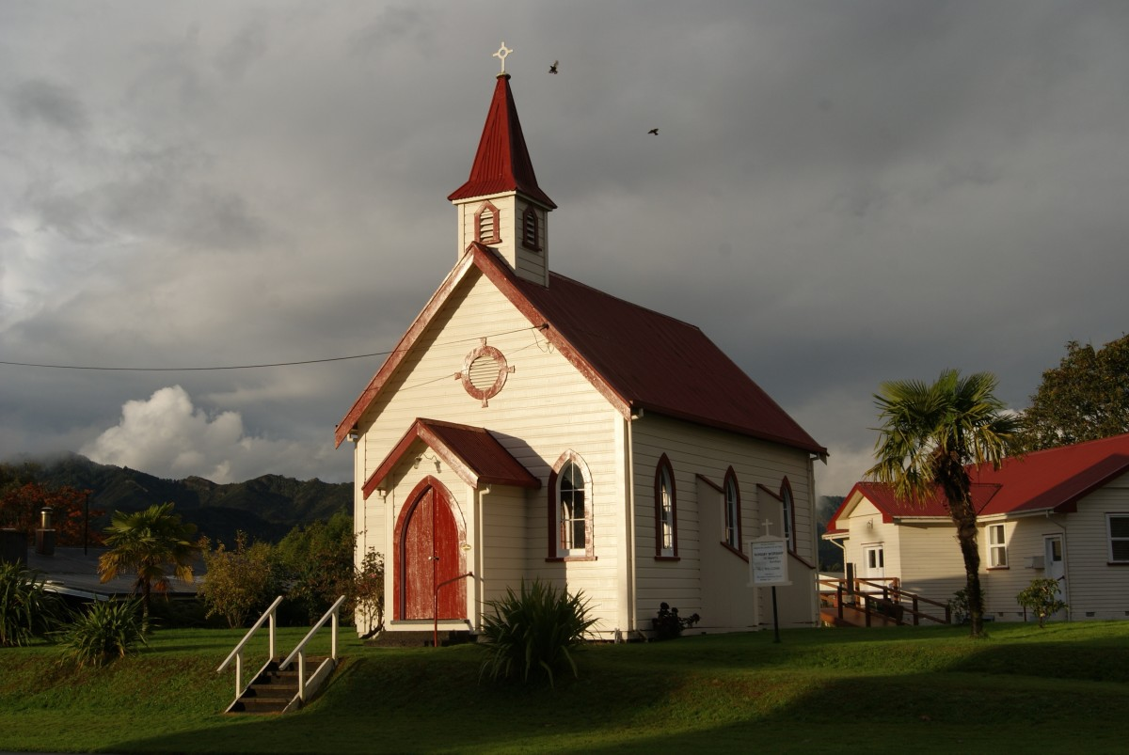
I thought it was the building

AMAZON SMILE
FOR GRACE CHURCH
Don’t forget to sign up with Amazon Smile to have 0.5% of the purchase price of eligible items given to Grace Church at no cost to you! You can also go to the Grace Church website home page and click on the link there.

*******AmazonSmile Shopping App for Android Users Now Available******
You can now support Grace in the Amazon shopping app on your Android device! Simply follow these instructions to turn on AmazonSmile and start generating donations to Grace from your Android device.
- If you have the latest version of the Amazon Shopping App, open the App on your Android device.
- View Settings and select AmazonSmile.
- Follow the in-App instructions to complete the process.
AmazonSmile is not currently available for IOS users – we’ll let you know when it becomes available.

