Arab Republic of Egypt
The Cabinet of Ministers
Ministry of State for Environmental Affairs
Egyptian Environmental Affairs Agency

The information required in this form should be filled in an accurate and legible way.
The administrative authority should review and stamp the form, then send it to EEAA for review and give opinion. Site visit report or any additional attachment might be submitted

Environmental Screening FORM C

Project title: KÁRAHNJÚKAR HYDROELECTRIC PROJECT

Executive Summary & history:
Large-scale industry has been on the agenda in East Iceland for almost three decades and in all this time the main focus has been on the industry site in Reyðarfjörður.
• 1975-1976 the Norwegian company Norsk Hydro examined possibilities of building an aluminium plant in Reyðarfjörður. The power was to come from the Fljótsdalur hydroelectric power plant.
• 1980-1985 the Australian company Rio Tinto Zink had plans about building a silicon metal plant in Reyðarfjörður. The power was again to come from the Fljótsdalur hydroelectric power plant. This project was well on its way before it was abandoned.
• 1989-1990 Reyðarfjörður was again in the picture as a site for large-scale industry when the multinational firm Atlantal, owned by Hoogovens, Alumax and Gränges, was searching for a site for an aluminium plant. The final choice was Keilisnes in South of Iceland but the power was still to come from Fljótsdalur hydroelectric power plant. The National Power Company, Landsvirkjun, had already started constructions when the project was suspended in 1991.
• 1998 discussions were taken up again with Norsk Hydro about an aluminium plant and a hydroelectric power plant in East Iceland. Memorandum of understanding was signed in June 1999, for a 120.000 tonnes smelter and a power plant in Fljótsdalur with reservoir at Eyjabakkar, known as the Noral Project.
• In 2000 investors came to the conclusion that the smelter needed to be bigger in order to be profitable. In May a new memorandum of understanding was signed for the Noral Project. The aluminium plant was now planned to have a production capacity of about 240.000 tonnes per annum in its first stage and a second stage with a capacity of about 120.000 tonnes was planned for later. A project company, Reyðarál, jointly owned by Norsk Hydro and Icelandic investors was to develop the plans for the smelter but Landsvirkjun would supply the power for both stages with a hydroelectric power plant at Kárahnjúkar and a diversion in Jökulsá in Fljótsdalur Valley
• In March 2002 it was announced that Norsk Hydro could not meet deadlines set for September 1st in the decision process, because of Hydro´s massive investment in the German aluminium company VAW. Still Hydro clamed interest in the project at a later stage. The Icelandic government immediatly established a commission to look into other company’s interest in the project and shortly afterwards talks started with Alcoa, the worlds biggest aluminium producer.
• April 19th 2002, a joint action plan (JAP) was signed with Alcoa to explore the possibility of constructing a state-of-the-art aluminium production plant in Eastern Iceland and on May 23rd an extension of the Joint Action Plan was signed that runs until July 18th, 2002. At that time, the parties will make a decision whether to sign a formal Memorandum of Understanding and proceed with the project. In the project under review, Alcoa would own and operate a 320,000 metric ton per year aluminium plant, which would receive power from a 500+ Mw hydroelectric power station in Eastern Iceland. That power station would be constructed and operated by Landsvirkjun, the National Power Company of Iceland.
• July 19th 2002 a Memorandum of Understanding (MOU) was signed in Reykajvík between the Government of Iceland, Landsvirkjun, Iceland's national power company and Alcoa formalizing their cooperation on a 295,000-metric-ton-per-year, low-emission aluminium smelter to be built in eastern Iceland. Under the new MOU, Landsvirkjun will begin development of a 630-megawatt hydropower facility in eastern Iceland, and Alcoa will complete environmental and engineering studies of the smelter near Reyðarfjörður in eastern Iceland. The MOU also encompasses a harbour facility at Mjóeyri as well as related infrastructure improvements in eastern Iceland. The management of Alcoa will aim at presenting the Plant Project to its Board of Directors for full approval not later than in the Board meeting of January 2003. Landsvirkjun will aim at submitting the Power Contract, and the Harbour Fund will aim at submitting the Harbour Agreement, to their respective Boards of Directors for full approval before the end of December 2002. In the event that Alcoa, the Government and Landsvirkjun are unable to ultimately agree upon the basic premises for binding definitive agreements on implementation of the Plant Project, or on interim milestones for the establishment of such agreements before the end of March 2003, this MOU will terminate, unless the Parties mutually agree to extend the term of the MOU or replace it by a further Memorandum. Below are various photographs from the Kárahnjúkar project's impact area. The photographs are taken from the Environmental Impact Assessment report, published in May 2001.

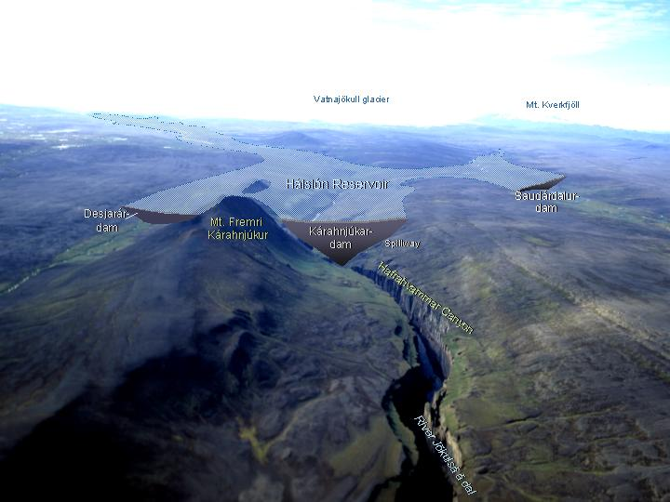

  - Type of project (infrastructure, petroleum and mining, tourism, industrial, other) Hydroelectric DAM Project.
  - Name of the owner (individual, company, etc): Landsvirkjun, Iceland.
  - Name of the person in charge (the responsible person)Project Manager (X)
Address: Iceland------------------------------------------------------------------------------------------------------------------------------------------------------------------------------
Telephone No: +777980976609----------------------Fax No. +687678977908
  - Competent Administrative Authority: Ministry of Environment, Iceland.
Address of the project: The Kárahnjúkar hydropower project is being built in the highlands of Northeast Iceland. The impact area of the project includes highlands by the glacier Vatnajökull as well as land along the rivers through the valleys of Jökuldalur and Fljótsdalur out to the coast of Héraðsflói. This expanse lies within the following four communities:
Austur-Hérað
Fellahreppur
Fljótsdalshreppur
Norður-Hérað

City ٱ, village X, accredited industrial zone ٱ, others ٱ (please specify)-------
B. In a residential area ٱ, Outside a residential area X
C. Individual building ٱ A multiple story building with a residence above ٱ
Total area of the project (Square meter): Dam height: 190 m (highest of 3 dams)
Reservoir size: 57 km2

Type of project:
New X Extension ٱ
Type of extension: -----------------------------------------------
- If the type of project is an extension, has an EIA study been submitted for the original project?
Yes ٱ No ٱ
- Date of obtaining a previous approval from the EEAA: ------------------------
- Production capacity: Power generation, Installed capacity: 690 MW
and/or storage capacity: Reservoir size: 57 km2

Please mention units used: Concrete Building & Hydroelectric generators
Main products: Electric Power generation

Introduction:
Landsvirkjun’s aims and objectives in constructing Kárahnjúkar Power Plant are to utilize the energy resources of Iceland in accordance with the national law on Landsvirkjun, and to enter into a profitable investment. The power-generating capacity of the proposed plant will be up to 750 MW, with an estimated annual electricity production of 5,000 GWh. The intended energy consumer is a proposed aluminum plant in Reyðarfjörður on the east coast, or another large-scale energy buyer if those plans change.

Law & Regulation: Iceland law No. 106/2000 & WCD Report.

Project description:
The plan of the project is that the plant be developed in two phases, with the latter phase being taken into account during design of the first phase.
The arrangement of Phase 1 is that the western glacial river, Jökulsá á Dal, will be dammed at the mountain Fremri-Kárahnjúkur. This Kárahnjúkar Dam is located just south of Hafrahvammagljúfur canyon, with two smaller dams on each side: Sauðárdalur Dam above the valley Laugarvalladalur and Desjarárdalur Dam at the upper end of the valley Desjarárdalur. These three dams create a storage reservoir named Hálslón. The surface of the reservoir when full stands 625 m above sea level, so that it will stretch upstream to the edge of Brúarjökull, a tongue of Vatnajökull, and cover some 57 km2. The usable volume of the reservoir is estimated as 2,100 GL (million m3), based on the lowest water level, 550 m in altitude. The largest dam, Kárahnjúkar Dam, is 190 m high and constructed of rock sealed with concrete on the reservoir side. The other two dams, Sauðárdalur Dam, at a height of 25 m, and Desjarárdalur Dam, reaching up 60 m, are customary structures of rock and earth fill around a dense core. A headrace tunnel will carry water flow east from Hálslón, then northeast under Fljótsdalsheiði heath to an underground power station at the uppermost reaches of Fljótsdalur valley. The tunnel is about 40 km long and will largely be drilled with TBM fullface boring machines to measure around seven m in diameter. From the power station, the water runs via a tailrace tunnel located about 1 km upstream from the farm of Valþjofsstaðir and then through a tailrace channel into the bed of Jökulsá í Fljótsdal/ Lagarfljót river, at about 26 m above sea level. The switchgear and a building for it, along with a service building, will be located at the mouth of the access tunnel in Fljótsdalur valley. Access to Kárahnjúkar Dam is intended from Fljótsdalur valley. A road has been laid along the Bessastaðaá river, leading up onto Fljótsdalsheiði heath and from there farther along the heath to Laugarfell. This road is to be continued completely across the heath to the dam. Because the road extends over the dam, a connection is created over the river Jökulsá á Dal to Brúardalir valleys. Phase 1 of the hydropower project also includes the diversion of Bessastaðaá river. Drainage from Gilsárvötn lakes, which are on Fljótsdalsheiði above the power station, is retained using a 1-metre-high concrete weir and is then diverted via Þóristjörn pond to the plant’s headrace tunnel.
The harnessed flow for Phase 1 is about 90 m3 per second, installed power will attain up to 625 MW, and the anticipated energy production is 3,800 GWh/year.

Phase Two is divided into three project components, numbered sequentially after Phase One, which is Component One of the project. For Component 2, the glacial river farther to the east, Jökulsá í Fljótsdal, is to be dammed 2 km downstream of Eyjabakkafoss waterfall, which is north of the Eyjabakkar wetlands. This dam will be about 32 m high, made of rock and gravel, and will create a small reservoir which has been named Ufsarlón.
The surface is expected to be 625 m above sea level and in that state reach to the top of the falls. A raised road, which now reaches to Laugarfell, will be extended to the dam area and over the dam itself. From Ufsarlón water will be diverted through a 13.5-km-long tunnel to the headrace tunnel coming from Hálslón. These tunnels connect near Axará river on Fljótsdalsheiði. By this arrangement, Hálslón reservoir can be fed by both glacial rivers (see Section 5.2).
In Component 3, diversions to the west of Jökulsá í Fljótsdal will be joined to the system’s main artery of water. North of Snæfell mountain, the uppermost parts of Grjótá and Hölkná rivers will be diverted through channels to Laugará river. A 6-m-high dam is proposed in Laugará river where the current road on Fljótsdalsheiði lies, and water from all three rivers is to be diverted along a tunnel sloping down into the tunnel from Jökulsá í Fljótsdal. This diversion has been called Laugarfell Diversion. Also, Hafursá river, east of Snæfell, is to be diverted into Jökulsá í Fljótsdal above
Ufsarlón.
Component 4 has been named Hraun Diversion, originating east of the planned dam across Jökulsá í Fljótsdal in the so-called Hraun area. In all, this plan involves the diversion of six tributaries - Kelduá, Grjótá, Innri- Sauðá, Ytri-Sauðá, Fellsá and Sultarranaá - to feed Ufsarlón. Most of the diversion will be conveyed by tunnel. The dam in Kelduá river is the largest, 25 m high, and will change Folavatn lake into an 8-km2 reservoir. Other dams belonging to Hraun Diversion are much smaller and surface disturbance will therefore be slight. The road to Ufsarlón will be extended to
Kelduá river, whereas only tracks are planned east of that river. The flow turned to hydroelectric production after Phase 2 increases by about 30 m3, installed power supply increases by as much as 125 MW, and estimated annual energy production by 1,090 GWh.

Project data
Location of the project (please attach a map that clearly shows the location of the project in relation to residential areas and neighboring activities. The map should have a suitable and clear scale and should be approved by the competent administrative authority). 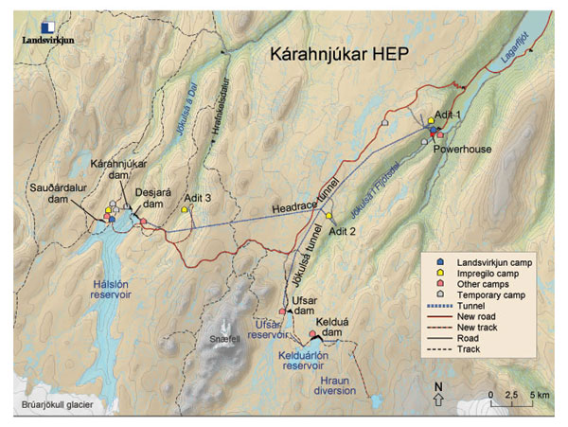

2.6. A general description of the area surrounding the project including a description of the different activities, historical areas, protected areas, tourist and recreational areas, etc…

Landsvirkjun’s aims and objectives in constructing Kárahnjúkar Power Plant are to utilize the energy resources of Iceland in accordance with the national law on Landsvirkjun, and to enter into a profitable investment. The power-generating capacity of the proposed plant will be up to 750 MW, with an estimated annual electricity production of 5,000 GWh. The intended energy consumer is a proposed aluminum plant in Reyðarfjörður on the east coast, or another large-scale energy buyer if those plans change.

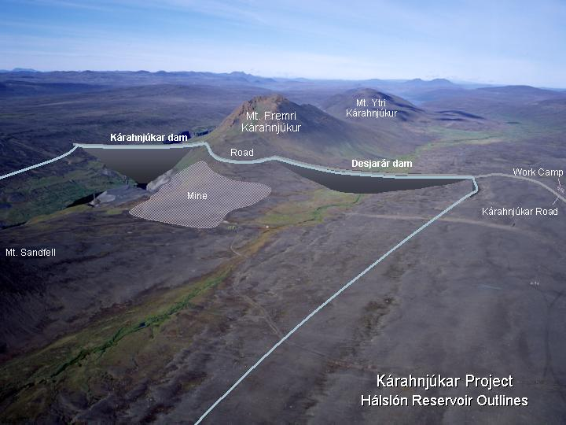
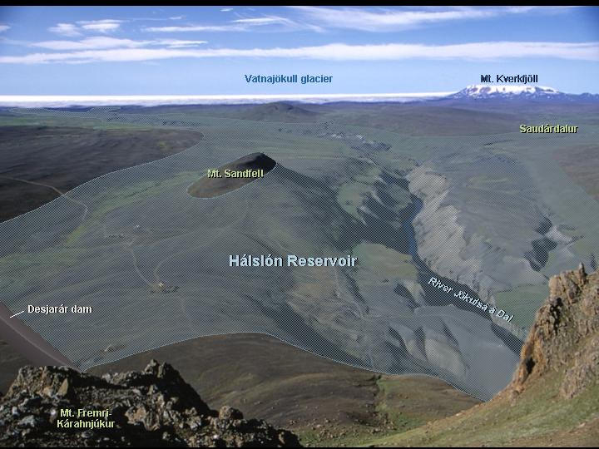
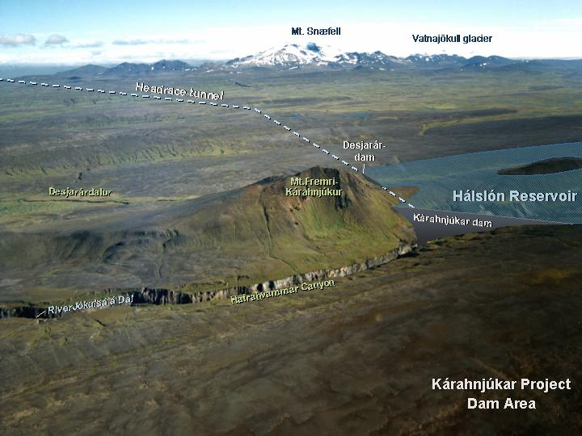

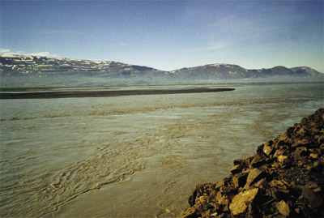 |  | 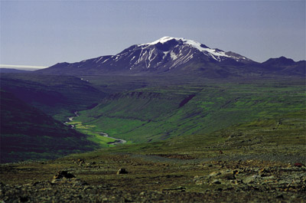
River Jökulsá á dal above its  estuary by Héraðsflói bay.  Photo: Tommy Fransson. |  | View from Teigsbjarg up Fljótsdalur  valley to the mountain Snæfell  Photo: Hreinn Magnússon.
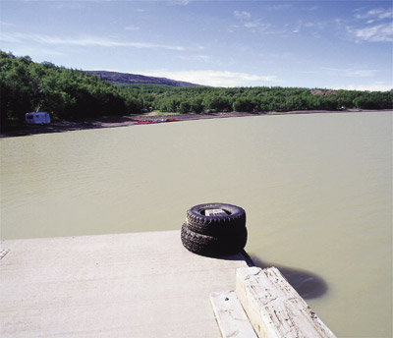 |  | 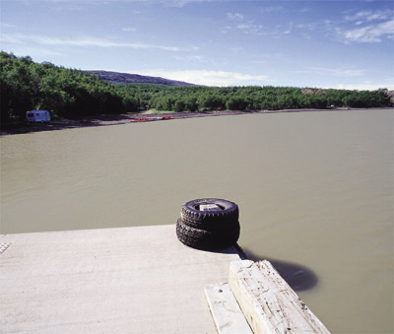
Colour change in the River Lagarfljót. A computer generated image
indicating to the left the hue before development and after it to the right.
Digital composition.
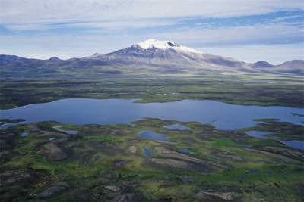 |  | 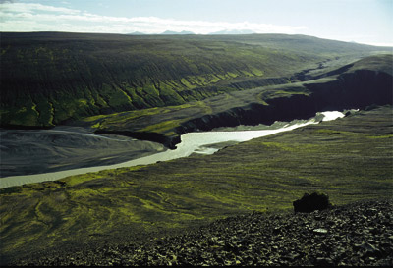
Overlooking Lake Folavatn.  Photo: Hreinn Magnússon. |  | Hnitaspordur at the lower end of the  Hafrahvammar canyon.  Photo: Ágúst Guðmundsson.
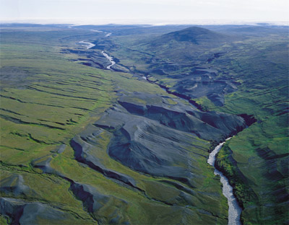 |  | 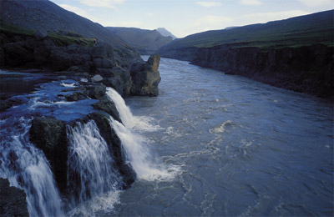
Heath habitat in the basin of the  proposed Hálslón reservoir.  Photo: Hreinn Magnússon. |  | The river Saudá flowing from the  left into the glacial river Jökulsá  á Dal.  Mynd: Hreinn Magnússon.
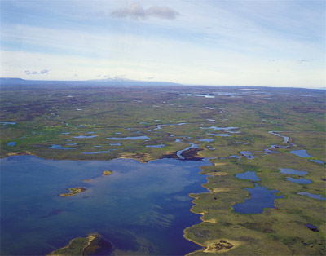 |  | 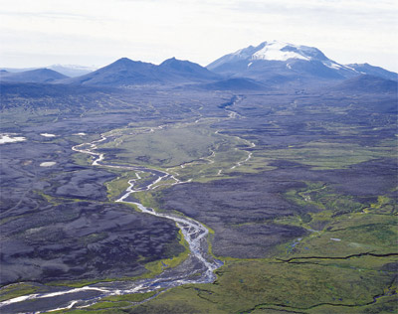
Lakes and ponds of Gilsárvötn.  Mynd: Hreinn Magnússon. |  | View over Hölkná river towards Mt.  Snæfell.  Photo: Hreinn Magnússon.
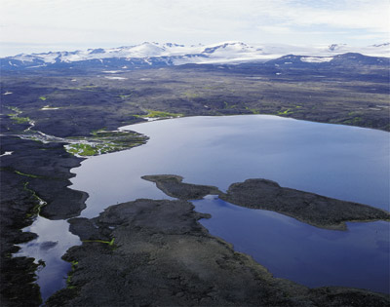 |  | 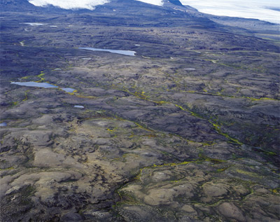
Lake Saudárvatn.  Photo: Hreinn Magnússon. |  | The uplands of Hraun.  Photo: Hreinn Magnússon.
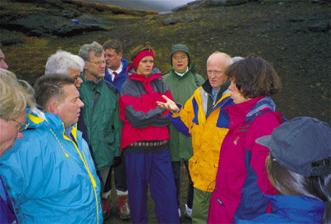 |  | 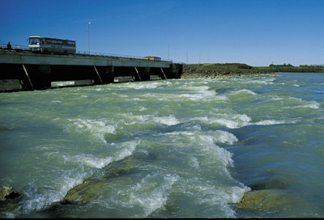
Members of Parliament visit the  proposed dam site.  Photo: Atli Rúnar Halldórsson. |  | Rapids in the river Lagarfljót.  Photo: Atli Rúnar Halldórsson.
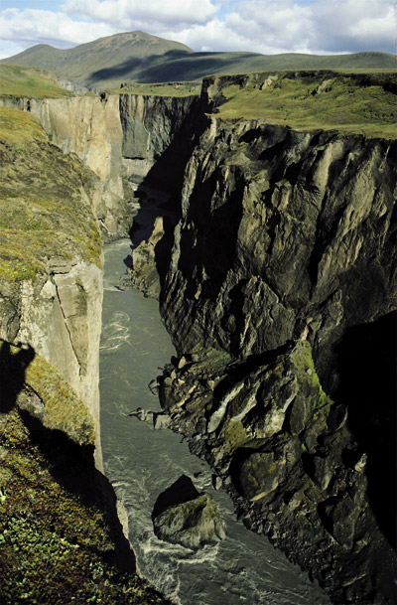 |  | 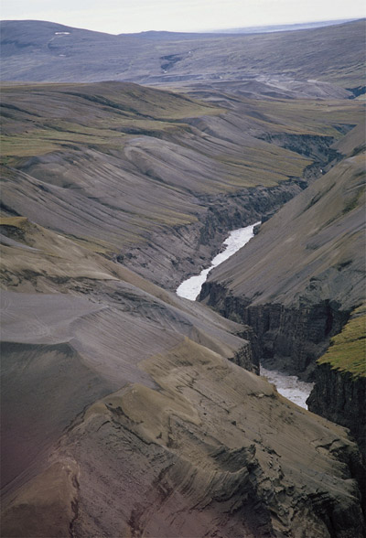
Hafrahvammar canyon.  Photo: Hreinn Magnússon. |  | Benches of sediment in the slopes  upstream from the Kárahnjúkar  mountains.  Photos: Atli Rúnar Halldórsson.
The Kárahnjúkar dam will have a maximum height of 193 m and will be constructed using 8.5 million m³ of fill materials. The Desjará dam will be 60 m in height. Read more on key figures here.
Installed capacity | 690 MW
Generating capacity | Approx. 4,600 GWh/year
Turbines | Francis, vertical axis
Number | 6
Rated discharge per unit | 24 m³/s
Rated output per unit | 115 MW
Hálslón reservoir
Area of full reservoir | 57 km²
Lenght of reservoir | 25 km
Live storage | 2,100 million m³
Reservoir full supply level (FSL) | 625 m a.s.l.
Reservoir minimum operating level (MOL) | 575 m a.s.l.
Hálslón servoir catchment area | 1,806 km²
Average inflow to Hálslón reservoir | 107 m³/s
Kárahnjúkastífla dam
Maximum dam height | 193 m
Dam length | 730 m
Fill materials | 8.5 million m³
Desjarárstífla dam
Maximum dam height | 60 m
Dam length | 1,100 m
Fill materials | 2.8 million m³
Sauðárdalsstífla dam
Maximum dam height | 25 m
Dam length | 1.100 m
Fill materials | 1.5 million m³
Ufsarlón pond
Area of full reservoir | 1 km²
Maximum water level | 625 m a.s.l.
Ufsarlón pond catchment area | 430 km²
Average inflow to Ufsarlón pond | 31 m³/s
Ufsarstífla dam
Maximum dam heigth | 37 m
Dam length | 620 m
Fill materials | 0.6 million m³
Kelduárlón reservoir
Area of full reservoir | 7.5 km²
Reservoir full supply level (FSL) | 669 m a.s.l.
Live storage | 60 million m³
Kelduárstífla dam
Maximum dam heigth | 26 m
Dam length | 1,650 m
Fill materials | 0.8 million m³
Tunnels | Approx. 72 km
Headrace from Hálslón (dia: 7.2-7.6 m) | 39.7 km
Headrace from Ufsarlón (dia: 6.5 m) | 13.3 km
3 adits to headrace (dia: 7.2-7.6 m) | 6.9 km
2 diversion tunnels and adit at dam | 2,4 km
Grouting galleries at dam | 0.5 km
Surge tunnel (dia: 4.5 m) | 1.7 km
2 diversion tunnels Hraunaveita (dia: 4.5 m) | 3.7 km
2 vertical pressure tunnels (dia: 4.0 m) | 0.8 km
Access tunnel to power station (dia: 7.5 m) | 1.0 km
Tailrace tunnel (dia: 9.0 m) | 1.3 km
Cable tunnel (dia: 4.0 m) | 1.0 km
Total head | 599 m
Rated discharge (maximum discharge) | 144 m³/s
Average discharge | 110 m³/s

Project phases and their expected starting dates:
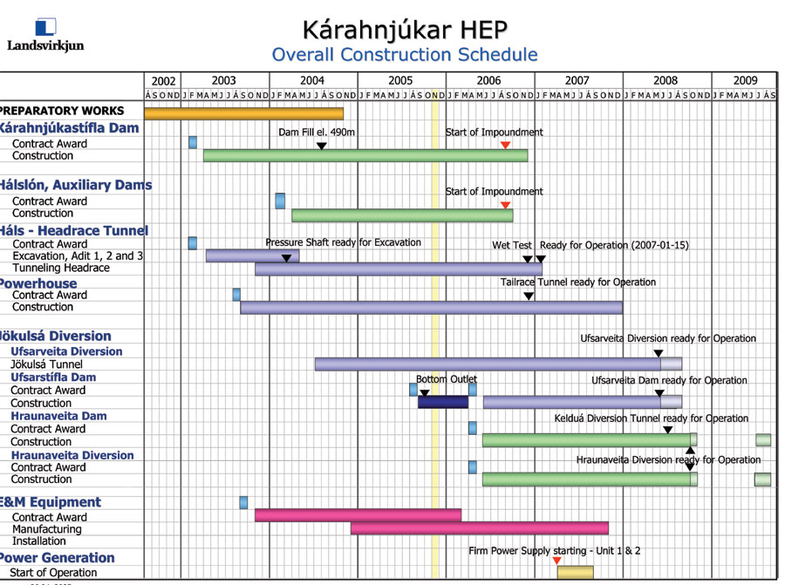
Construction: April 2003 Actual operation: April 2007
Impacts
Hydroelectric power plants always involve changes in the environment.
When rivers are dammed and their flow diverted through power-generating stations, their courses below the dams are altered and land above the dams is flooded. In addition, channels, new roads, and various other visible structures are introduced.
Regarding the proposed Kárahnjúkar Power Plant, such changes occur in drainage since the rivers Jökulsá á Dal and Jökulsá í Fljótsdal, along with a number of smaller rivers, are diverted to an underground power station uppermost in Fljótsdalur valley. From there, water runs into Jökulsá Fljótsdal and Lagarfljót. The combined water continues downstream to the current joint mouth of the main rivers at Héraðsflói bay. In addition, areas become flooded where storage reservoirs are formed. The largest is the reservoir at Hálslón below Brúarjökull, about 57 km2, similar in size to Blöndulón on Auðkúluheiði heath in North Iceland.
Due to the construction and subsequent operation of the plant, roads will need to be built and quarries will have to be dug, and excavated materials from tunnels will need to be placed in so-called spoil areas. This involves changes to the landscape, but also improved access to the area for tourists and local residents.
The assessment deals with direct effects of the proposed project on the natural and human environment. Section 9 describes impact on the natural environment - animals, plants and other aspects of the ecosystem, such as soil, the sea, freshwater and the atmosphere, impact on the human environment is discussed, i.e. on society, cultural heritage, geological formations, landscape, employment and financial worth, visual aspects and tourism. On an impact map below, presenting the major environmental influences of the proposed Kárahnjúkar plant,
Options & Alternative designs within the proposed project
A variety of alternative designs and locations for structures were studied with the intention of minimizing environmental impact. Close collaboration was maintained with the project designers, and solutions were chosen considering both environmental impact and cost. Intended quarries have been located as often as possible within proposed reservoir sites, and in road building, an effort will be made to bypass delicate areas, while construction of permanent roads in the highlands will be held to a minimum. In particular, the location of spoil areas, dams, spillways and channels was considered, and the solutions for each separate component.

The choice of variations in design is an important way to lessen impact on the environment. Alternatives to the Kárahnjúkar project

The most feasible option for providing the required electricity to a large aluminum plant in East Iceland through a single hydropower plant is without doubt harnessing the three glacial rivers of Jökulsá á Dal, Jökulsá í Fljótsdal and Jökulsá á Fjöllum, all of which originate at the north edge of Vatnajökull glacier.

The Ministry of Industry came in 1994 to the conclusion that, ahead of the river Jökulsá á Fjöllum, priority study should occur of the two rivers farther east. The reason for this was above all the negative environmental impacts that would accompany exploitation of Jökulsá á Fjöllum. Consequently, investigations of recent years have focused on Jökulsá á Dal and Jökulsá í Fljótsdal, and three main choices have come under consideration. In short, Kárahnjúkar Power Plant with a diversion from Jökulsá í Fljótsdal is the option causing least environmental disruption, while also being as economically feasible, or more so, than other alternatives.

Intentions now to build Kárahnjúkar Power Plant may be traced to the so-called
Noral declaration of 1999, which was renewed in the year 2000. This is a declaration of intent to build an aluminum plant in Reyðarfjörður that would use a great deal of electricity. Current estimates lead to requesting power of up to 6,000 GWh per year.

Various other options to generate electricity for energy-intensive industry were considered before the choice was made of continuing to prepare the Kárahnjúkar plant and assess its environmental impact. Landsvirkjun concluded it was less feasible to collect power from various plants elsewhere in the country. However, it should be pointed out in this context that detailed cost estimates, along with environmental impact assessments, have not been conducted on this hypothetical option.

Nevertheless, the conclusion was reached that the overall environmental impact would be considerable if many plants were to be built at different locations around them country, with the accompanying network of power lines.

The conclusion is drawn that the Kárahnjúkar project, with power harnessed from Jökulsá í Fljótsdal, represents the most efficient of existing options, with regard to environmental impact, cost, and projected energy needs.

The “zero” option
In discussing alternatives, the effects of not going ahead with the proposed project - “the zero option” - were also evaluated. The main impacts of this option was discussed.

Current use of the land is considered to be the baseline of comparison, but future possibilities for the highland area north of Brúarjökull are also explored. Aspects such as large-scale tourism and the establishment of a national park are examined, as well as the impact of this on the area. Unchanged land use means a larger area remains as “untouched open spaces” geographic appearance is not modified and unique geological formations are left undisturbed. This, however, means more difficult access for travel in the highlands unless measures are taken of other sorts. Among other things, there would be no connecting road over the glacial rivers, which currently are an obstacle to east-west travel. A continued decline in population may be expected in East Iceland, with associated difficulties for local settlements, unless other employment possibilities emerge in the region. In discussing the “zero option,” possibilities were examined of establishing a national park in the area, whether or not the Kárahnjúkar plant is built. If there is no development in connection with the plant, a larger area remains intact, undisturbed by man. The realisation of the project need not, however, conflict with the establishment of a national park. In many areas of the world, hydroelectric plants and national parks coexist, or the plants are part of national parks.

CONCLUSION
National and international comparisons
In a global context, the Icelandic environment is on the edge of the Arctic region. Margins are in general sensitive to disruption and variations in environmental factors. In addition, Icelandic soil is vulnerable to erosion, while volcanic ash and wind-blown material increase this vulnerability over wide areas. The highlands in the project area resemble, to a large extent, Arctic regions such as in Greenland, the northern areas of Canada and Russia, as well as some of northern Scandinavia. They all have similar vegetation with limited productivity, large rivers and a limited variety of fauna. On the other hand, Iceland is very unique in that geothermal activity is considerable and the soil and bedrock young. The two glacial rivers involved - Jökulsá á Dal and
Jökulsá í Fljótsdal - represent a significant portion of Iceland’s undeveloped glacial waterways. Their combined catchment area represents 7% of Iceland’s total watershed. The area disrupted by Kárahnjúkar Power Plant, particularly through dams, reservoirs and roads, is unique in many respects, and certain parts of it are considered to have high conservation value. The Kárahnjúkar plant will impinge upon the wilderness north of Vatnajökull, and “untouched wilderness” in Iceland and abroad has been reduced due to various man-made constructions.

Impacts and benefits
The Kárahnjúkar hydropower project will leave a lasting impression on its impact area. Changes will occur in the natural terrain and land use in areas where vegetation and fauna are sensitive. Sections 7 and 9 discuss the conservation value of various distinct locations in conjunction with this project.
A list of the main aspects of nature which will change or be lost with the establishment of the plant is as follows (see Impact Map):
Structures impinge upon undisturbed open spaces in the highlands, reducing them by 925 km2.
Changes in the landscape occur with the formation of Hálslón reservoir, covering an area of approximately 57 km2.
Valuable habitats of vegetation and small animals are lost under
Hálslón.
About 32 km2 of established vegetation is submerged by Hálslón and an additional 8 km2 disappear under other structures and storage reservoirs.
Considerable changes will occur in the flow of two large glacial rivers.
Volume increases in Lagarfljót, but average flow in Jökulsá á Dal decreases significantly.
The appearance of Hafrahvammagljúfur canyon will be modified considerably, with almost no water flow below the dam.
Other changes considered to be main environmental impacts on the Impact Map are:
Important calving and grazing grounds for part of the East Iceland reindeer stock are lost and migration routes are disturbed.
Increased blowing of dust and sand from the Hálslón shores can harm vegetation on Vesturöræfi.
The Kringilsárrani reserve is reduced by a quarter.
Important geological features are inundated and scientific investigation of them becomes difficult.
Changes will occur in the alluvial flats of Jökulsá á Dal: deposits of sediment will become somewhat vegetated and the river will be restricted to a narrower channel.
Many waterfalls, mainly in the catchment of Jökulsá í Fljótsdal, will be reduced or even disappear completely.
Sediment in Lagarfljót will increase, the river become darker in color and conditions for aquatic life deteriorate.
Some hayfields along Jökulsá í Fljótsdal and Lagarfljót will be dampened by a raised groundwater table.
The coastline of Héraðsflói will recede, but natural impact on that area is limited.
The main positive impacts and gains from the Kárahnjúkar hydropower project are in particular connected to the sale of energy to large-scale industry. The economic impact of the overall Noral project – energy production and the Reyðarál aluminium plant - has been estimated to be:
GDP increasing from 8-15,000 million ISK per year.
National export values increasing about 14%.
Increased economic activity in East Iceland.
Increased employment in the country, particularly East Iceland.
The impact area of the proposed development stretches from the Brúarjökull glacier down to the sea at Héraðsflói. On the one hand there is a sparsely vegetated highland area with broad open spaces, glacial rivers and land use limited primarily to sheep grazing and hiking. On the other hand, there is a lowland area with the main utilization being agricultural (sheep and cattle farming and forestry), along with denser centers of human settlement at Egilsstaðir and Fellabær. As in many marginal areas, centuries of grazing, especially by sheep, but later also reindeer, have had impact on highland vegetation.
The conservation value of land within the area impacted by the plant is highest in the highlands, due to their uniqueness and minimal human disturbance. For example, the conservation value of the area submerged by Hálslón is rated high on a national scale.
The appearance of the highlands changes at the river Jökulsá á Dal. West
of the river are currently barren sandy areas with isolated remnants of growth in valleys, whereas east of the watercourse there is one of the largest thoroughly vegetated areas of the highlands for altitudes 500 m above sea level. Hálslón reservoir will create a clearly defined boundary between Brúardalir on the west and Vesturöræfi on the east. According to the proposal for the project currently under discussion, an expansive, continuous undisturbed area will remain from Hálslón all the way to
Lónsöræfi east of Vatnajökull, where the only signs of man-made impact are tracks and mountain huts.
The main development will occur at the northern edge of the sector which has been mentioned as a potential national park. From Kárahnjúkar it is 10 km on the map to the nearest residence, which is Aðalból in Hrafnkelsdalur valley.
In Section 6 of this report, under discussion of public planning, it is pointed out that the current national and regional plans for the area assume utilization of the rivers Jökulsá á Dal and Jökulsá í Fljótsdal for hydropower. The planned Kárahnjúkar plant is therefore not contrary to land use envisioned in these reports. The Regional Plan for Iceland’s Central Highlands for 2015 contains the recommendation to use Hálslón as a storage reservoir for both rivers, which is precisely one main aspect of the current plan for the Kárahnjúkar plant. This avoids the need for a reservoir at Eyjabakkar, which contains important wetlands, vegetation and bird life. The Eyjabakkar wetlands can then become part of a continuous wilderness east of Hálslón, extending to Vesturöræfi, Snæfell, Eyjabakkar and Lónsöræfi. It may be emphasised that hydroelectric plants and nature conservation can go hand-in-hand if care is taken, and many examples of such coexistence are found around the world. It is clear that certain sacrifices of nature must be tolerated if plans for the power plant are realised. Effort has been made to limit negative impacts on the environment by the selection of certain design options and through other suggested mitigating measures.
Economic gains from the project have been discussed above, and, if plans for energy use in East Iceland come to fruition, this will also have a positive impact on residential trends in an area where population is decreasing and few alternatives have emerged for necessary economic development or for further strengthening of settlement. It is Landsvirkjun’s conclusion that the environmental impact of the project is within acceptable limits, in light of economic benefits which the anticipated power plant would yield to the nation, and of the development in employment associated with the sale of power. The developer therefore applies for approval of the project.

Description of any other measures not mentioned earlier to mitigate the negative impacts of the project:
A number of opinion polls have been carried out examining attitudes toward the Kárahnjúkar Hydroelectric Project. The most extensive polls have been conducted by the Institute of Social Sciences at the University of Iceland and Gallup. The Icelandic media has also carried out a number of smaller polls.
A new poll carried out by the daily newspaper Frettabladid found that more than 64% of respondents that take sides favour the construction of the Kárahnjúkar hydro station and the building of an aluminium plant in Reydarfjordur, East Iceland. These results are somewhat similar to those from previous polls examining attitudes toward the project.
The project enjoys significantly greater support outside the Reykjavik area where about 75% of those who took sides are in favour of the project in contrast to about 57.5% in Reykjavik and nearby areas. Men are more in favour of the project than women.
The question asked was: Are you in favour of or opposed to the Kárahnjúkar hydro station and the building of an aluminium plant in Reydarfjordur?
Of all the respondents 54.3% were in favour of the project, 30.2% opposed, 12.3% were undecided and 3% refused to answer. The sample consisted of 600 people and was divided evenly between genders and proportionally between constituencies.
A summary of older polls carried out to examine attitudes toward the project can be found
(Public Hearings report is Attached).
10. Measures undertaken to protect the health and safety of workers and fire prevention facilities: Landsvirkjun, the National Power Company of Iceland, lays great emphasis on ensuring staff safety and occupational health as well as keeping the environmental impact of any project undertaken by the company at minimal levels. Therefore, contractors are required to use an approved safety and environmental control system throughout the project, and to comply with Landsvirkjun's (environmental policy regarding power development ATTACHED).

DECLARATION
Hereby I, the signer, declare that the information submitted above is accurate and true and that in case there is any modification of the information stated above, the EEAA shall be informed through the Competent Administrative Authority. Hereby I declare:
Name : Dr.XXXXXXXX Identity Card number and address: Egyptian Modern Center for Environmental Consultations
Position (in the capacity of ): Egyptian Environmental Assessment.
Date: 20 December 2006.
Appendixes: - Public Hearings Report.
- Environmental Policy.
References: - http://www.karahnjukar.is/
- http://www.dams.org/

Form filled in with the knowledge of the competent administrative authority

Name: ----------------------------------------------------------------------------------------------
Professional title:----------------------------------------------------------------------------------
Signature: ------------------------------------------------------------------------------------------

Official Stamp

