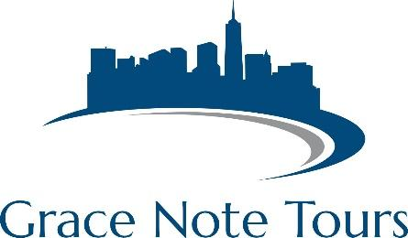

*The easiest trip-planning experience ever….guaranteed!*

**Washington DC – Sample Proposal**

**Package Inclusions:**

2 nights lodging at a 3-star accommodation

2 breakfasts

2 dinners

Admission to International Spy Museum

Tour of Smithsonian Museums

$1,000,000 tour liability insurance

1 free director package

Director Resource Binder

**Options:**

Washington Nationals Baseball

Tour of US Capitol (based on availability)

Group performance on the National Mall

Kennedy Center Performance

National Archives

Mount Vernon

Ford’s Theatre

Old Town Alexandria

Arlington National Cemetery

National Zoo

Transportation is NOT included in this proposal.

**Not what you want? Let’s customize to suit YOUR needs and educational requirements!**

**Washington DC Sample Itinerary**

**Day 1**

Arrive in DC; visit Smithsonian Museums

Check into hotel

Dinner

Performance at Kennedy Center

**Day 2**

Breakfast

International Spy Museum

Lunch

Tour of Capitol/National Archives/Library of Congress

Dinner

Nationals Baseball Game

Return to hotel

**Day 3**

Breakfast

Check out of hotel/load Bus

Group workshop or performance

Depart for home