EMERGENCY PLAN – HENDRA PONY CLUB
Chief Warden: Instructor In the event of Club house fire emergency:
Deputy Wardens: Parent(s) * Alert others in the immediate area
H&S Officer: Tina Smith * Utilise kitchen extinguisher if trained
First Aid Officers: Claire Thompson * Call Emergency Services: 000
Fiona Mamet * Evacuate the area as per assembly plan

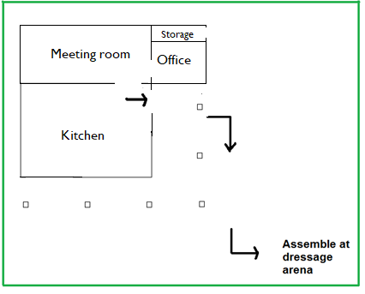
In the event of a Rider emergency:
- Alert parent, or guardian
- Call 000
- Assign an adult to accompany child
to hospital

In the event of a Horse emergency:
- Call owner, or if not available call a Club
Official for advice
- Call vet: Mark McGarry 0437 411 928
Brett Morris 0408 720 843
Manly Rd Vet 3396 9733
Samford vet 3289 1322

Club Officials: Lyndall Vaughan – 0438 678 420, Gael Gant – 0425 431 179, Terri Dillon – 0401 468 155

