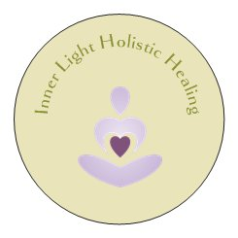
Inner Light Holistic Healing

Distant Healing Preparation

Before we start, I will need a picture of you alone. You can email this picture to me at
info@inner-light.ca .

Next is to find a comfortable space where you do not expect to be disturbed. You may light a couple of candles, have soft meditating music in the background. Whatever makes you feel comfortable. Be sure you are warm and have comfortable clothing. Remove all excess jewellery and watch.

Next is to try and have no expectations, I know sometimes easier said than done. Go into this experience with a sense of wonder and curiosity. If you find that your mind is getting in the way focus on your breathing. Taking deep breaths or repeating a mantra helps also whether it is love, peace, etc…

Each distant healing is unique. You may feel a sense of energy moving inside of you, tingling, twitching, heat or coolness. You may find yourself moving in a dreamlike meditation, thoughts and memories may come up, just put them on a cloud and watch it float away. You may become teary, let the tears flow. It is one way that the body releases stress chemicals. Blocking tears keeps the toxins inside the body. You may just fall asleep.

Just before the session is to start, I always ask three questions. Hearing and repeating these questions out loud makes it more affirmative and that you are ready.

- Do you accept this healing? Yes
- Do you accept change? Yes
- Are you willing to release things that are no longer needed? Yes

If it is of love, it is of you. If not, it does not exist. You are nothing but love and light. So be it! So be it! So be it!

Now it is time for the session to begin. You may set an alarm clock or a timer for 45 minutes. I will Skype or email shortly after the session and share what I had felt or sensed.

After the session, you may want to jot down any thoughts, ideas or sensations while they are still fresh in your mind. Be sure to drink lots of water and take notice of any changes that might incur. Needing to use the bathroom more; getting a cough or cold; feeling teary; sweating & sleeping more. These are all ways the body uses to clear toxins from its system and heal itself.

