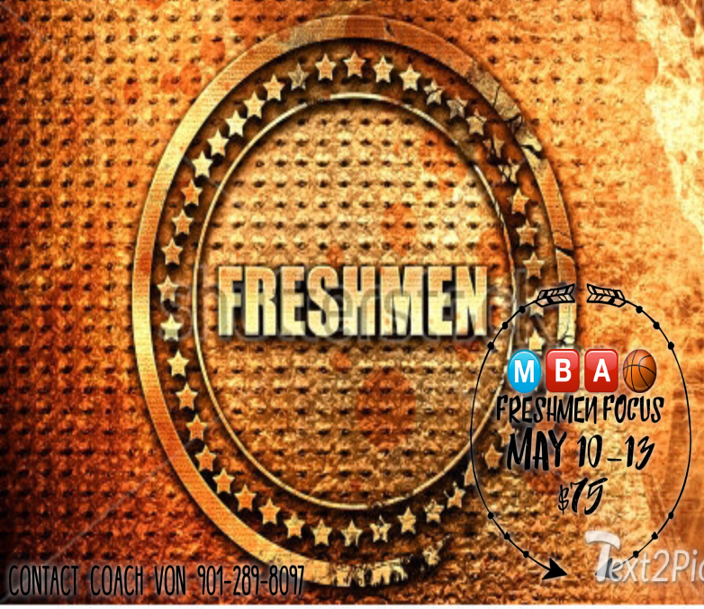

PLAYERS TO WATCH
Player’s Name | Pos. | Team
Trey Bonds | G | Team Development
Justin Borders | G | TNBC
Tamarious “T Mac” Brown | F | Team Development
Malik Moore | F | Memphis Royals
Vincent Thomas | G | Memphis Royals
Conner Gillespie | G/F | TNBC

FRESHMEN FOCUS:
SESSION 1

TEAM DEVELOPMENT: FRESHMEN FOCUS CHAMPIONS
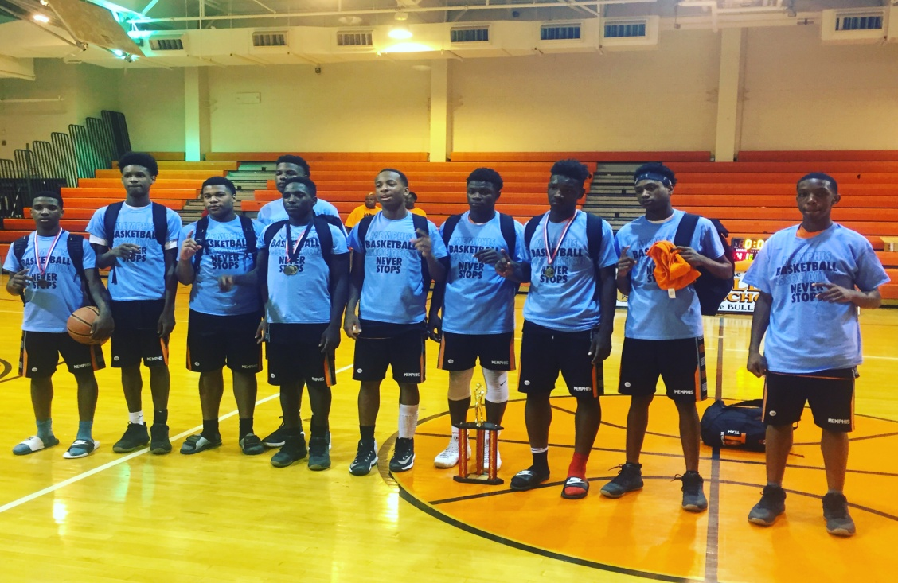
We’ve been saying it. We’ve been saying it. We’ve been saying. TEAM DEVELOPMENT is LEGIT! Strong guard play, outside shooting, aggressive defense, crashing the boards, and more heart than a cardiologist.
We first took notice of Team Development after their last game against Team Penny (the top team in the city and quite possibly the state). Development played Penny good and lead most of the game before eventually faltering and losing.
Minus a 6’5 or 6’6 big or and 6 feet lead guards Team Development has everything else it needs to compete with the big dogs.
Team Development is lead by Trey Bonds, quick & strong hard playing combo guard that can lead the team at the one and get buckets from the wing. He can shoot it from anywhere and is hard to stop from attacking the rack and finishing. His backcourt partner is Trey Warren, a solid guard that doesn’t mind getting his teammates involved but is also capable of taking and making the big shot.
Alphonso Gulledge is another important piece to Development’s roster. Gulledge is a lanky guard that is quite crafty and capable of scoring all over the court.
Their starting post players are huge reason that they are able to compete at such a high level. Tamarious Brown and Chad Brovan are beasts. Though undersized they are far from outmatched. They are physical and aggressive kids that are relentless on the boards and are able to use their strength and physicality to score in the low post.
Will Huery is a reserve big that comes off the bench and puts in good minutes. Huery has the best size of all of Development’s bigs.
But it isn’t so much the individual talents that make Development so good. It’s their aggression on defense for one. Add the fact that they play the entire game. Up or down, Team Development plays from the tip to the buzzer. And finally they can absolutely shoot the three, and at clutch moments at that.
In our opinion Team Development may be Top 5 in the area.

MEMPHIS ROYALS: FRESHMEN FOCUS RUNNERUPS
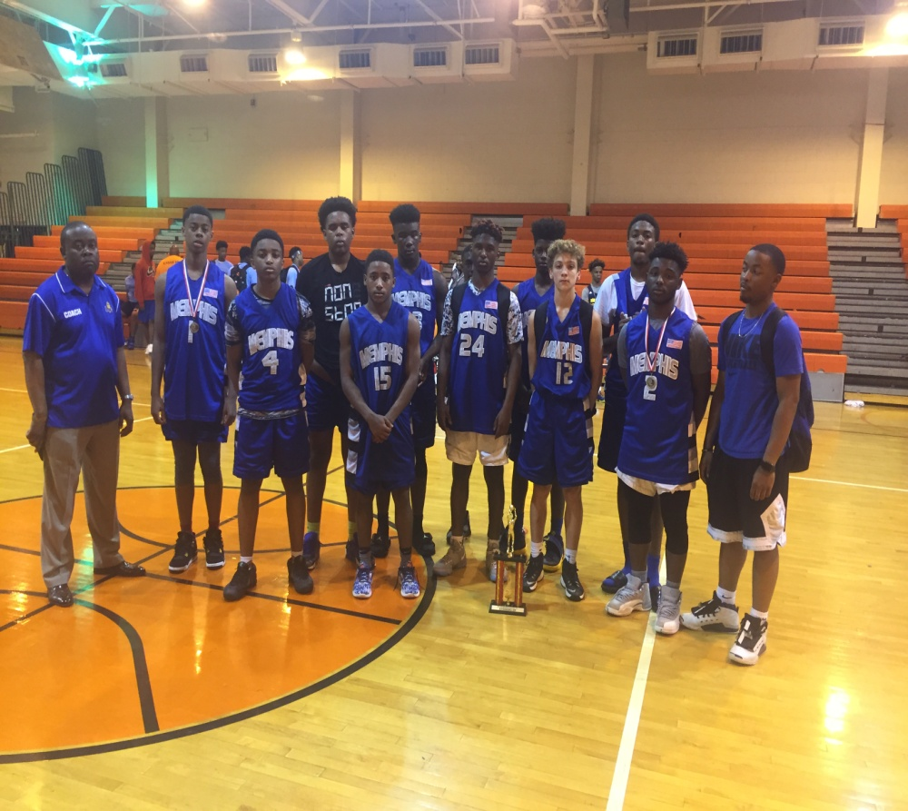
The Royals have long been a solid team in the class of 2020. Their chemistry, size, depth, and solid guard play keeps them competitive year in and year out. This year is no different. They have fielded a squad ready to take on the best in the area.
In the post they are one of the bigger teams in the area. With guys like Malik Moore, Caleb Spann, and Zion Mathis, who all stand well over six feet. Malik is a born scorer. Not only might he have the best low post moves of any player in the class but he is automatic from the free throw line, and he can step outside and shoot the three. Caleb Spann is a pure athlete, just as fast as anyone on the court, as strong as any other post player, and can jump out the gym. Zion, is yet a 3rd big, he’s a solid rebounder, shot blocker, and low post presence.
Their depth is yet another asset that most teams can’t match. The Royals are solid at every position not just in paint. On the wing they have several solid guards; Cam Holman, Torrien Stewart, Mike Neal are capable of being lead guards. Cam Holman is a two way player with a knack for scoring whether it be inside or out. Mike Neal is a long guard who can also score it from all over the court, and Torrien Stewart is a kid who can get hot from outside and absolutely light it up!
As we said it’s their solid guard play that separates them from most other teams. Point guard Morgan Edwards is one of the fiercest competitors in the class. He’s one of those smack the floor, clap in your face kinda kids that’ll lock up on defense and put buckets up on offense. Alex Marsh is another Royals guard that can flat foot play. Marsh is a sharp shooting sniper that can knock it down from deep, but is also a solid ball-handler. Vincent Thomas however is the lead scoring guard for the Royals. He’s got a super quick first step, he’s hard to guard, physically strong, and as competitive as they come. Kylan Knight is yet another guard that helps to add to the Royals’ depth. He’s a natural scorer that is deadly from outside but doesn’t shy away from getting buckets inside the arc as well.
The Memphis Royals are easily one of the top 2020 teams in the area.

TNBC (THOMPSON): FRESHMEN FOCUS FINAL FOUR
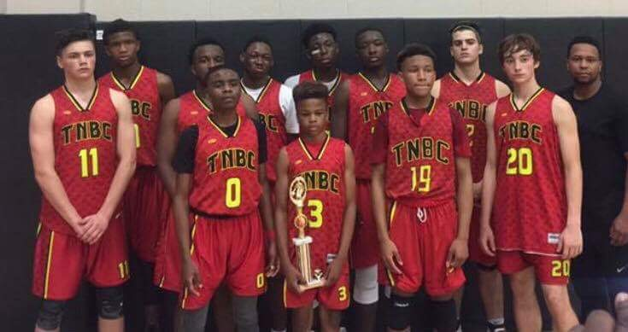
One of the most well coached teams in the city as far as 2020 is concerned, Coach T (Keenan Thompson) puts his squad in the perfect positions to succeed, all they have to do is follow his lead. Coach T gets a little (more like) a lot of help from scoring sensation Justin “JBo” Borders. Borders is a crazy-quick PG that scores and scores and scores. His hesitation moves and crossovers make him incredibly hard to guard. And he’s able to pump in the air and finish any way he needs to though contact or not.
TNBC has a solid supporting cast to go along Borders. Connor Gillespie is a sharp shooting with a nice build. Connor is very capable of knocking down trey after trey after trey.
Charlie Ealy is another wing that will assist in point production. He’s a long guard that gets out on the break and finishes well at the rim. 2021 guard Garrett Crume plays up with TNBC and gives them good minutes. He’s an athletic kid that plays hard, hustles, and defends well.
Kendrick Powell is the man in the middle. A dominating post presence, Kendrick scores well in the paint on the offense end, rebounds well, and is a capable shot blocker.
The beauty of TNBC (Thompson) is the system. Coach T orchestrates it, the kids execute it, and they have been ultra successful. We expect for their success to continue.
On another note we want to wish K’Juan Banks a speedy recovery.

FRESHMEN FOCUS: ALL-TOURNAMENT TEAM
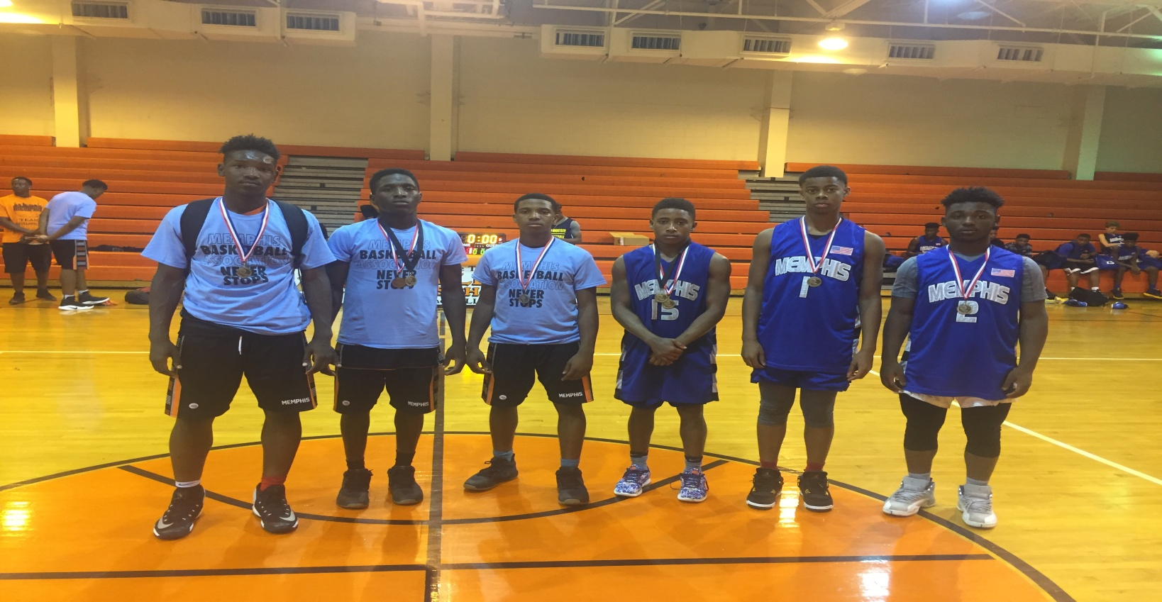
Pictured from Left to right; Tamarious Brown (Team Development), Trey Bonds (Team Development), Clint Warren (Team Development), Vincent Thomas (Memphis Royals), Torrien Stewart (Memphis Royals), & Kylan Knight (Memphis Royals).

