Introduction to Crystal Therapy Course
Journal
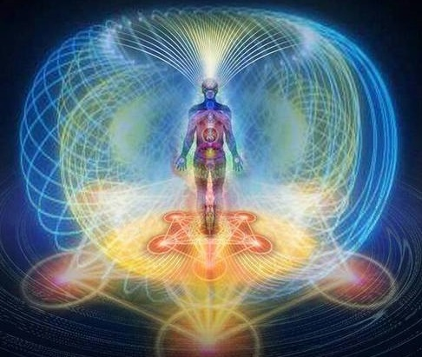
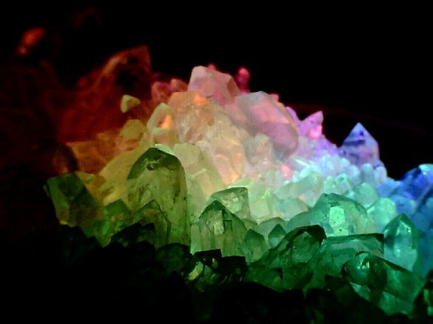

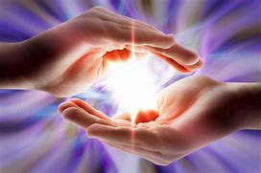

Write down your intention for completing the course, along with a personal affirmation to use throughout the program. For example: “My intention is to learn about crystals to assist my spiritual practice.” A sample affirmation could be: I am receiving crystal clear insight to help me live my best life.

Intention:
__________________________________________________________________
____________________________________________________________________________________
____________________________________________________________________________________
____________________________________________________________________________________
____________________________________________________________________________________
____________________________________________________________________________________
____________________________________________________________________________________

Affirmation:
__________________________________________________________________
____________________________________________________________________________________
____________________________________________________________________________________
____________________________________________________________________________________
____________________________________________________________________________________
____________________________________________________________________________________

As you move through the course, repeat your intention and affirmation daily; each time you do so, you are activating your crystal consciousness and expanding your energies.
Sacred geometry describes the building blocks of nature–the patterns, shapes, and forms that are part of the makeup of all living things. It is the system of universal design in which the energy of creation organizes itself into form. The Platonic solids were known to the ancient Greeks, and described by Plato in his dialogues Timaeus and Critias, which were written approximately 350 B.C. Let your curiosity guide you to find sacred shapes. Where did you see the Platonic solids today and which shape(s) did you match? The magical realm of sacred geometry expresses itself in the beautiful creation of crystals, snowflakes, and flowers and throughout the expansive tapestry of the universe.
1. __________________________________________ ____________________________________________
2. __________________________________________ ____________________________________________
3. __________________________________________ ____________________________________________
4 __________________________________________ ____________________________________________
5. __________________________________________ ____________________________________________

Today, select a personal quartz crystal or other stone to work with for the week. Why were you drawn to this crystal—shape, color, texture, or.? _____________________________________________________________________________________________________________________________________________________________________________________________________ ______________________________________________________________________________________________________________________________________________________________________________________________________ ______________________________________________________________________________________________________________________________________________________________________________________________________ ______________________________________________________________________________________________________________________________________________________________________________________________________ ______________________________________________________________________________________________________________________________________________________________________________________________________

Name three ways to cleanse crystals:
1. ________________________________________________________________ ____________________________________________________________________________________________________________________________________ 2. ________________________________________________________________ ____________________________________________________________________________________________________________________________________
3. ________________________________________________________________ ____________________________________________________________________________________________________________________________________

Select one option and practice clearing your quartz crystal or personal stone.

How will you program (set the intention) to work with your crystal? Will it be to send or receive energy? Why? ______________________________________________________________________________________________________________________________________________________________________________________________________ ______________________________________________________________________________________________________________________________________________________________________________________________________ ______________________________________________________________________________________________________________________________________________________________________________________________________ ______________________________________________________________________________________________________________________________________________________________________________________________________ ______________________________________________________________________________________________________________________________________________________________________________________________________ ______________________________________________________________________________________________________________________________________________________________________________________________________
When do you recharge a crystal? How do you do so? ______________________________________________________________________________________________________________________________________________________________________________________________________
__________________________________________________________________
__________________________________________________________________
__________________________________________________________________

How will you program (set the intention) to work with your crystal? Will it be to send or receive energy? Why? ______________________________________________________________________________________________________________________________________________________________________________________________________ ______________________________________________________________________________________________________________________________________________________________________________________________________ ______________________________________________________________________________________________________________________________________________________________________________________________________ ______________________________________________________________________________________________________________________________________________________________________________________________________ ______________________________________________________________________________________________________________________________________________________________________________________________________ ______________________________________________________________________________________________________________________________________________________________________________________________________

When do you recharge a crystal? How do you do so? ______________________________________________________________________________________________________________________________________________________________________________________________________ ____________________________________________________________________________________________________________________________________ __________________________________________________________________ ____________________________________________________________________________________________________________________________________

Crystal Meditation 1. Create a sacred space for your crystal meditation. It is a special space: u Free of electronics and daily distractions; u With elements of nature; and u Where you can relax in peace without interruptions. 2. Set your intention, and write down a question for contemplation. 3. Select your meditation crystal. 4. Meditate for 15–30 minutes, holding the crystal in your receiving (nondominant) hand to amplify the energy of your intention. 5. When your meditation is complete, write about your experience and the insights you received. ______________________________________________________________________________________________________________________________________________________________________________________________________ ______________________________________________________________________________________________________________________________________________________________________________________________________ ______________________________________________________________________________________________________________________________________________________________________________________________________ ______________________________________________________________________________________________________________________________________________________________________________________________________ ______________________________________________________________________________________________________________________________________________________________________________________________________ ______________________________________________________________________________________________________________________________________________________________________________________________________ __________________________________________________________________

