Trinity Times

Volume 9, Issue 7/8
July & August 2021

I am thrilled and excited to be starting a new journey with the wonderful people of Trinity and New Chapel UMC. I am told that both churches pride themselves in getting things done.
I look forward to working with both congregations to fulfill the calling that God is leading you to. In the coming weeks I hope to be meeting with church leaders and members to discuss your visions and hopes for the future. I will be happy to meet with you both privately and collectively. I know that working together we can get things done.
Recently Pastor Steve May sent fellow Pastors his thoughts on Getting Things Done, he based his reflections on Psalm 90:12 which asks God to, "Teach us to make the most of our time, so that we may grow in wisdom." Each day for me is a challenge to be more productive in my personal as well as well as spiritual life. I found these reminders to be helpful to me and I hope they will be helpful to you as well.
Steve wrote:
Three things I've noticed about productive people.
1. They're protective of their time. They don't waste their time and they don't let others waste their time. They tend to ask themselves, "Is this the best thing I can be doing at this moment?"
2. They know how to say to no. Productive people spend most of their time doing things that take them in the direction of their goals. They know how to make the distinction between a good use of their time and the best use of their time. Productive people know that their time and strength and resources are limited. You can't do everything that everyone else wants you to do; you can

only do what God has called you to do. It's important to know how to say, "no."
3. They limit the number of projects they pursue. I've never met a truly successful person who was spread too thin. They tend to dig deep, not wide. Productive people invest more of their time in fewer projects. The result is that they get more done.
Some people I've known who were supposedly good with managing time were, in fact, abrupt and impatient, always with the impression that you're imposing. It doesn't have to be that way.
Effective time management doesn't mean that you're always in a hurry. It means that you're always focused on doing what matters. This includes, sometimes, just hanging out with your kids and doing nothing. It includes, sometimes, swapping stories with co-workers and employees. It includes, sometimes, sitting in a park and just thinking about what's happening in your life.
William Penn said, "Time is what we want most, but what we use worst." Using time well is a lifelong pursuit, a never-ending process of weeding and pruning.
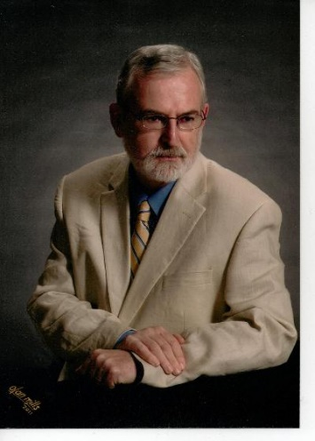
May your use of today bring God glory and lead you closer to him. [SM]
For any needs you may have or to schedule an appointment you may call the church office or reach me on my cell phone at 803-543-0082.

In Christ,
Pastor Doug
Pastor Douglas Benton

Trinity United Methodist Church

1160 Trinity Church Road
Newberry, SC 29108
803-276-1245 Office
www.trinityumcnewberry.net

Pastor Douglas Benton
803-543-0082 Pastor Cell
dobenton@umcsc.org

www.trinityumcnewberry.net
PLEASE VISIT OUR WEBSITE
AS OFTEN AS YOU CAN!

Peggy Bogart, Church Secretary
Head Usher: Harry Longshore
Choir Director: Jane Pollard
Organist: Eddie Welborn
Substitute Organist: Phyllis Sanders
Video Board: Josh Pitts, Caroline Senn,
Foster Senn, Bryan Waldrop
Acolytes/Cross Bearers Coordinator: Eli Martin
Newsletter Editor: Harriet Stevenson
GREETERS, ACOLYTES, USHERS, AND SCRIPTURE READERS NEEDED!!!

Now that we are almost back to normal worship we would like to have our church servants helping us with the services again. That means we need greeters, acolytes, ushers to collect offering and scripture readers. Please let Pastor Doug or Phyllis Sanders, Chairperson of Worship, know if you would be willing to help. Thank you so much!

We are a caring church and want to share your concerns. Let us know if you or someone you know would like to share a prayer request with us. We will be happy to pray for you. Contact Peggy Bogart, Church Secretary, or Harriet Stevenson, Communications Chairperson, to add or remove names from the Church Prayer List.

Nursing Home: Gloria Brehmer (new resident of Springfield Place)
Trinity Member Prayers: Robert Pollard (recent hospitalization), Mary Forrest (car accident), Shirley Berry (recent fall), Wayne Black (recent hospitalization), Frieda Kesler (back surgery), Ashley Wilson (recent hospitalization)
Family and friends of Trinity: Phillip Sanders, Blake Hendrix, Wilson Bowles, Charlotte Berry, Sal Welborn (White Oak – surgery), Megan Wainwright, Diane Merchant (White Oak), Neil Thomas, Francis Leopard, Harriet Connelly, Ricky Dorman

We have made some changes to our website. Go to www.newberryumcnewberry.net and let us know what you think. We have added the weekly bulletin and info about VBS.

There will be a VERY IMPORTANT meeting of all VBS volunteers on Thursday, July 8, at 10:00 a.m. in the Fellowship Hall. If you are helping or would like to help with VBS, PLEASE be at this IMPORTANT MEETING to discuss roles and responsibilities and to give input. Thanks so much! Trinity has awesome volunteers! Call Harriet at 276-3602 to RSVP.

4 – C. J. Griffen
4 – James Marion Pitts 1 – Linda Lominack
7 – Denise Pitts 1 – Tony Pitts
8 – Taylor Bouknight 2 – Linda Rowe
9 – Dale Longshore 4 – Harry Longshore
12 – Austin Pollard 7 – Johnnie Pitts
14 – Hagen Waldrop 11 – Kelly Morris
14 – Matthew Pollard 16 – Mary Forrest
18 – William Johnson 20 – Sharon Senn
29 – Alice Longshore 24 – Shelbie Johnson
30 – Beverly Pitts

CHURCH MEMBERS IN THE NEWS
Leah Longshore Caldwell was recently announced as the 2020-21 award winner of the J. L. Geddis Staff Excellence Award in recognition of her contributions to Spartanburg Methodist College. She is the Director of Alumni Relations at SMC. Leah is a member of Trinity and is the daughter of Susan Longshore.
Michael Bouknight, a CT/X-ray Tech at Newberry County Memorial Hospital was recently highlighted in their Get to Know the Face Behind the Mask and was commended for the role he plays in keeping our community safe and healthy. Congratulations!
Who is that MASKED man?

BACK TO SCHOOL BLESSING – August 15

Students, teachers, faculty, administrators, and all others involved in the education of our children are invited to attend the 11:00 a.m. service and receive a blessing for a successful 2021-2022 school year. Bring backpacks or mobile devices for blessing..

So Proud of our Trinity Boys!

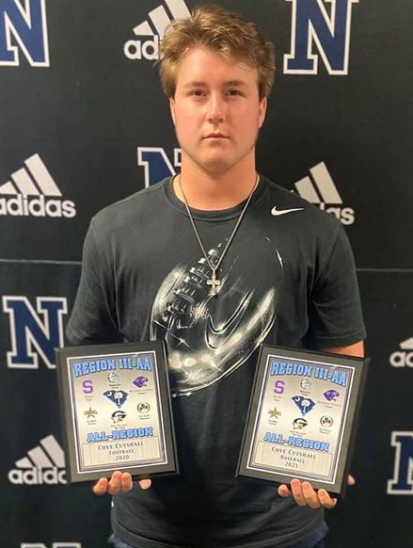
Coye Cutshall
All Region Football &
Baseball NHS
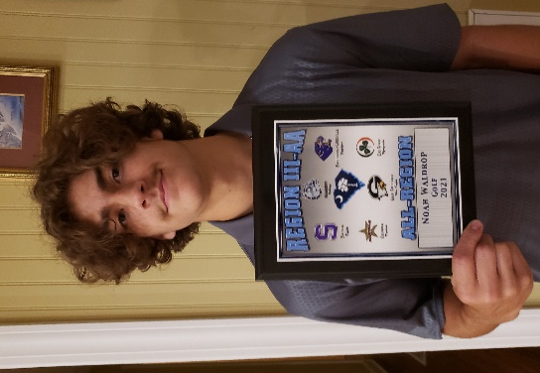
Noah Waldrop
All Region Golf NHS

Wyatt Wilson
MVP Shotgun Team
Newberry Academy

Servant Saturday at Trinity –
We had many servants of God
who came out on May 7 and
helped clean up and beauify
Trinity. Thank you so much!
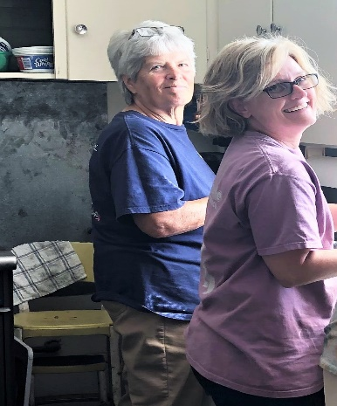
Myrtle, Sylvia, and Holly
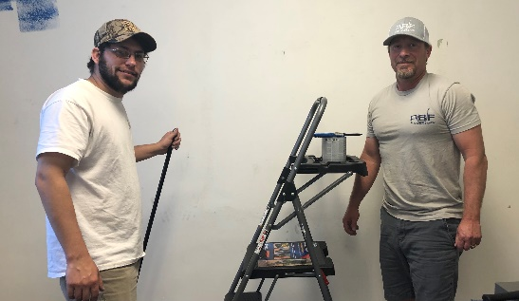
Michael and Bryant
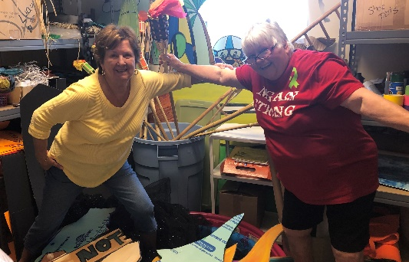
Phyllis and Clarissa
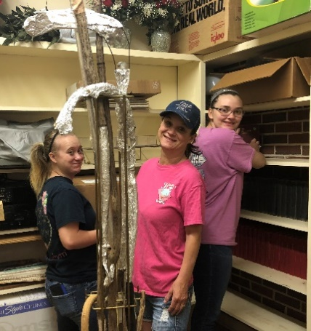
Taylor, Bridget
and Shelbie

Harriet and David
Hendrix also helped.
Thank you, Harriet,
for organizing this
Spring Cleanup!

BARNYARD ROUNDUP
Jesus Gathers Us Together
July 20th & 21st 9:00 AM – 1:00 PM
July 21st – Closing Program and Family Cookout 6:30 p.m.
Psalm 23 ”The Lord is my shepherd; I shall not want.” Psalm 23:1
Mark your calendars for this very exciting 2 days of fun, Bible stories, music, crafts, games, snacks, and lunch. Registration forms are available in the narthex of the church and online at myvbs.org/trinitybarnyard. Pre-registration is encouraged to help us in ordering crafts and for a smooth registration the first day of VBS. Please try to turn in registration forms by Wednesday, July14.
VBS 2021 is “Farm-tastic!”

ITEMS NEEDED FOR VBS

John Deere or other large farm toys for props.

Kid-friendly small animals that you can
bring by for kids to pet – rabbits, baby ducks, baby chicks, hamsters, baby calves, kittens, puppies, etc.

A tractor or other farm equipment we can borrow for a week or so to go in front of the church to put VBS sign on and attract attention.

If you have any of these items or you have questions, contact our VBS Coordinators: Betsy Black, Clarissa Hendrix, Phyllis Sanders and Harriet Stevenson

LEARN ABOUT JESUS!

GAMES in the PASTURE
at the FUNNY FARM!

MUSIC in the BARNYARD
PRAISE ROOM!

MAKE CRAFTS!

FUNNY SKITS at the
MOO-tiful Theatre!

LIVE ANIMALS (hopefully)

BIBLE STORIES AT THE
HOG HEAVEN LIBRARY!

SNACKS & LUNCH at the
OINK-OINK DINER!

SENN FREIGHT LINES, TRINITY MENS CLUB AND TRINITY WOMENS CLUB WILL PROVIDE LUNCH AND THE WEDNESDAY EVENING COOKOUT!
Meet our newest Trinity Member:
Jed Daniel Brehmer,
son of Lance and Kaitlyn Brehmer
brother of Mia Kate Brehmer
Baptized on May 16, 2021

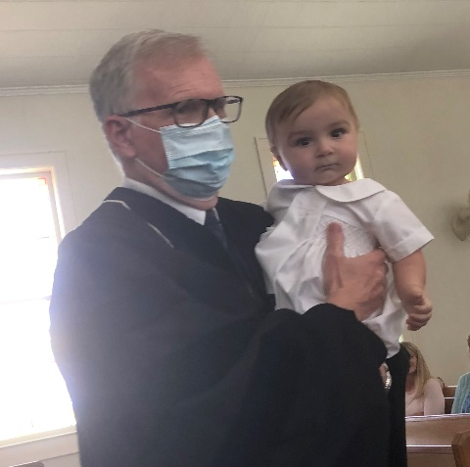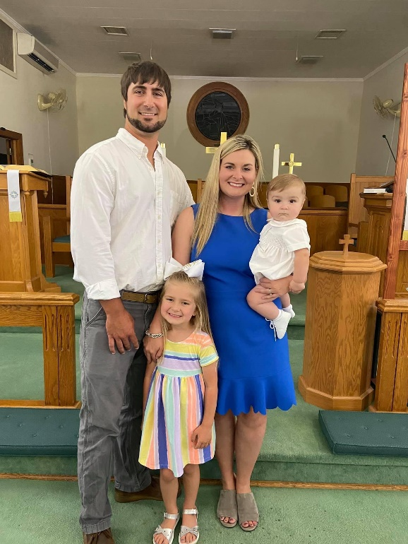
Lance, Kaitlyn, Jed and Mia Kate.

Dear Trinity Friends,
We appreciate the “shower” of cards.
my mother, Shirley Berry, received for
her 98th birthday. Some came by mail
and some by special delivery. She has
read all of the cards and reread most
of them. She always enjoys receiving
cards and reading them multiple times.
We are so fortunate and thankful to
have her with us on her 98th birthday.
She has so many fond memories of the
people and events at Trinity. Thank
you all for your thoughtfulness.
Sally B. Hillman
MYF Leaders - Josh and Erin Pitts

MYF is planning a trip to Carowinds one Saturday in July. You will be hearing more about this in the near future. Summer is a busy time and we have to work around vacations but it is in the works. We will also meet one Sunday in July for a movie night at the church. Dates and times will be announced in church and you will also be notified in advance. Hope to see you in church and have a great summer!
It is with deep sympathy that we announce the
passing of one of our former pastors, Rev. David Templeton, on June 26, 2021, at the Abbeville Nursing Home. Much love is extended to his family. Blythe Funeral Home, Greenwood, is in charge.

July 3 – Boston Butt and Turkey Hash Fundraiser – Pick up Noon – 4:00 p.m.
July 8 – Meeting of all VBS Volunteers in Fellowship Hall – 10:00 a.m.
July 12 – Administrative Council – 6:30 p.m. – Fellowship Hall
July 20-21 – Vacation Bible School – 9:00 a.m. – 1:00 p.m.
July 21 – VBS Program and Family Cookout – 6:30 p.m.
August 2 – Trinity Women’s Club Meeting – 6:00 p.m. – Fellowship Hall
August 4 - Trinity Men’s Club Meeting – Fellowship Hall
August 9 – Administrative Council – 6:30 p.m. – Fellowship Hall
August 15 – Back to School Blessing – during 11:00 a.m. service

GETTING TO KNOW PASTOR DOUG

Birthday: Doug: November 21 Carrie: January 9(fiancée)
Favorite Food: Bar B Que
Favorite Dessert: Ice Cream
Sweet or Unsweet Tea: Unsweet
Regular or Diet Soda: Diet
Favorite Bible Verse: Romans 12: 3-21
Favorite Book of Bible: Proverbs
Favorite Hymm: Amazing Grace
Last Book You Read: Leadership in Turbulent Times by Doris K. Goodwin
States Travelled: 48
Favorite Vacation Spot: Grand Teton’s
Favorite Hobby: Photography
Carolina, Clemson
Or Other Alabama – Roll Tide

Trinity United Methodist Church
1160 Trinity Church Road
Newberry, SC 29108

