

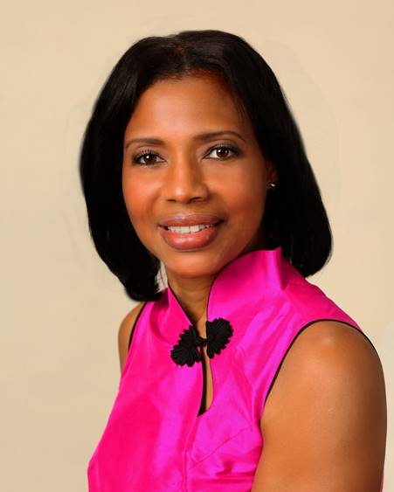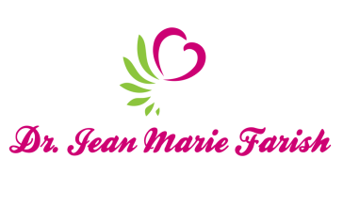

LOVE LIGHT NewsLetter

***I am excited to host my VoiceAmerica Empowerment Show-LOVE LIGHT with amazing Guests to cultivate a lifestyle of love and wholehearted connections through worthiness. My show is aligned with my mission to live an altruistic and heart centered life.***

**MEET LOVE LIGHT GUEST**

**DAVID ORTEGA BECERRIL**

**Molecular Biomedicine Specialist**

**Founder and Director, GEN-ES MX**

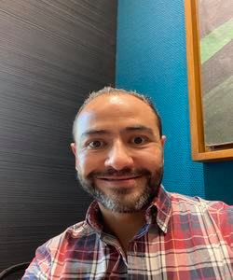

**April 3, 2020**

***Your Heart Connection: A Doorway to Holistic Living***

**ABOUT David Ortega Becerril**

**David Ortega Becerril’s vision is “*Cultivate* *in* *people* *an* *independence* *culture* *to* *Master* *their* *integral* *Health,* *helping* *them* *to* *create* *a* *more* *conscious,* *pleasant*, *mindful* *and* *heightened* *life* *experience!***

**He has18 years of teaching and training in different platforms mainly College Education for Nutrition, Medicine and Biology related career areas, and course creator for Universities. He has 11 years of Project Manager Experience at Pharmaceutical Companies, training physicians in protocol knowledge of multiple therapeutic areas and trainer of staff. He has 3 years of experience as an Entrepreneur and Founder of a Health & Science Wellness Company, *GEN*-*ES* *MX*, which encompasses five core areas of health with a strong science approach: Nutrition, Exercise & Metabolism, Emotional Resilience, Financial Wellness and Trainer of High Performance Habits.**

**His education includes Postgraduate studies in Epigenetics of Obesity, Masters in Molecular Biomedicine and Biomedical Engineer, Pharmaceutical Administration Diploma, Project Management Diploma and High Performance Coaching.**

**Website:** [**www.davidortegab.com**](http://www.davidortegab.com)

**M. Sc. David Ortega Becerril**

**Molecular Biomedicine Specialist**

**Founder and Director**

**GEN-ES MX**

***“An empowered self is a loving self, and keep your love light shining.”***