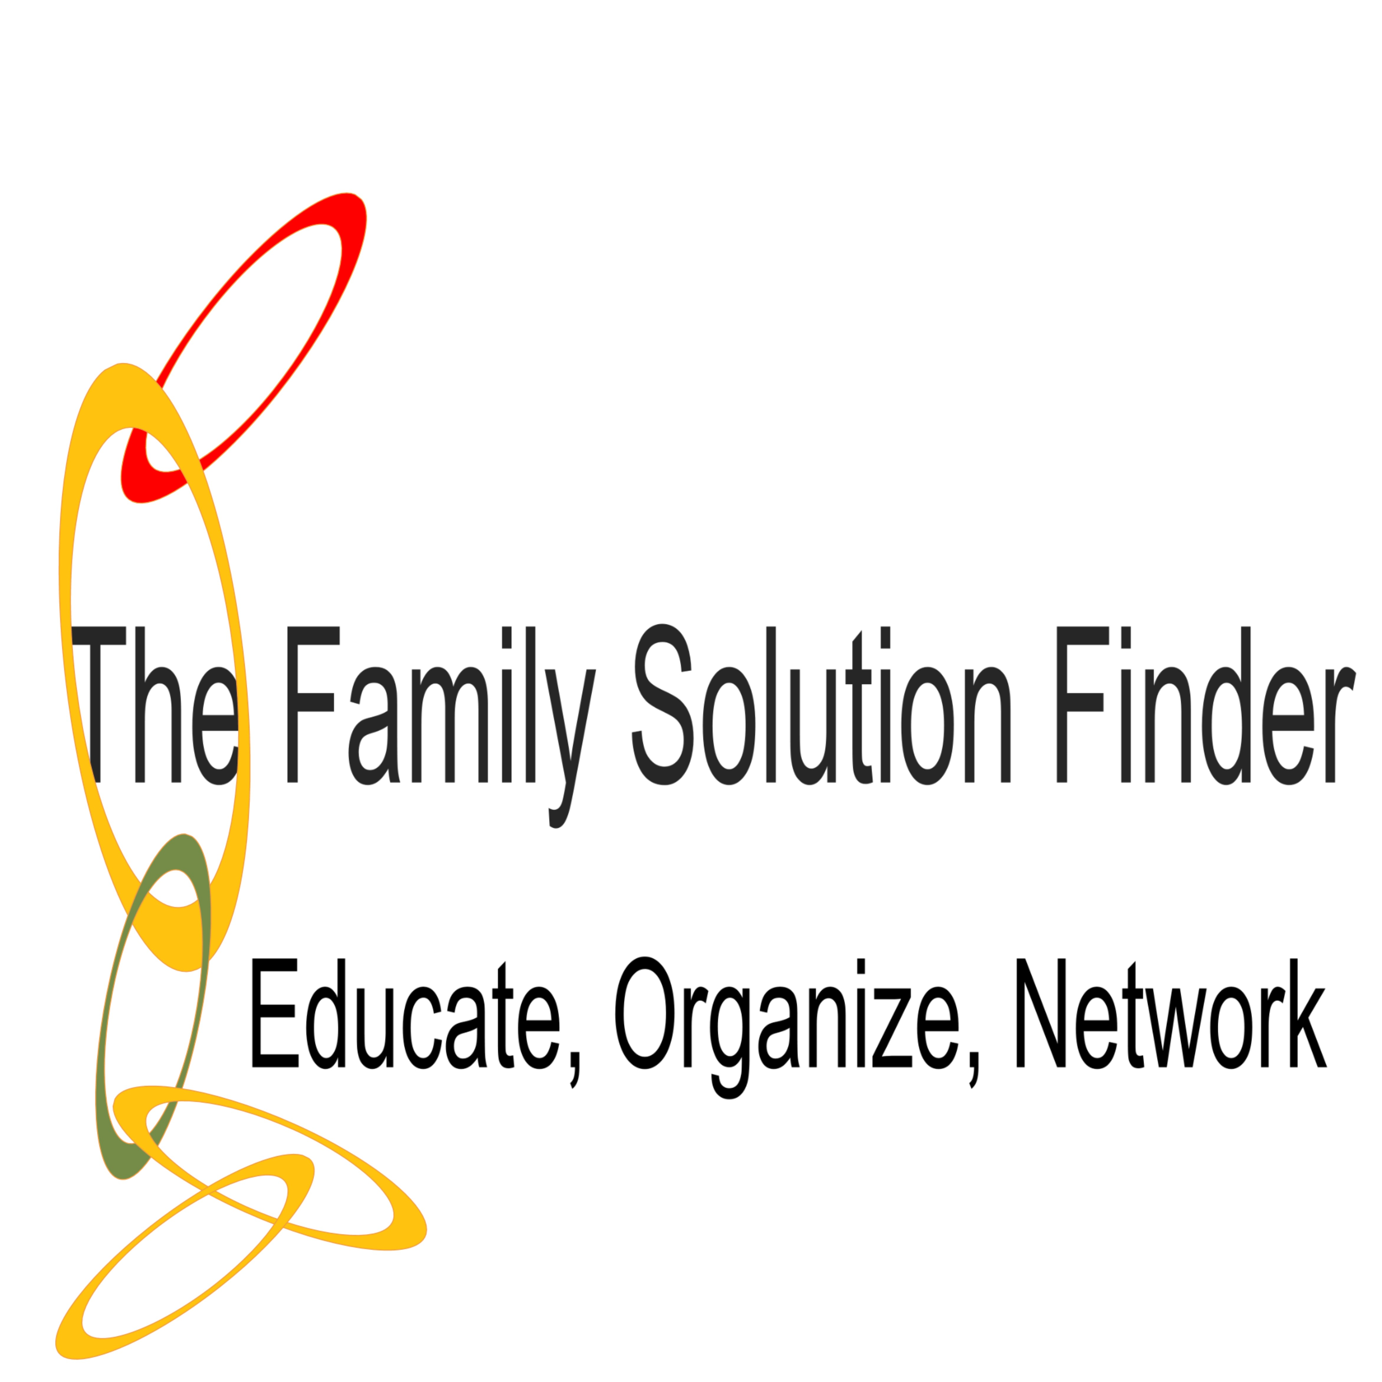

LEARNING MODULE I-IV

Enabling vs. Consequences
Location: Address or Room Number
Date: Date
Point of Contact: Name(s) number or email address.
Time: Time
- Week One Meeting:
Family Solution Finder Learning Series, Study Guidebook Seminar # 10 Enabling vs Consequences.
Seminar # 10 Power Point Presentation (download) Enabling vs Consequences.
- Week Two Meeting:
Invited local professional speaker, (topic: Enabling in SUD’s)
Family Solution Finder Learning Series, Workbook Seminar # 10 Enabling vs Consequences. (Apply lesson to the family life situations).

- Week Three Meeting
The Family Solution Finder Learning Series, Family Coping Skill Set, The 3-D’s Workbook, Seminar # 10 Enabling vs Consequences.
- Week Four Meeting
The Family Solution Finder Learning Series, Resource Connections workbook, Seminar #10 Enabling vs Consequences.

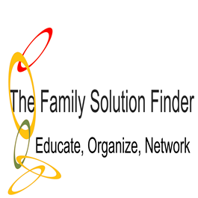

LEARNING MODULE I

MEETING AGENDA

Week One Meeting Seminar # 10 Enabling vs Consequences

  - Pre-Meeting Reading Assignment Family Solution Finder Learning Series review “Study Guidebook”, Seminar #10 Enabling vs Consequences.
  - Presentation Power Point Seminar #10 Enabling vs Consequences, be sure to click the “enable content” button on the power point screen to load the video.
  - Open support group discussions

Learn about the issue

LEARNING MODULE II

MEETING AGENDA

Week Two Meeting Seminar # 10

Enabling vs Consequences

  - Pre-Meeting Reading Assignment Family Solution Finder Learning Series review “Workbook”, Seminar #10 Enabling vs Consequences.
  - Invited profession speaker with Q&A,
  - Complete Practical Life Exercise in worksheet Seminar #10 Enabling vs Consequences.
  - Open Support Group Discussion

Apply the issue to a real-life family situation

LEARNING MODULE III

MEETING AGENDA

Week Three Meeting Seminar # 10

Enabling vs Consequences

  - Pre-Meeting Reading Assignment Family Solution Finder Learning Series review “Family Coping Skill Set” Workbook, Seminar #10 Enabling vs Consequences.
  - Invited Personal Testimony, with Q&A (optional)
  - Complete F.T.R. in worksheet for Seminar #10 Enabling vs Consequences. Determine the solution.
  - Complete Value Based Family Decision Making Model in Family Coping Skills worksheet for Seminar #10 Enabling vs Consequences. Develop a family decision.
  - Complete Family Plan of Action in Family Coping Skills worksheet for Seminar #10 Enabling vs Consequences. Design a family plan of action.
The above 3-D’s:
Determine the solution
Develop a family decision
Design a family plan of action

LEARNING MODULE IV

MEETING AGENDA

Week Four Meeting Seminar # 10

Enabling vs Consequences

  - Pre-Meeting Reading Assignment Family Solution Finder Learning Series review “Resource Connections Workbook”, Seminar #10 Enabling vs Consequences.
  - Invited profession speaker with Q&A,
  - Complete Practical Life Exercise in worksheet Seminar #10 Enabling vs Consequences.
  - Open Support Group Discussion

Find a local provider to assist the family with this issue.

