PROFESSIONAL BIOGRAPHY OF FLOYD A. KEITH

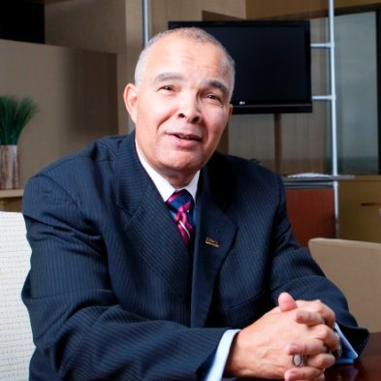

Floyd Keith has accumulated 50 years of service and expertise in both the sports and business professions; with 29 of those years in high level management. He is currently the CEO of PPA (Planned Positive Attitude) Professional Services which provides services in professional development, diversity and inclusion and motivational speaking.
Mr. Keith served as a sales manager for the Indianapolis Marriott East for 2 years (2018-2020) until the tragic onset of the Covid 19 pandemic which forced the furloughing of most hospitality staffing throughout the country. During that short span of time, as the sales manager for the social, minority, education, religion, and fraternal markets, he accomplished the following for the Indianapolis Marriott East:
- Negotiated 6,804 contracted sleeping room nights
- Negotiated $862,291 in contracted room revenue via 32 signed contracts
- Negotiated $321,933 in contracted food and beverage minimums via 32 signed contracts
Floyd served 12 years as the Executive Director of the Black Coaches and Administrators from 2001-2013. Prior to BCA, he coached collegiate football for 30 years on the Division 1 level .
Floyd was appointed Executive Director of the BCA in 2001. During his tenure, the BCA reinforced its position as the preeminent force for the social consciousness of ethnicity in American sports while increasing its membership from 172 to over 5,500. The number of corporate sponsors grew from 1 to a high of 26 in 2011.
From 2002-2006, Floyd led the contractual negotiations for the securing of event promoters for 8 BCA Invitational and Classic pre-season basketball events and 5 pre-season exempt football events. Under his leadership, the BCA exceeded the $1M mark in fund raising on 4 occasions.
Keith conducted collaborative diversity and inclusion efforts known as “Equity in Hiring Summits” ” from 2002 to 2005 dedicated to the resolution of the inequities in the hiring of ethnic minorities for head coaching and administrative athletic positions on the intercollegiate level. The nationally acclaimed BCA “Hiring Report Card” was a direct result of these summits. Under Floyd’s leadership, the BCA objectively influenced the way intercollegiate searches are conducted in America. Since the initial 2003 BCA report for football, there has been a 600% increase in the number of FBS head football coaches.
Floyd is nationally recognized for the development of the NCAA-BCA “Achieving Coaching Excellence Program” for collegiate basketball coaches. ACE was a collaborative professional development program possible through a matching grant from the NCAA and designed for the advancement of minority basketball coaches to become head coaches. Of 164 past participants during his tenure with BCA, over 50 head coaching positions resulted.
Floyd has received numerous national honors. In 2004, Sports Illustrated recognized him as one of “The 101 Most Influential Minorities in Sports”. Black Enterprise listed him as one of the “50 Most Powerful Blacks in Sports” in 2005. The All-American Football Foundation honored him as the 2004 Executive Director of the Year. Mr. Keith served six years (2005-2012) on the “Honors Court of the National Football Foundation and College Football Hall of Fame”. In 2013, he was recognized by the Rainbow/Push Coalition with the “2013 Trailblazer In Sports” award. Most recently, Floyd was recognized as a recipient of the distinguished “2021 NCAA Legacy Award” for his career achievements in coaching, diversity and inclusion and community service.
His coaching honors are many. Included, are 8 NCAA and AFCA appointments, 3 presidential positions and 2 conference chairmanships. He has been named conference “Coach of the Year” on 3 separate occasions, including the “1995 New England Coach of the Year in Division 1 Football”. The National Consortium for Academics and Sports awarded him the “2007 Giant Steps Award for Coaching”. The All-American Football Foundation honored him in 2005 with the Johnny Vaught Outstanding Coach Award. Recently, he was awarded the Bigger Picture Award by the Alliance for Women Coaches in June 2013.
Coach Keith served 7 years as the Head Football Coach for the University of Rhode Island. Prior to URI, he was the quarterback coach for 9 years at Indiana University. While at IU, he coached 3 NFL Quarterbacks; highlighted by, Trent Green. Floyd also served as the Head Football Coach at Howard University for 4 years, which was preceded by five years as an assistant at Colorado. His collegiate coaching career began as a 21 year old full-time assistant at Miami University, where is listed in the “Cradle of Coaches”.
In 2003, he was inducted into the Ohio Northern University Athletic Hall of Fame and was recognized as an ONU Distinguished Alumni in 2008. In 2008, Floyd was inducted into the Memorial High School Alumni Hall of Fame. He graduated from ONU in 1970 with a Bachelor of Science in Education.
The Keith family is comprised of his wife, Dr. Nicole R. Keith, a Research Scientist for the Indiana University Center for Aging Research of the Regenstrief Institute, Inc.; Associate Professor for the Department of Kinesiology and recently named President of the American College of Sports Medicine. They are proud parents of four: Kenyari (25), Imani (223), Mikia (21) and Kailan (18).

