AVON

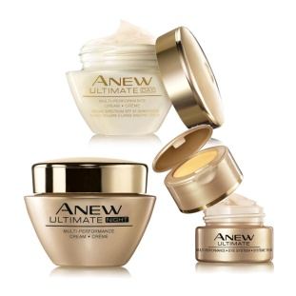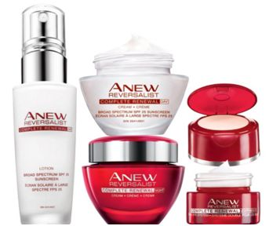

Anew
Clinical

Are You Using the Correct Skin Care Regimen?

Beautiful, younger-looking skin is as simple as picking the right treatment for your age and skin’s needs.

There are 4 basic steps to the perfect skin care each morning and night.

Step 1 Cleanse

Step 2 Treatment –Target Your Concerns

Step 3 Moisturize

Step 4 Eye Treatment

Let me help you select the correct skin care regimen for you!

Marjorie E. Benhamou

855-360-AVON

Website: www.AvonGoldenStars.com

Email: AvonMB@aol.com

Facebook: www.Facebook.com/AvonGoldenStars

YouTube: www.youtube.com/channel/UCErOTXh4FF0bAy4pwS24Fug

