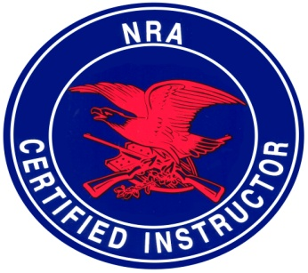
Defensive Firearms Training
Registration Form
(Print & Complete)
Name: | ________________________________ ____________________________________ _______________________________
 | Last | First | Middle

_________________________________________________________________________________________________________________
Street Address | City | State | Zip

_______________________ _______________________ ______________________ _______________________
Home Phone # | Business Phone # | Cell Phone # | Fax #

_______________ _________________________________________________________
Age | Email Address

 | AZ CCW PERMIT CLASS (8 HRS/1 Day)  AZ ARMED SECURITY GUARD COURSE (16 HRS/2 Days) | $ 65 ($25 Deposit)  $100 ($75 Deposit)
 | BASIC HANDGUN SAFETY & MARKSMANSHIP (4 HRS/1 Day)  BASIC PERSONAL PROTECTION IN THE HOME COURSE (4 HRS/1 Day) | $ 49 ($25 Deposit)  $ 70 ($25 Deposit)
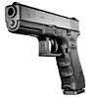

Date of Class you wish to attend: | ___________________________________ | (See Schedules)
 | Available on 1st come 1st serve basis

Method of Payment:
 | Personal Check |  | Money Order |  | Cashier’s Check (Mail Check with form)
- MILITARY MEMBERS AND AIRLINE EMPLOYEE SPECIAL 10% REDUCED RATE APPLYS!
Understand that the cost of the course checked above has a non-refundable deposit and that any change in schedule
must be made at least 72 hours prior to date of course and approved by A&M Investigations’ Defensive Firearms Training.
There will be a $25 Charge for returned checks. You may contact us at 602-577-1557 any time.
Signature ____________________________________________ Date _____________________________
Mail this form along with Check Cashier's Check or Money order.
Mail to: A&M Investigations, LLC • PO Box 67255 • Phoenix, AZ 85082
Note: You will receive a CONFIRMATION by e-mail or by letter, along with a map to range 5 days prior to class.

