Supporting the Body that is Battling Cancer
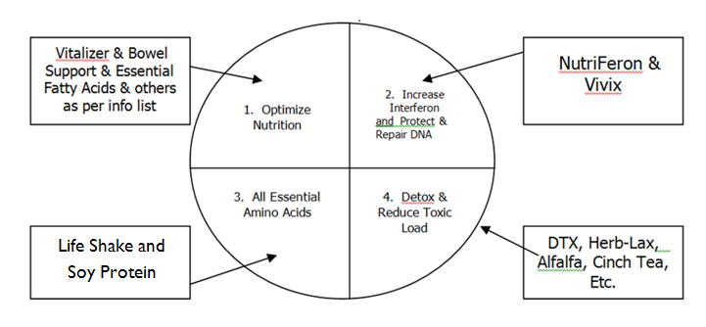
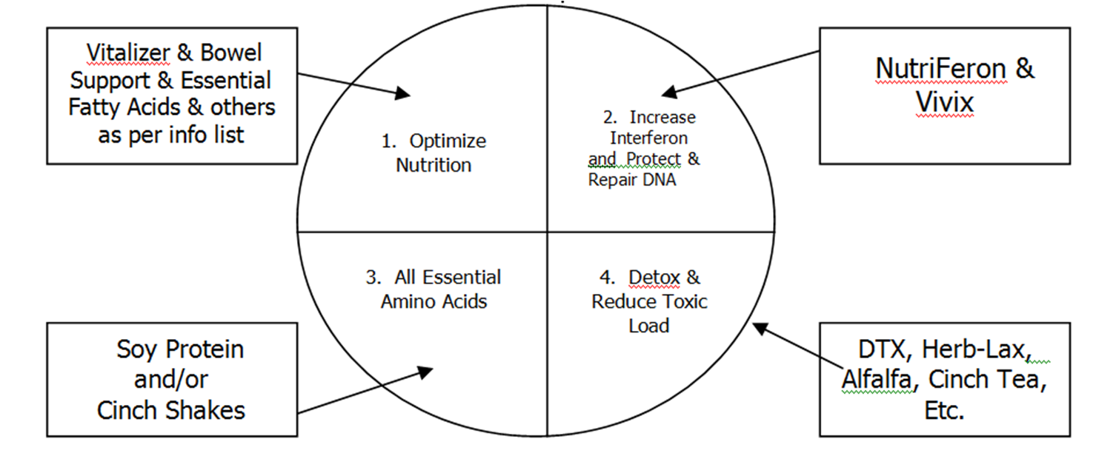

Life Shake and Soy Protein
DTX, Herb-Lax, Alfalfa, Energy Tea, Etc.

- The body is in a BATTLE … maintenance nutrition was not adequate to stop the cancer from developing, so do not expect maintenance nutrition to stop it from spreading or reoccurring. (Some start by taking 2 or 3 Vitalizer strips every day … a simple program that is not overwhelming.) GLA slows down cancer cell division, therefore, optimal amounts are recommended.

- Every cell in the body has the ability to make interferon, which helps to protect the cellular tissue from cancer. Obviously the cells were not making enough. NutriFeron causes the cells to make more interferon. Two per day is what is recommended for a well person. Obviously you want to double, triple or quadruple. Vivix is essential to repair and protect the DNA of both cancer cells and cells that are not cancerous.

- Soy protein/Life Shakes contain ALL of the Essential Amino Acids, which help you to produce antibodies to fight the cancer. Two or three servings per day is a great choice. Soy contains isoflavones that helps to fight cancer, so that is another reason to choose an abundance of RAW soy in your diet.

- Remove or reduce anything that weakens / aggravates / interferes with the cellular function. Detoxification is ESSENTIAL and can be addressed from many angles. (daily supplements, cleanses, colonics, ozone, chelation suppositories, etc.)

Additional Health Options of GREAT Benefit
- Vitamin C intervenous
- Colonics
- Ozone intervenous
- Laetrile (in the form of eating 20 apricot kernels daily)
- Stem cell enhancement products

TOP TEN Supplements for a Strong Immune System:

- NutriFeron … first supplement of choice. It contains four herbs … pumpkin seed, plantago seed, safflower flower and Japanese honeysuckle flower bud. Together, these four herbs work synergistically to do the following:
- increase the production of all immune system cells
- increase the speed and activity of all immune system cells
- increase the accuracy of all immune system cells
- increase interferon and all communication between immune system cells
NutriFeron was released to the world marketplace in February 2003. It is the result of decades of work by eminent immunologists. It was developed by Dr. Yashuhiro Kajima, the discoverer of interferon. Dr. Kajima began his immunology research in 1932, and NutriFeron is the result of this pioneering research that began 72 years ago. It is available exclusively through Shaklee distributors.

- Protein Powders
A. Life Shakes & Soy Protein) (Complete, Balance Protein … contains all 9 Essential Amino Acids)
- Being deficient in just ONE essential amino acid can depress your immune system by as much as 30%
- All antibodies made by the B cells are produced from protein
- Mental, physical & environmental stress nearly double your body’s requirements for protein
- Inadequate protein causes the thymus to shrink and the T cell production is reduced
- Soy protein contains isoflavones that have been clinically proven to slow up the multiplication of cancer cells

- Physique (Whey Protein)
- Contains the amino acid called Cysteine, which produces “glutathione” in the body. It is nicknamed “the master antioxidant” for the body … WHY? … Vitamin C, Vitamin E, and Selenium are well-known and widely used antioxidants. However, ALL other antioxidants depend upon the presence of glutathione to function properly. The immune system’s function is to identify and attack germs and other invaders, including cancer cells. A body with plenty of glutathione fights off these threats more easily by denying most of them a foothold. Glutathione enables the body to produce more white blood cells.

3. Vitamin C
- Speeds up the overall work of the white blood cells
- Helps to reduce the negative affects of stress on the immune system
- Increases the production & stimulation of the T-killer cells which destroy cancer cells
- Blocks the formation of nitrates into cancer-forming compounds.

- Carotenoids and Flavonoids
- Carotomax
- Contains Lutein, Zeaxanthin, Lycopene, Alpha Carotene, Beta Carotene, Astaxanthin
- A deficiency in Beta Carotene is devastating …. Thymus shrinks & reduces the number & activity of T cells …. also causes reduction in total B cells
- Deficiencies in carotenoids slow the response time of the whole immune system
- Deficiency causes abnormality in epithelial tissues of the body
- Each capsule contains:
  - Beta carotene equivalent to that found in 125 medium bananas
  - Lycopene equivalent to that found in 2,830 apricots
  - Lutein & Zeaxanthin equivalent to that found in 162 medium pink grapefruits
  - Alpha Carotene equivalent to that found in 102 cups of raspberries
  - Astaxanthin equivalent to that found in 4 oz of salmon

- FlavoMax (from Shaklee U.S.)
- Each capsule contains:
  - Anthocyanidins & Proanthocyanidins equivalent to 213 cherries
  - Flavan-3-ols equivalent to 31 cups blueberries
  - Flavanones equivalent to 27 medium limes
  - Flavonols equivalent to 2,355 medium carrots
  - Flavones equivalent to 31 cups shredded red cabbage

- Vitamin E + Selenium + Grapeseed
  - Vitamin E:
  - Enhances the B cells’ ability to produce powerful antibodies
  - Makes T cells & macrophages work more quickly & effectively
  - Selenium (found in Shaklee Vita Lea & Vita-E)
- Increases the production of antibodies
- Increases the ability of the macrophages, B cells & T Killer to kill bacteria & tumors
- Facilitates the removal of mercury & cadmium from the body

- Detoxification Herbal Formulas:
  - DTX:
    - A “Complete Liver Protection Package” containing Milk Thistle, Schizandra, Reishi Mushroom, Dandelion, Artichoke, and Turmeric.
    - These six herbs DETOXIFY & PROTECT the liver, the body’s blood filter, thereby increasing the overall detoxification of the whole body.
    - They increase the production of “glutathione” (see 2B above)

  - Herb-Lax:
    - Bowel Conditioner & Detoxifier containing nine herbs: buckthorn bark, blue malva flowers, alfalfa, rhubarb root, culvers root powder, fennel seed, anise seed, senna and deglycerized licorice.
    - It facilitates blood, bowel, liver, and cellular detoxification

7. Optiflora (Prebiotic-Powder & Probiotic-Pearl)
The adult body REQUIRES three to five pounds of probiotics in the intestinal tract to increase nutrient absorption and to kill foreign invaders that enter through the mouth. This is ESSENTIAL for a powerful immune system.

8. B Complex
- Increases speeds in the immune system response
- Note: thiamine, B6, riboflavin, B12, folic acid & pantothenic acid are especially needed, but DO NOT take large amounts of a single B vitamin. The whole complex works together as a unit. Too much of a single B can produce a deficiency of some of the other B vitamins and DEPRESS THE IMMUNE SYSTEM.

9. Vita Lea (multiple vitamin/mineral from Shaklee)
This is the basis of every nutritional support program … balances the body chemistry and essential to bring the body to homeostatis.
- High potency nutrient complex … No artificial colours, flavours, sweeteners or preservatives
- Clinical tests showed that using Vita Lea consistently for one year reduced sick days 65%
- Easy to digest & gentle on the stomach … Confirmed bioavailability
- Spirulina coating (a powerful antioxidant)

10. Vivix
• slows down the initiation, promotion and progression of abnormal cells
• see youtube: http://environmentofsuccess.com/youtube-videos/yp32-author-joseph-maroon-md-resveratrol-evidence-vid0214-vlc/

Other Supplements of Benefit
- Zinc:
  - Is a key nutrient required by the thymus to make T cells.
  - Severe deficiency has been shown to cause major abnormalities in the immune system.
  - People who perspire a lot require more zinc

- Alfalfa:
  - Called the KING of all Plants in food circles
  - contains a smorgasbord of minerals that balance the body chemistry, heal, and maintain an internal alkaline environment to reduce the risk of disease. Use liberally.

- CoenzymeQ10
  - Is the “high octane fuel” manufactured by the liver to energize the mitochondria (energy generators) of every cell.
  - Cells of the body will always function and heal better if they have optimal levels of CoenzymeQ10

- OmegaGuard and GLA
  - Slows down cancer cell metastasis
  - Essential for excellent delivery of nutrients in the bloodstream

- Garlic
  - Enhances the action of the macrophages & T cells
  - Especially makes the macrophages more aggressive
  - Also makes T killer cells more active (remember these are the cells that destroy cancerous cells & cells sick with viruses)
  - The National Cancer Institute has begun a 20 million dollar study on the anti-cancer effects of garlic

Other Modalities of Benefit:
- Apricot Kernels
  - contain Vitamin B17 also called laetrile.
  - Holistic practitioners have found that it acts like natural chemo therapy in the body without any negative side effects. (According to Francisco Contreras, M.D., Administrator of the Oasis of Hope Cancer Hospital, laetrile releases cyanide to kill cancer cells directly. It also lowers cancers resistance to traditional treatments like radiation and chemotherapy.)
  - 5 per day are recommended for cancer prevention / 20 per day are recommended for cancer treatment

- Infrared Saunas
  - When you raise the core temperature & create a “hyperthermia” effect (or temporary artificial fever) in the body, the immune system is strengthened as it works to combat disease
  - Sweating is essential to detoxify. When you detoxify, you reduce the toxin load on the immune system and free it up to spend it’s energy to protect and heal YOU.

- Essiac
  - Blend of four herbs – burdock root, sheep’s sorrel, slippery elm, and Indian rhubarb root
  - Discovered by Canadian nurse, Rene Caisse, in the early 1900s. Thousands have claimed to have their cancers reduced by using these detoxifying herbs.

- Vitamin C Intervenously
  - Provides all the benefits under Vitamin C (see above), but allows you to receive massive amounts directly into the bloodstream (you can only absorb so much Vitamin C per hour through the digestive system).
  - Massive amounts of Vitamin C jumpstart the immune system’s power and speed

- Black Seed Oil Capsules

- Turmeric

- Ozone Intervenously
  - Ozone neutralizes poison in the body, thereby reducing the toxin load on the immune system
  - It is especially beneficial to neutralize the toxic side effects from chemotherapy and radiation therapy

- Milled Flaxseed
  - Slows down cancer cell metastasis
  - Flax fibre contains lignans that can block the formation of hormone-based tumors or growths

