Meet Chef Kurt and Kathy, our Innkeepers! Three years ago they came to us with a host of experience and fun new ideas for the Riverside Inn! They love being Innkeepers (Kurt & Kathy chose something they love to do and call it work). They found their previous experience as business owners made for an easy transition to innkeepers many years ago. Both Kurt and Kathy have Hotel/Inn Management Certification and they are both Ordained.
Originally from Ohio they have been Innkeepers at several Bed and Breakfasts in different states including New York at the Chautauqua Institution where they managed 3 Victorian guest houses consisting of 52 rooms & 3 suites, an Ocean view B&B in York Harbor, Maine an Inn in Providence, RI and the Manor House in Norfolk, Connecticut.
Kurt previously owned a successful Wedding/Florist shop in Ohio for over 20 years. Chef Kurt will be the one creating the delicious breakfasts, cookies, and other goodies for guests to enjoy. He is a Master Florist and will make your wedding or special event perfect. Kathy has enjoyed several vocations but has always focused on customer service. She has owned an Independent Insurance Agency in Ohio, has been a Merchandiser for Hallmark and T-Mobile and a Youth and Young Adult Ministry Director who retired from her last “On Staff” position at Mayville United Methodist church.. Kathy has had the honor of being "Business Woman of The Year" and “Best of the Best" Radio air personality. She will be the one making your reservations among other things..
Kurt and Kathy welcome you to share their home and property they so love and enjoy, as you escape from your own busy life. Come: rest, relax and be pampered with true “Southern Style Hospitality” while you experience the "Good Life" here at Riverside Inn.
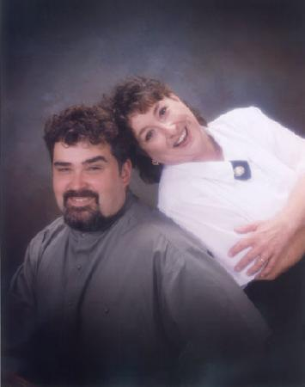 4/10/15

