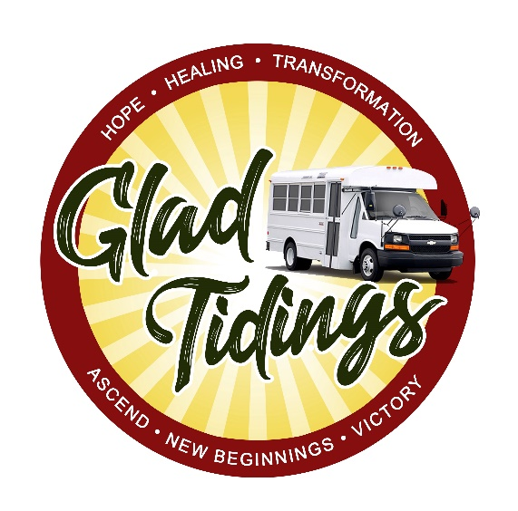
If you are reading this post, God has guided you to my page for one reason or another. I am truly grateful to have you here. Many people on my page just read without friend requesting or commenting for privacy reasons, which I am totally fine with. But if you don't have a problem with commenting etc., I would love to hear from you.

I am a certified Life Coach or should I say Breakthrough Coach. I graduated from Houston Community College with an Associates Degree in Criminal Justice. I also graduated from the University of Houston where I majored in Criminal Justice and Minored in Psychology. What makes my approach unique is I use my many years of experience in coaching, worldly education, and spiritual training to address the issues and complexities an individual may be facing which not only allows me to take coaching to the next level but to also achieve life changing results. Through my experience, the most lasting change comes when you help promote an individual's healing from the inside out. Mind, body and spirit. Usually you cannot heal one without healing a part of the other. It all functions as one unit.

What makes my coaching methods so dynamic is the fact that I don't depend on my own knowledge, wisdom and understanding of a person or a situation. I partner with the Holy Spirit, which allows me the ability to tap into my spiritual gifts. These unique gifts enable me to provide Prophetic Direction/Warnings/Correction/Encouragement/Confirmation/Healing & Deliverance/Life Coaching services, and Prayers specifically for God's chosen. With the help of God, I have helped men and women from all over the world change their lives and refocus themselves. I have been able to not only spark a change that allowed them to leave abusive relationships, dead careers, and toxic environments but to also move forward, reinvent themselves and create a life that they love and are proud of.

I also serve the homeless through out Gwinnett and Hall County, which I will be explaining more about in the next couple of days. Not only do I reach Gods CHOSEN online, my services are also face to face, which is truly an honor having the ability to meet and interact with Gods CHOSEN Kings and Queens whether they are walking down the street, at the park, beach, laundry mat, amusement park, trap house, sleeping in the woods, living in a shelter, sleeping in their car, on police duty, patrolling an area or at Starbucks😁. Just know if God wants to get a message to you, send an encouraging word or wants me to bring you something specific to your situation or you to mine, I will hunt you down, rain sleet or snow to make sure we connect and you are good.😂 We got you 💯💯💯!

He does not play when it comes to his CHOSEN..for real. But on another note, I hope the information I am providing has been beneficial. I am still working out the kinks as well as getting my website up and running so please bear with me. Although everything is moving super fast in the Kingdom, and my schedule is crazy, God has told me to keep posting no matter what, so I will continue to be obedient.

If you would like to support Glad Tidings ministry, the information will be posted below. Please only sow a seed if you are led by God to do so. Thank you...God bless!

Cash app: $GladTidingsontheGO

