**M&R Capital Management Clarifies How the 2020 COVID-19 Recession is Not a Repeat of the 2008 Financial Crisis Recession**

**by Paul DeSisto, CFA, Managing Director**

The recession that we are experiencing now in the wake of the COVID-19 pandemic is strikingly different from that resulting from the 2008 financial crisis. This is evidenced by the very rapid rebound in stock prices in just the few months since the pandemic began, compared with the laborious recovery of stock prices that stretched out over four years from 2007 through 2012.

A great deal of household wealth is invested in stocks and bonds.  Household net worth is defined as the current market value of all assets owned by a household after subtracting the sum of all liabilities from that total value.  The largest portion of household wealth, 42%, is represented in investments in stocks and bonds and other financial assets, in both investment accounts and retirement programs. This is significantly larger than the value of all residential real estate at 30%. 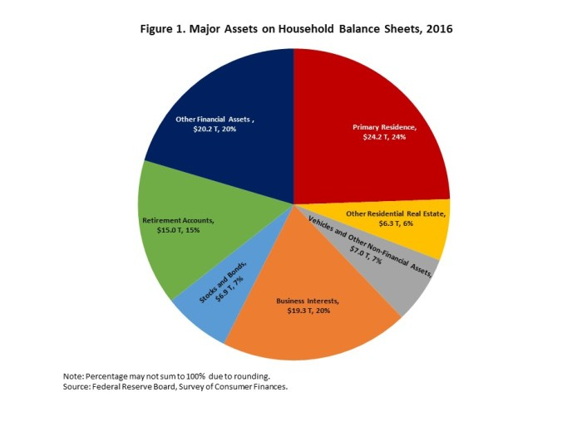The chart below displays the growth of household wealth going back to a period just prior to the financial crisis.  From it we see how household wealth declined steadily during the 2007-2009 housing and financial crisis.  This long and painful drop occurred during a severe recession that lasted 18 months, much longer than the average post WWII recession duration of 10 months.  (Recession is defined by the National Bureau of Economic Research as a decline in economic activity that lasts more than a few months.)  From it we see that household wealth did not reach its 2007 high until the beginning of 2012.

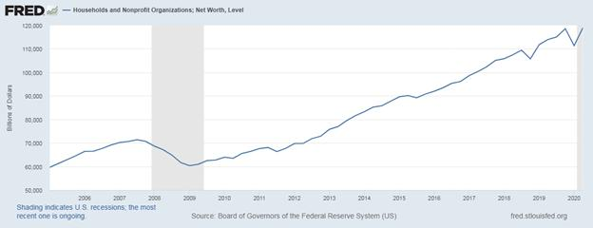

Compare the recovery in household net worth then with that in the current recession, which began in February and is in its eighth month.  Household wealth dropped precipitously in the early part of this year, but quickly regained all that it had lost.  The different nature of the two recessions is the reason.  The earlier recession was a financial crisis involving inflated housing prices stemming from an overheated housing market, fueled by easy money and lowered lending standards by lenders and government agencies tasked with insuring and making a secondary market in subprime mortgages. This was the period of NINJA loans, **N**o **I**ncome, **N**o **A**ssets, and of **N**o **D**oc loans, where buyers had no documentation, or proof, of income, or had incomplete tax returns. These and other subprime loans were facilitated by federal government policies designed to make housing available to everybody, including people whose modest financial resources and sophistication did not warrant home ownership.

To ensure an active secondary market, or liquidity, for these mortgages, quasi-government agencies like the Federal National Mortgage Association, or Fannie Mae, and the Federal Home Loan Mortgage Corporation, or Freddie Mac, purchased the mortgages from lenders and packaged them as mortgage-backed securities, which were purchased indiscriminately by investors who felt protected by the implied federal guarantee of the two agencies' securities. Investment banks and other institutional investors bought huge amounts of these securities with borrowed money. For example, Lehman Brothers invested very heavily in these assets using margin, reaching a leverage ratio of 24-to-1. A decline in the value of the assets of 4% or more moved the company to negative equity. Fannie Mae and Freddie Mac also heavily leveraged themselves, Fannie to 20 times, and Freddie to an astounding 70 times, but even these numbers understate their leverage, as they guaranteed billions of dollars worth of other mortgage backed assets. Shareholder-owned and supported by powerful lobbyists , the two companies fought higher capital requirements recommended by their government regulator, the Office of Federal Housing Enterprise Oversight (OFHEO), because more capital would have diluted returns to shareholders.

It eventually became apparent that these triple-A rated securities were not really triple A, but held various tranches of lower-rated mortgages, also known as Alt-A mortgages. As investors became more aware of the actual mortgages underlying these securities they began to sell. Once begun it accelerated rapidly as over-margined investors rushed to unload their securities which were rapidly declining in price. What began as a trickle quickly became a flood and the market became illiquid as buyers for the securities dried up. Illiquidity soon became insolvency, and some firms like Lehman Brothers declared bankruptcy. American International Group which insured asset-backed securities but hadn't put sufficient capital aside to pay claims, but was considered too important by the government to be allowed to declare bankruptcy, was bailed out by the U.S. Treasury. Other teetering financial firms like banking giant Citigroup were rescued by government action, while venerable investment banks Bear Stearns and Merrill Lynch were bought out.

The current recession's difference with the 2008 recession could not be more apparent. The present crisis is caused almost solely by government action, particularly at the state and local levels, to reduce business activity in response to a natural phenomena, the COVID-19 pandemic.  But what has been done by government fiat can quickly be undone. And our financial system is sound. Unlike the earlier crisis, banks today are much more heavily reserved for loan losses. Instead of a 4% or 5% ratio of equity to assets that they had before the crisis they are at 10% to 12%. Regulation has also gotten tighter, with the large banks subject to periodic Federal Reserve "stress tests," to see how they would fare in a future financial crisis. Even their dividends are subject to Federal Reserve review. Finally, the Financial Accounting Standards Board’s Current Expected Credit Loss impairment standard, or CECL, which requires “life of loan” estimates of losses to be recorded for unimpaired loans, went into effect in 2020. With these safeguards in place it is no surprise that the current recession appears to be ending quickly.

Regarding banks, they are not especially profitable now, with the tiny spread between short and long-term interest rates rendering their long-established business model of "borrow short, lend long" minimally profitable. As a result many banks are trading below book value, making their shares inexpensive based on traditional value metrics. Patient owners of bank stocks who can be satisfied for a couple of years with steady and growing dividends may be nicely rewarded when interest rates return to higher levels.

The final chart in this report shows the movement in stock prices during the period under review, as represented by the Standard & Poor's 500 index of large capitalization U.S. stocks. As with household net worth, stock prices also regained all that it lost, plus more, showing a positive correlation between the two measures. Financial assets are the largest component of household net worth. We maintain that staying invested in stocks despite the uncertainty we are experiencing now, along with the current environment of low interest rates and modest inflation, is the best way to grow a stock portfolio and increase household wealth.

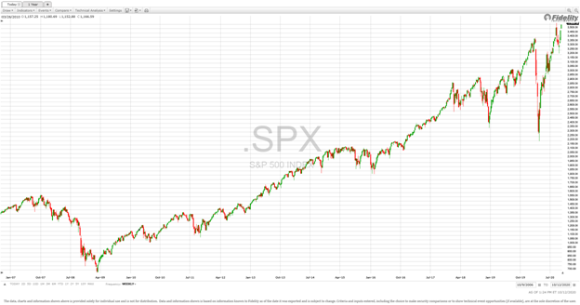

Paul M. DeSisto, CFA

Executive Vice President and Managing Director

M&R Capital Management, Inc.

25 Union Place

3rd Floor

Summit, NJ 07901

Tel: 212-584-8999

Fax: 212-584-8998

TF: 800-646-4442

Mobile: 973-432-6872

[www.mrcapco.com](http://www.mrcapco.com/)

[Like Us On Facebook](https://www.facebook.com/pages/M-R-Capital-Management-Inc/167696820064278)

[Follow M & R Capital Management on LinkedIn](http://www.linkedin.com/company/m-&-r-capital-management-inc-?trk=company_logo)