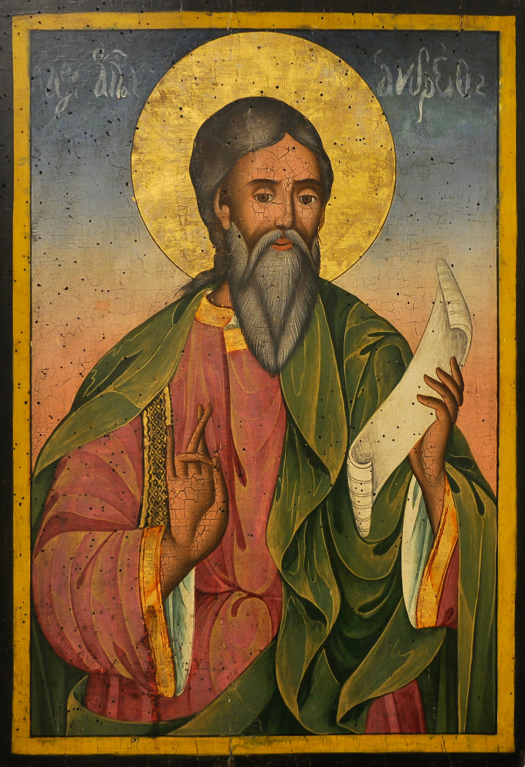
St. Andrew the Apostle

St. Andrew's Christmas Novena Begins November 30th!
by Gretchen Filz

Advent always begins on the Sunday closest to November 30th, the feast day of St. Andrew the Apostle. Is this just a nice coincidence, or is there deeper significance?

There is indeed a deeper significance. St. Andrew was the very first disciple called by Our Lord—that is why, in the Orthodox tradition, he is known by the name Πρωτóκλητος, which means "First-Called." Andrew is the one who convinced his brother, Simon, to become Jesus' disciple. "We have found the Messiah!" Andrew said to him. Now we know Simon as Peter, the first pope.

In keeping with his role as "the first-called," the feast of St. Andrew is found at the beginning of our new liturgical year. There are many popular traditions associated with St. Andrew's feast day, especially in those countries that have him as their patron saint: Scotland and Russia. But the most popular St. Andrew's feast day tradition is for everyone. This tradition is a Christmas novena that begins on St. Andrew's feast day.

It is called the St. Andrew Christmas Novena, or more simply, The Christmas Novena. It is a wonderful way to enter the Advent season which is marked by a time of anticipation, penance, and prayer. While the origins of this prayer are unknown, it is over 100 years old (at least) and may have come from Ireland. If the St. Andrew novena were prayed as a regular nine-day novena, it would end on the Feast of the Immaculate Conception on December 8th. However, this novena prayer is prayed much longer than nine days—it is prayed throughout all four weeks of Advent.

It is piously believed that whoever recites the St. Andrew Christmas Novena Prayer FIFTEEN times each day from the feast of St. Andrew (November 30th) until Christmas Eve will obtain the favor requested.

Prayer is an essential part of Advent. Reciting this special novena prayer each day is a simple yet beautiful way to celebrate the spiritual significance of the Advent season and to experience a deeper conversion to the heart of Jesus. The St. Andrew Christmas novena is commonly found in many Advent prayer books which are also loaded with many other beautiful prayers and traditions for this time of year. And since Andrew helped his brother find the Messiah, and he can do the same for us as our spiritual brother. He can lead us, in spirit, to the Christmas crib, saying, "Here is the Messiah."

It might not be easy to pray this novena fifteen times a day for twenty-five days, but if you are able to, it will undoubtedly leave your heart well-prepared to welcome the coming of Christ. The beauty and sweetness of this prayer will unfold for you through its daily recitation, allowing you to meditate more fully on the profound mystery of the Incarnation. It is not very hard to memorize. In the meantime, you can copy it, save it to your phone or computer, print it out, or tape it to your car dashboard- whatever you need to do to help you remember to pray it each day until Christmas Eve.

