Sister Circle Ministries Incorporated
Kingdom Sistah's Spiritual Conference
"Sistah's Preparing / Positioning for Spiritual Action"
2 Corinthians 10:3-5


Greetings My Dear Kingdom Sistah,

Sister Circle Ministries Incorporated is excited to announce its 1st Women's Conference, "Kingdom Sistah's Spiritual Conference" "Sistah's Preparing / Positioning for Spiritual Action" September 24-26, 2009, at Hampton Inn, 3750 Crain Highway, Waldorf, MD 20603.
Our Kingdom purpose on day one will be a "Seasoned Women's Panel" that will address spiritual questions. This will be the time for you to meet the women of God and to ask spiritual questions on singleness, marriage, women in leadership and more. Come prepared for an awesome rap session with the women of God.
The Kingdom purpose for days 2 and 3 is that every Kingdom Sistah will be more empowered, enlightened, and equipped in their prayer life, learn how to breakthrough when trials come by applying praise; how to dress appropriately for the enemy of our soul by learning and understanding the power of the Spiritual Dress Code: The Spiritual Armor of God.
We will have four outstanding and dynamic women speakers that are empowered and filled with the power of the Holy Spirit through the salvation of Jesus the Christ our Savior to present, preach, and teach the unadulterated Word of God.
Registration fee is $25 and is now being accepted. You can register by sending your payment to Sister Circle Ministries Incorporated, 9266 Senna Court, Waldorf, MD 20603. All checks should be made payable to Tammy McNair.

Reminder to invite a Sistah to join us for this empowering conference.

Conference Itinerary

Thursday, September 24, 2009
Seasoned Women's Panel
7:00pm - 9:00pm
Come prepared with your questions (your questions can be anonymous)

Worship Service / Workshops

Friday, September 25, 2009
Worship Service
7:30pm - 9:30pm
Kingdom Sistah's Spiritual Conference 2009
Sistah's Preparing / Positioning for Spiritual Action
Pastor Trena Stephenson
Woman of God Ministries
Silver Spring, MD

Conference Itinerary (cont.)

Saturday, September 26, 2009
Morning Glory (Worship/Prayer)
8:30am - 9:30am
(Continental Breakfast will be served)
Elder Tammy McNair
Sister Circle Ministries Incorporated /
Evangelist Beverly Goodwin
HolyNow Nation of Women Ministry
Workshops
9:30am - 10:45am
The Power of Praise: Using/Understanding Praise is Our Weapon
Pastor (Prophetess) Tresti Cunningham
Church of the Promise Land Ministries, Forestville, MD

11:30am -12:45pm - Lunch (On Your Own)
1:00pm - 2:15pm
The Power of Prayer: Using/Understanding Prayer is Our Weapon
Elder Maria Mobley
Pentestcostal Evangelical Church, Landover, MD

2:30pm - 3:45pm
The Power of the Spiritual Dress Code: Using/Understanding the Spiritual Armor of God
Apostle Dr. Margo Moore-Valentine, Pastor
The House of the Prophets Network Church International
Landover Hills, MD

  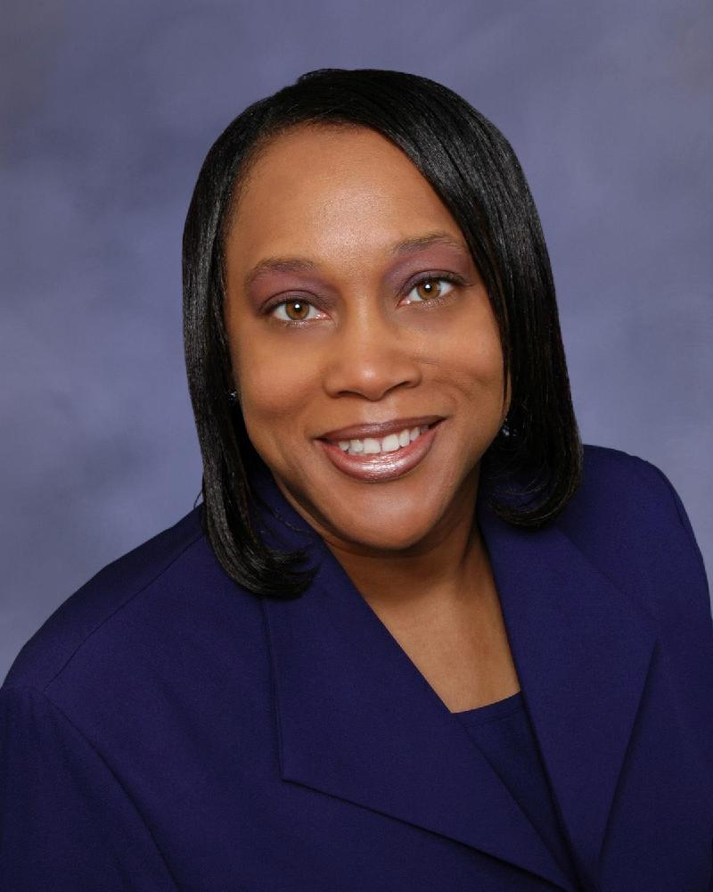
  Sister Circle Ministries
  Conference Host:
  Elder Tammy McNair
  September 24-26, 2009
  Hampton Inn
  3750 Crain Highway
  Waldorf, MD 20603
  More Information
  www.SCMinisteries04.org
  SisterCircle2003@aol.com
  Johnetta Keeve
  Events Coordinator
  EventPlannerSC@aol.com
  Sister Circle Ministries
  Mission
  For Sisters in the body of Christ, to dwell together in unity and love one another with the love of Jesus Christ as they learn and grow in the Word of God.
  Foundational Scriptures
  Behold, how good and how pleasant it is for brethren to dwell together in unity. Psalm 133:1
  A new commandment I give unto you that ye love one another, as I have love you... John 13:34
  ...for I am fearfully and wonderfully made: marvelous are they works...
  Palms 139:14
  Goals
  To encourage, empower, equip and spiritually build up Sister's in Christ to grow in their relationship with God by providing different avenues of ministry events:
  - Bible Studies/Rap Sessions
  - Spiritual Workshops
  - Spiritual Advances
  - Spiritual Conferences
  - Prayer Breakfasts
  Sister's Learning and Growing Together in Christ
Save $5.00 | If you register for the Kingdom Sistah’s Spiritual Conference "Sistah's Preparing / Position for Spiritual Action" before September 1, 2009 you will get $5.00 of the registration cost of $25.00.
Expires: Tuesday, September 1, 2009

