Week 10

Episcopal Formation Part 5

Course Overview
Instructor
Archbishop T Henry Jr
Email
EpiscopalFormation@coaab.org
This week we examine Chapter 11 – Symbols of the Episcopacy. We will cover the various symbols and appointments used by bishops in the course of their ministry in the church. We will give a little information on their origin and their meanings if any.
Students should leave this week with a working knowledge of the various symbols and how they should be used in the life of the church. What is proper to what service and in what context.

Course Materials and other Resources
Episcopal Formation: The Second Edition, by Archbishop Thomas Henry Jr
Additional Materials on the Week 10 Page. Click the links to read the material.

Read the following Scriptures:
Exodus 39:27-31

Read chapters 11 of “Episcopal Formation: The Second Edition”
Additional Reading will be available on the Website.

Course Study Guide
We will divide this lesson up into two parts as we deal with the Symbols of the Episcopacy. Part one begins on the next page.

The Symbols of the Episcopacy
Basic Symbols of the Bishopric – All bishops may wear or make use of a ring, mitre, Pectoral (precious metal or wooden) and a crozier. Normally, bishops will make use the ring and pectoral mostly. Some traditions do not make use of the mitre.
The Episcopal Ring – shows the bishops is joined to or married to the church (diocese/communion) in that location. The ring can be a signet as pictured here or one with the Gem. Contrary to popular opinion a signet can be worn while in solemn pontificals. Some prelates have an everyday ring and ring that they wear during celebrations.
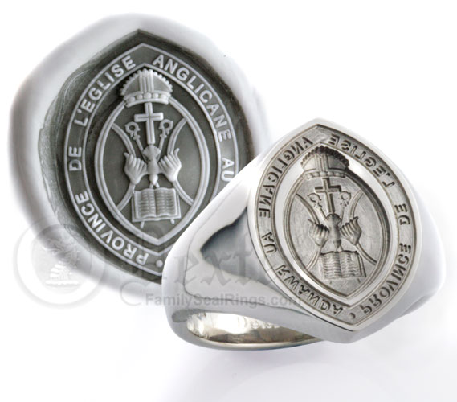
-
The Mitre – It is the headdress the bishop wear. The top represents the flames of fire that was on the apostles’ head in the upper room and the infulaes or tails represent the Old and New Testament of the Bible.
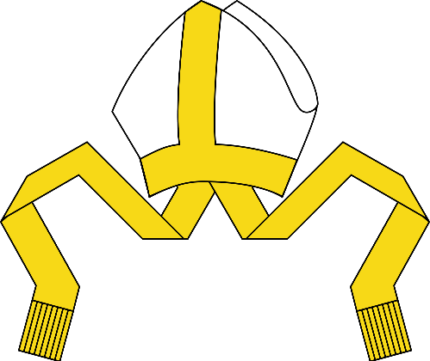
Pectoral Cross – The Pectoral Cross was one of the first appointments used in the WESTERN or LATIN church to show that one was a bishop. It is called Pectoral from Pectus because it is supposed to be worn hanging on the chest. The custom of placing it in the pockets is a recent one and ONLY DONE for a cleaner appearance when the suit was button and has no deep meaning to it.
Also note that when in ANGLICAN Choir dress the Pectoral should be suspended by a chain or cord. The Celebration Cord should not be used with Anglican Garb. It should be used with Roman Garb and the Chasuble.
The Pectoral does not have to be gold; the bishop makes use of any precious metal or a wooden cross of his choice as his pectoral unless the diocese or communion as a pectoral that represent the office of the bishop that remains the property of the communion/diocese that the bishop must wear in the exercise of his duties.
A primatial pectoral is pictured here from the Evangelical Lutheran Church of America.
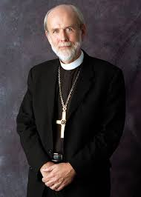
Crozier – The Bishop’s staff is called a Crozier. It usually has a crook at the top to represent that the bishop is the shepherd or PASTOR of the sheep. The Crozier represents that the Bishop has limited authority.
Metropolitan-Archbishops, primates and presiding bishops may make use of a pastoral staff with the cross on the end instead of a crook. It can have one or two bars. This staff is use to show that this particular bishop exercises authority over other bishops. Usually the cross sits on top of an orb or ball. They may also make use of the crozier. When they use the crozier it expresses the reach of their authority over the other bishops and not just limited authority over one diocese.
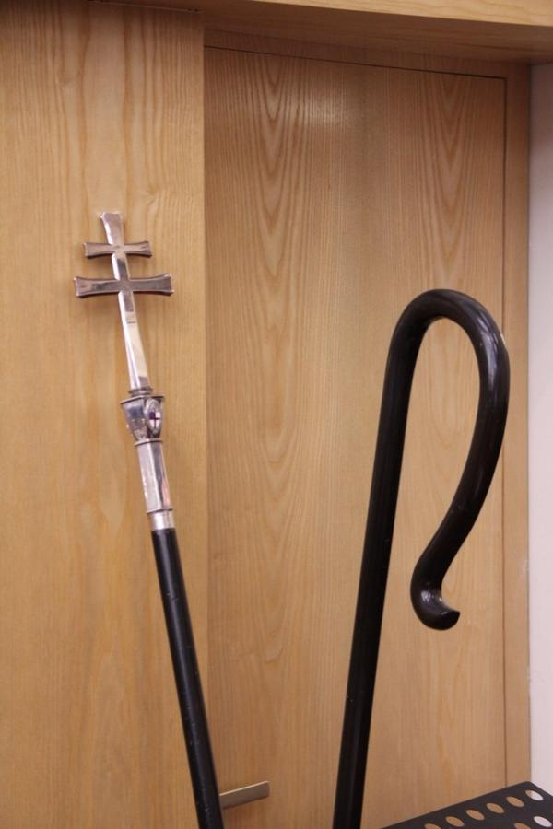
Pictured here is a primatial staff (the one leaning against the wall) and a crozier (the one on the right with the crook)
Archiepiscopacy - The symbols of the archbishop is the archiepiscopal staff (Pictured above). If the Archbishop is a metropolitan, then he will make use of the pallium as well (Pictured below).
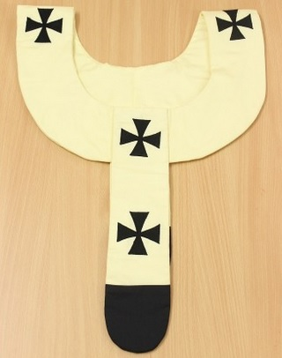

The Rubrics -
- The Mitre is worn during certain parts of the service and removed at other parts: Remove while praying, during the opening hymn, the reading of the Gospel, the name of Jesus and the Eucharistic Prayer. It is worn during the processional, preaching, while seated, while giving the final blessing and benediction.
- The crozier is always carried in the left hand so that the right hand is free to bless the people. When being carried by others before the bishop, they hold it with both hands and will not walk with it like the bishop.
- The pectoral cross can be worn inside the left pocket or hanging while in civic attire.
- Zuchettos are not worn with Anglican vestments. It is worn with Roman Catholic Vestments. Zuchettos like birettas can be worn by all clerics and the color matches the cassock of the wearer. Women do not wear zuchettos, it is a purely make vestments meant to cover his baldness from being tonsured.
- Birettas are both indoor and outdoor garments and follow the same rules of the Mitre.
Bishop in Choir
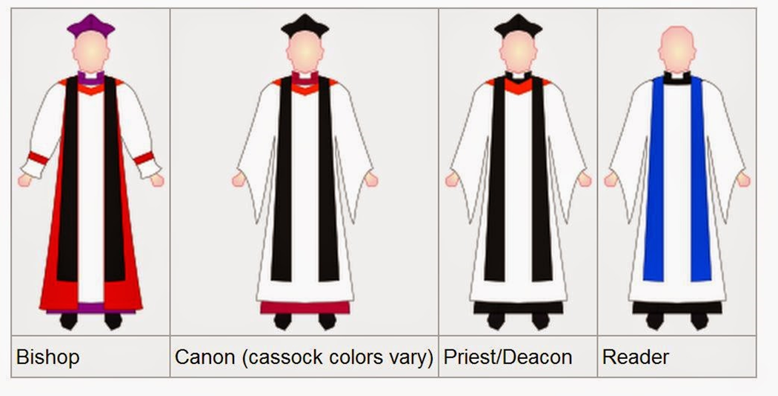
Most Pentecostal since the adoption of Anglican Vestiture by the COGIC have made use of them. Many have adopted several variations that have taken away from the original meaning of the vestments. Some have even gone as far as to tout their interpretation of them as law. We will deal with Anglican Vestiture and what the Congress actually officially uses as Choir Dress.
The Tippet is a black scarf it is supposed to be black for all clerics. Only License Lay Readers or what some called License Ministers, wear a Blue Tippet to show that they are not ordained clergy.
The Anglican bishops, no matter their ranks, all wear purple cassocks. This is done to show that all bishops are sacramentally equal. They wear black cassocks as well. The use of the black cassock in choir is done when the bishop is wearing a black chimere.
Anglican bishops, as with all Anglican clergy, may wear an academic hood in Choir Dress. The tippet is worn top of the hood.
The Anglican Rochet is worn with Anglican Choir. This rochet requires the use of matching cuffs. The cuffs should match the chimere. Some bishops make use of an Ecumenical Rochet which has the open sleeves instead of the cuff sleeves. These two rochet extends down to the shoes while the Roman Rochet extend down to the waist.
Anglican Choir make use of a Canterbury Cap and not a Biretta or mitre. The cap is purple matching the bishop’s cassock and is black matching the all over clergy.
The Pectoral should be suspended by a chain or cord; the Celebration or succession cord is not used with Anglican vestment.
The Canon is clergy of the cathedral or clergy that work close to the bishop who are not bishop but have been honored with the title.
Canon of Cathedrals are entitled to wear a different color cassock while functioning in a service being held at the cathedral, outside of the cathedral they wear black cassocks. Usually cathedral canons cassocks can vary from the purple of a bishop to red or even blue. Cathedral Canons are pastors. The pectoral cord can be black or colored if the bishop gives the dispensation for such.
Presbyter(priest)/deacons wear the black tippet (deacons will usually will wear a deacon stole) and English Surplice that extends to the knees or to the shoes. A pectoral cross (silver) suspended by a black cord.
License Lay Readers or License Lay Ministers wear a black cassock without a clerical collar, a surplice and a blue tippet. They are not ordained clergy so they do not wear the clergy collar in choir. Technically they are not considered clergy but more so lay person license to do clerical functions.
There are different rules for Roman Vestments in Choir.
COAAB Choir Vestments
Speaking to the simplicity that COAAB focuses on and the idea that we look towards the Jerusalem Council. We wear a Cassock, English Surplice, and a black tippet or stole with the organization seal on it. Or the Liturgical Stole. The Pectoral is also worn.
The Wearing of the Cope and Mitre
When wearing Anglican Choir the bishop is not to wear the chimere. It should be noted here that the cope is not an episcopal garment. It is used by the bishop in choir when he presides so that he can wear the mitre outside of eucharistic services. The mitre either matches in the Cope or is white or precious. The stole should be the same color as the cope. The tippet is not worn with the cope and mitre.
On the next page is a picture of the cope and mitre.
Please note that bishops, presbyters, deacons and even laity (laity when leading the service of prayer) may make use of the cope.

Note when wearing clerical vestments mentioned above the base should be black clericals – black pants, black, shoes, black socks, a black clerical shirt/colored shirt.
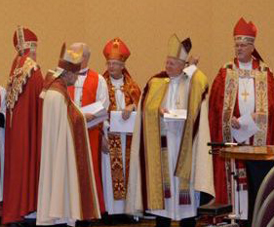
Bishop in Celebration Attire/Eucharistic Vestments
Eucharistic Vestments are sometimes called Pre-Reformational Vestments. They are called this by Anglicans because Anglican Vestiture is both Choir and Eucharistic Vestments. Eucharistic vestments as the name implies are worn during the eucharist only and not outside of the Eucharist. The chasuble is the distinctive Eucharistic Vestment worn by both bishop and presbyter. It is called the garment of Sacrifice and is only worn during the Eucharist. Normally worn with Alb, Stole and Chasuble and Episcopal Appointments. The Congress permits cassock, rochet to be worn in the place of the Alb while in Eucharistic vestments.
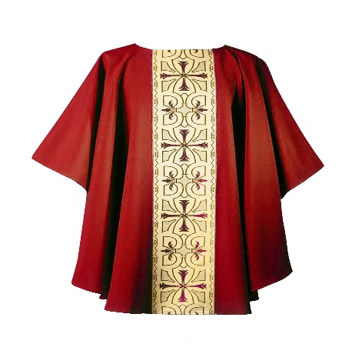
In Part 2, we will pick up on page 83 and continue to the end of the Chapter.
Course Schedule
Week | Subject | Course Information
1 | The Holy Scriptures | Inspiration, The Canon, Original text
2 | Sacramental Theology | Reformed verses Roman Catholic View of Sacraments
3 | Church History Overview | Ages of Church, Continuity, Reformation
Week | Subject
3 | Exam on Holy Scriptures and Sacraments (Online) Feb 29th
4 | The Liturgy and the Bishop
5 | Catholicity: Creed and Apostolic Succession
6 | Episcopal Formation Part 1
7 | Episcopal Formation Part 2
8 | Episcopal Formation Part 3
9 | Episcopal Formation Part 4
10 | Episcopal Formation Part 5
11 | Episcopal Formation Part 6
12 | Episcopal Formation Part 7
13 | Episcopal Formation Part 8
14 | Program Review

Homework
Answer the following:

Describe each piece above-
- Cassock –

- Anglican Rochet –

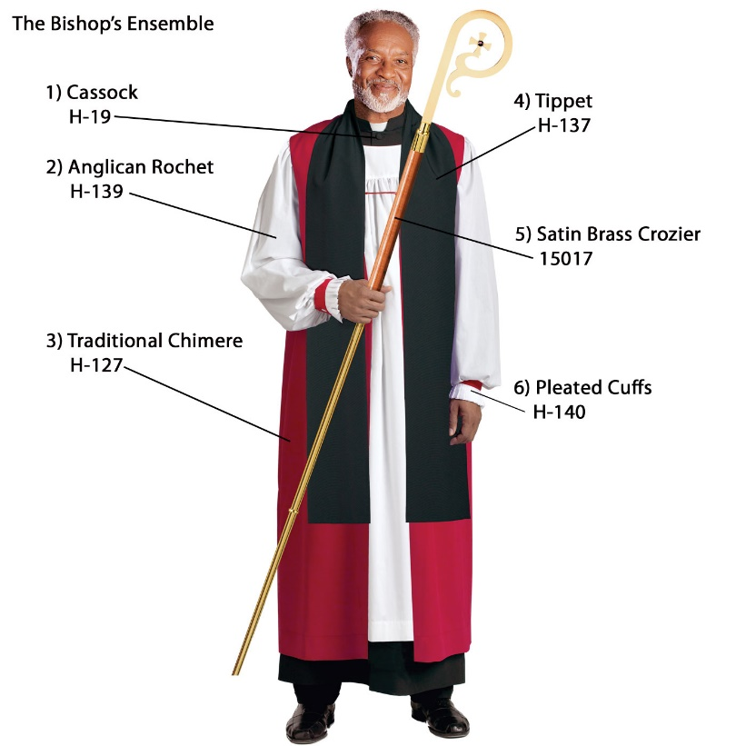
- Chimere –
- Tippet -
- Crozier -
- Cuffs –

What are the two main types of Episcopal Rings?
Why is it called a Pectoral Cross?
What is a Mitre and what does it represent? How is it used?

Who wears the Cope?

