Bernard’s message reads: God Bless
Crossword:
ACROSS 1 Access 4 Blinds 8 Rhyme 9 Loyalty
10 Antwerp 11 Aenon 12 Loftiness 17 Satan 19 Obadiah
21 On earth 22 Storm 23 Exhale 24 Depths
DOWN 1 Adrian 2 Crystal 3 Siege 5 Lay bare
6 Nylon 7 Saying 9 Lappidoth 13 Funeral 14 Spit out
15 Ashore 16 Thomas 18 Teeth 20 Aisle

Service times at St Mary’s
Sunday: 10:30am Holy Communion
or Morning Prayer
Normally the first and third Sunday is Holy Communion with Morning on the second and fourth. Baptisms by arrangement with the Rector.
Tuesday: 10.00am Holy Communion
12.15pm Lunch-time Service

St Mary’s and the Nave Café is open – Tuesday, Thursday, Friday & Saturday from 9.00am – 3.00pm

Readers contributions to the magazine are always welcome. Hard copy (hand written if easier) to the Rectory address or by email: to : st.marysstockport@gmail.com
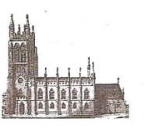
Editorial discretion with regard to content and space available will apply.
St Mary’s in the Marketplace
St Mary’s Rectory, 24 Gorsey Mount Street,
Stockport, SK1 4DU.
0161 429 6564
www.stmarysinthemarketplace.com.

St Mary’s in the Marketplace
Parish Magazine
September 2014

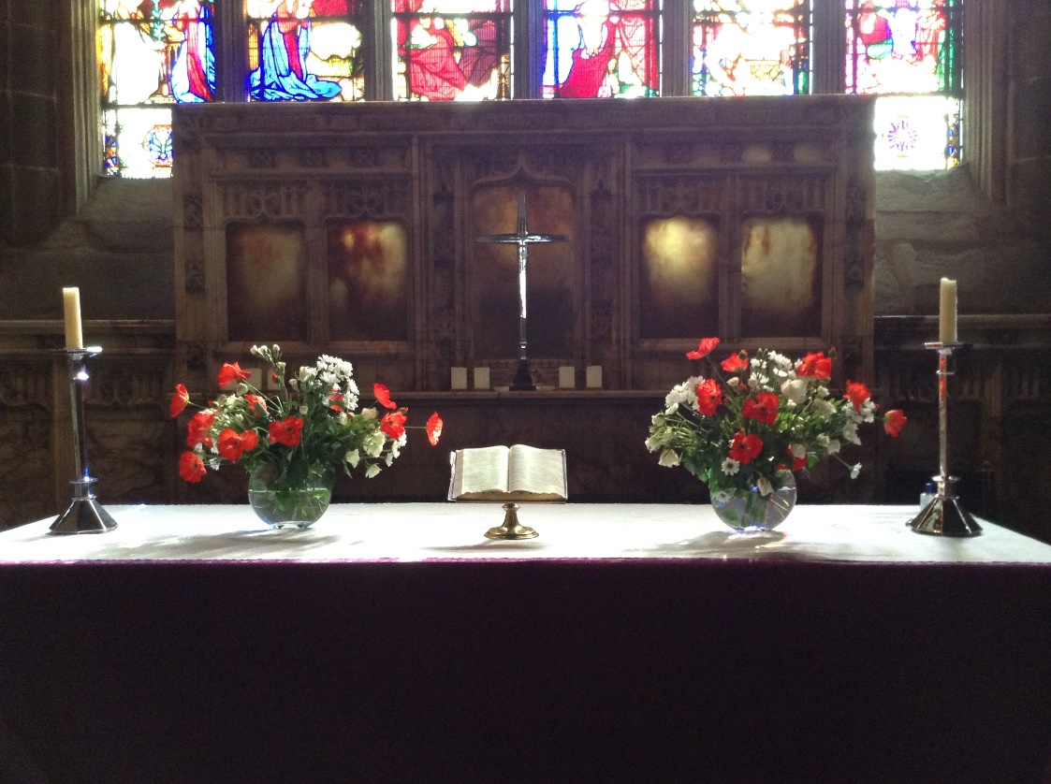

50p
From the Rector’s “ i-Pad”
Dear Reader
This month we are looking forward to Harvest Festival, which we celebrate each year, though not always on the same Sunday. I guess that is quite appropriate, since the harvest is brought in at different times of the year, and in different ways.
This year my garden has yielded another harvest, of red and black currants which have been made into jam, and very delicious it is too. It wasn't a bumper crop, but enough for a few jars. A week or two ago we went into the car park next to the churchyard and picked enough blackberries to make a few helpings of seasonal blackberry and apple desert , which also went down a treat. And only the other day I stood under a very ordinary tree in a local National Trust Garden and helped myself to the seasonal delights of juicy mulberries, which are not so common, but are really very tasty!
Three fruits, from an urban garden, a historic garden, and a wild garden. Just as we celebrate Harvest Festival on different Sundays of the year, and from different sources, so the harvest of our own lives differs. We each have differing gifts and the harvest is celebrated when we use those gifts to the glory of God and the good of the community and of His Church .
The most valuable gift to the church and to the community is

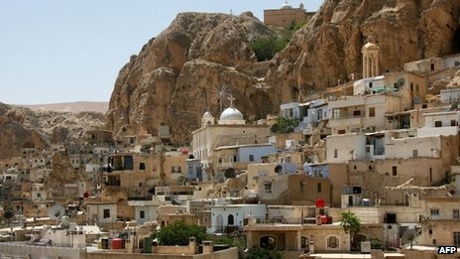
But what of Maaloula one of the earliest centres of Christianity in the world.

Syria crisis: In sacred Maaloula, where they speak the language of Christ, war leads neighbours into betrayal
Muslims and Christians had lived together in this town of churches and caves. Now it is empty…
Maaloula became the scene of battle between Al-Qaeda linked jihadist Al-Nusra Front and the Syrian Army in September 2013. Syrian rebels took over the town on the 21st October when it was reported that around 13 people had been killed with many more wounded as a result of Islamist forces shelling the historic town. On the 28th October government forces recaptured the town, but Maaloula was taken over by the Al-Nusra Front opposing the Syrian government again on the 3rd December 2013. 12 nuns were taken as hostages and moved between different locations ending up in Yabroud where they stayed for three months before officials from Qatar and Lebanon negotiated a deal for their release. The negotiations produced an agreement on a prisoner exchange under which around 150 Syrian women detained by the government were also freed, the nuns on the 9th of March 2014.

St Mary’s in the Marketplace
with
Stockport Heritage Trust

A special hour long candle-lit vigil on Monday 4th August.
Starting at 10pm with the opportunity to talk quietly over a cup of tea about relatives who lost their lives in the “Great War” and the chance to chat to a most interesting young ex-serviceman, himself having served in war torn areas abroad, who joined us in Church.
Assembling in the Tower at 10.45pm, St Mary’s in total darkness except for a single candle, the bell tolled for 15 minutes ending on the chiming of the clock at 11pm with the “calling to remembrance”, a minutes silence and the extinguishing of that single candle.
A simple yet moving tribute.
A special thank you to Tony Marsh for ringing the bell for us.

An Appreciation Dereen Dethick
Dereen was born on 5 Sept 1930 in Oldham; she was an only child. When she was young Dereen played the piano, and as a child she gave concerts. Later on she joined an amateur operatic group, Oldham Operatic, and enjoyed the delights of Gilbert and Sullivan.
Dereen would have liked to have been an architect, but couldn't find work, so she went to Paris and worked there for two years, helping to redesign the Paris Metro. Unable to follow her desired career she worked in a cotton mill, working out the size of the belts. She met her husband Joseph Dethick, from Derbyshire in the 1950’s in Manchester. He was an experimental engineer, and had been one of the brains behind the war ,engaged in secret experimental work. He was 10 years older than Dereen. She called him Jos, while others knew him as Jerry .Once married they lived in Oldham a long while. Sharza's parents had a Zip fastener factory called the Omah Trading Company. Sharza was born in 1961 and the family moved to Stockport.
Dereen was a good woman. Her great grandfather was a good man, and a great philanthropist, and he helped the poor children of Oldham in many ways. Dereen took to being a Sunday school teacher in a similar way. She longed to help poor children. She was so thoughtful that one day she took her class of children off to Blackpool to see the seaside. The children loved it. She took them to church. She bought them ice cream and fish and chips. And a good time was had by all!But when she got back the vicar was not amused and relieved her of her post because he said "she had taken them out of church! "I believe that marked the end of any close relationship with the church for Dereen, although I hope we may have made up for that damaging episode in some way in recent years at St .Mary's! Dereen made lots of friends along the way of life, especially here in Stockport, in the market, at antiques fairs and the like.
Even after she had died people were asking SHARZA " how's your mum" ? Dereen got involved with the Heritage Centre. In SHARZA 's words "My mum liked to get involved" And that was true also of St. Thomas's
Harvest at St Mary’s in the Marketplace

Tuesday 23rd – Sunday 28th September during normal opening hours
Collection of items for The Wellspring
Saturday, 27th September 10.00am
Produce and Other Goodies Sale
[goods available whilst stocks last - anything home-made and home-grown – home-produced]
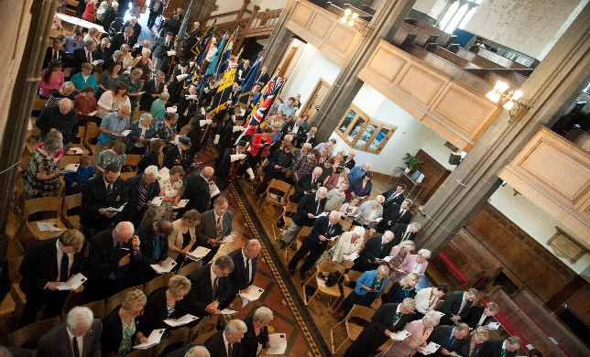
Saturday, 27th September
The Light Orchestra
Last Night of the Proms Concert
Tickets £5.00

Sunday, 28th September 10.30am
Harvest Festival Service of
Baptism & Holy Communion
[including the blessing of our harvest gifts to The Wellspring]
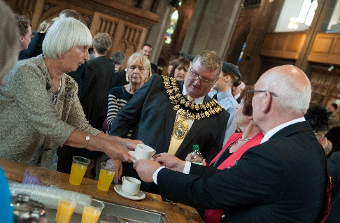
Harvest Sunday Lunch at the Nave Café
Tickets £12.00

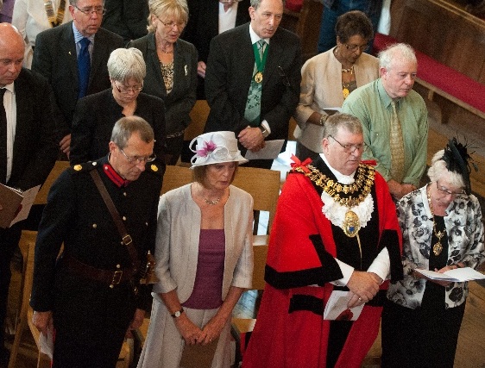
Civic Service
Commemorating World War 1
Sunday 3rd August
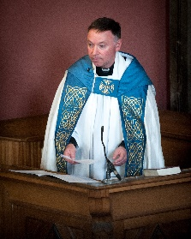
This very special service took place in the presence of the Mayor and Mayoress of Stockport, Cllr Kevin Hogg and Kathleen Hogg, with Christian Wewer DL & Mrs Wewer following a procession from the Armoury on Greek Street (Shaw Health) to St Mary’s. The Address was given by The Archdeacon of Macclesfield, the Venerable Ian Bishop. The service was led by the Rev Roger Scoones assisted by other members of the Clergy. Our guest organist Peter Williamson. With the congregation entering in large numbers it was indeed an experience to get everyone seated quickly and efficiently according to the designated seating plan. Many thanks to everyone who assisted in the planning of this service as well as on the day, making everything run smoothly (including the serving of nearly 300 cups of tea/coffee or glasses of squash at the end of the service. Thanks also to McVities for providing all the biscuits without charge. Flowers by Cheshire Flowers and St Mary’s in the Marketplace. Photographs: Gareth Lowe (Commercial Photographer) by permission Stockport Council
It would appear we have moved from grafiti to arson!
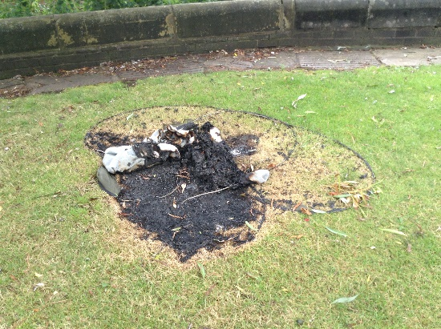
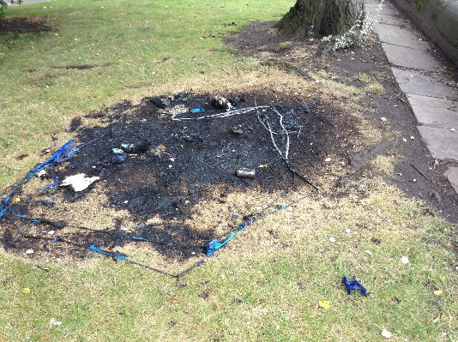
We are much obliged to the Fire Service who quickly attended and put the flames out following two small fires in the grounds of St Mary’s – but this has to have been deliberate – two tents in two separate locations. Not that the tents should have been there of course, but all the same…….. We are equally appreciative of Stockport Council for subsequently clearing up the mess and reviewing what action should be taken with the grass (re-turf or allow it to recover on its own).
Let us at least be thankful that it was not worse, no one was hurt, the only damage being to the two patches of grass.
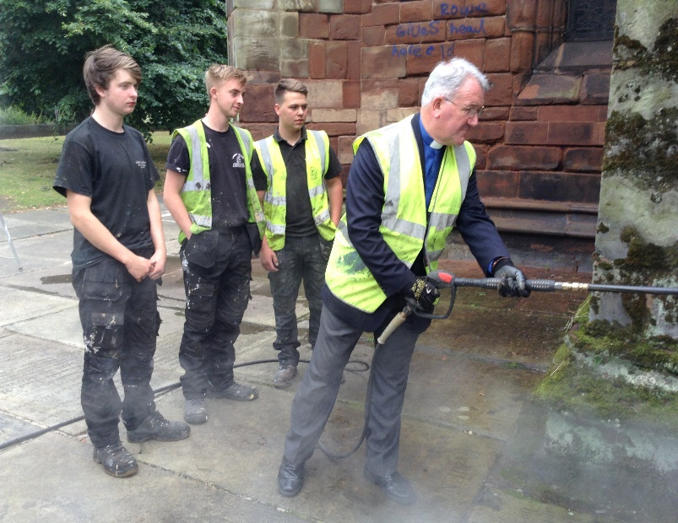
But….. the graffiti has gone…….
with a little help from the Rector and the services of three young gentlemen from John Lambert (NW) Limited.

Dear God
At harvest time we thank you for the changes in the seasons
Which bring the beautiful colours of the world.
When the golden, brown , green and yellow crispy
Leaves that fall of that grow on the trees.
We thank you for the dazzling sun which shines
Down from the azure sky and the smell of the fresh Autumn air.
Thank you for the clean rain that helps nourish the crops.
We thank you for the special time of year.
Amen (Anon)

Calling all Crafters (and that includes card making, needlework, knitting, drawing (even painting) or anything else you fancy doing.
Thursday at St Mary’s
11am – 2pm
Starting on the 4th September and running through to the start of our Christmas Programme (when clearly there will be a little disruption with our many concerts and services) and into 2015. This could be the start of something “BIG”…
Also joining us will be members of the Stockport Crafters Group from the 11th September – so come along and let’s make this a huge success inviting members of the community far and wide to join us.
ARAMAIC – The Language that Jesus Spoke
Rev Bernard Elsdon
If you wanted to hear the language that Jesus spoke, there is only one place in the whole world, where you could hear it spoken by everybody, and that is in the small village of MAALOULA (which means High Place), a scenic village in Syria. ARAMAIC is a somewhat strange language with no vowels, written from right to left, and greatly in use between the 7th century BC and the 7th Century AD., when it was replaced by Arabic and it was the main language of the Persian, Babylonian and Assyrian Empires. When Alexander the Great destroyed the Persian Empire, Aramaic ceased to be the official language, though still spoken widely and Western and Eastern dialects, and there are some traces to be found in the Dead Sea Scrolls.
Incredibly it is still used as a liturgical language in communities in Syria, Lebanon and Iraq, and still spoken by small communities in Turkey, Iran, Armenia and Georgia.
Here for your interest is the Aramaic alphabet:
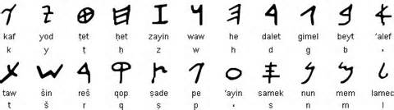
My message for you
* *
Remember that you read right to left and that * = a missing vowel
the volunteer. The church depends on volunteers, as do many worthy organisations, like the National Trust. If it were not for volunteers , churches all over the country would be closed and even when open would look dusty and dull and unwelcoming were it not for the volunteers. The National Trust could not open its great houses and fine gardens if it were not for the host of volunteers, who give thousands of hours service freely every year. This is the harvest of lives, the product of people giving of their time and talents willingly and generously , to the common good, whether it be in a church, a community organisation or a national treasure house or garden.
I would like to take this opportunity to say thank you to all those who volunteer their time and talents to St. Mary's , and who help to keep it open, sparkling clean and warmly welcoming. We may not be a national treasure, we may not have the finest collection of stained glass windows or the rarest wooden ceiling in the North West of England (though it is quite rare !) but we do have a group of volunteers, whose " harvest" in life is clearly evident to me. You know who you are! Thank you! If you are not yet a volunteer please offer to be part of our Harvest Field!
Harvest Festival is a joyful time of thanksgiving for hard work rewarded, whether it be in the fields, on the high seas, or in the shops and factories or places of work throughout our land. May God bless the harvest of YOUR life, and make YOUR life fruitful, to the glory of God this year and in the years to come!
Yours sincerely, labouring in the Harvest field.
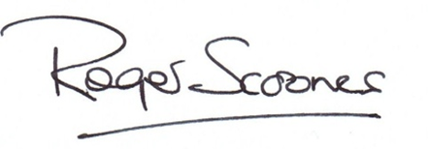

It’s fruit picking time….. Harvest at St Mary’s Rectory

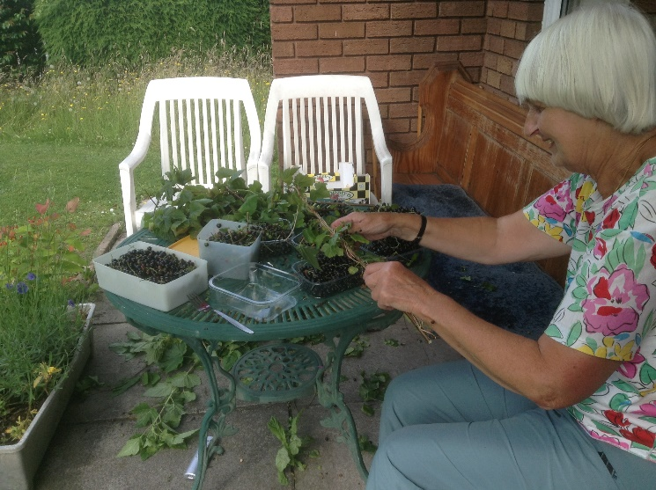
Margaret Forster and her helper, the Rector spent an afternoon stripping the Blackcurrant and Redcurrant bushes of their fruit back in July. The harvest was good but not as big as in previous years. Margaret , who is very knowledgeable about these things, has already made some delicious jam, (says the Rector, on good authority!) and has put more of the berries in store for future use!

Made to Order
St Mary’s is delighted to be able to offer on a “made to order” basis a hand-made cross made from off-cuts of timber previously part of some of our pitch-pine pews used to make bespoke furniture. Clearly this will a limited offer, whilst supplies of wood remain available.
Approx measurments: 9 ½” height / 5 ½” width /1 ½” inch
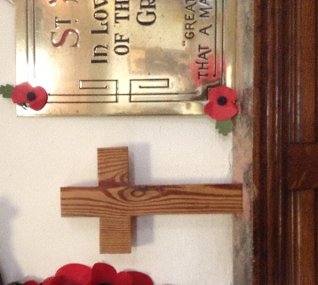
Please let us know if you wish us to get one for you for the modest price of £25.00

The Nave Café Our Summertime Special!

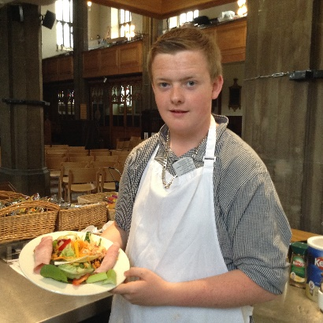
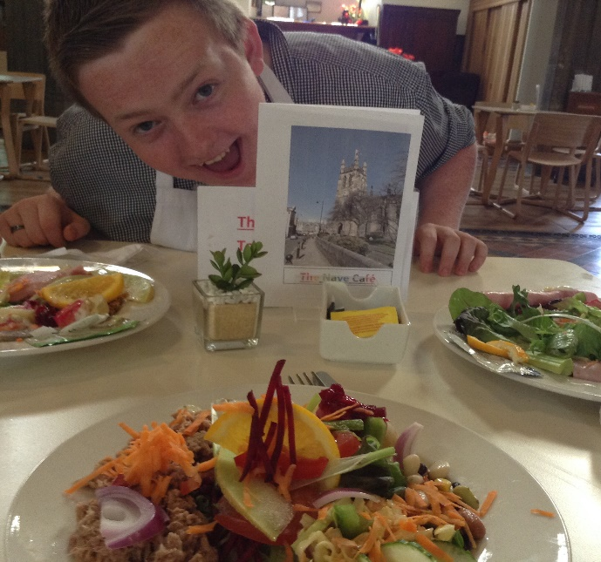
We hope that you have enjoyed our speciality plate salads over the last few weeks – certainly on a Saturday lunch-time they have become the “signature dish” of Luke Chappell.
They are such good value too, for a plate salad with “bits of this and that” to tempt your taste buds we charge only £2.50. If you add on something like ham, cheese, tuna or an egg – than £3.00 (bread and butter 50p extra).

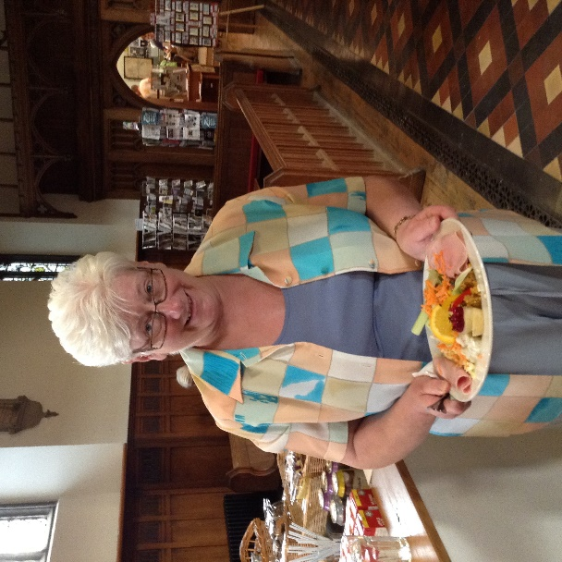
Thank you Yvonne for giving this one a try!

Our Café is “the bread and butter” of St Mary’s income – it needs your support, so please come and eat with us, tell your family and friends. We can take bookings for events which include Nave Café catering and are always happy to discuss options.

hospital on the radio station , when she liked to keep the diary. Dereen came on the carnival float. She liked being involved with the carnival committee, and with SHARZA , at the Plaza. Wherever her daughter went, Dereen followed after her, because she loved it so much, being involved.
There is no doubt at all that she was proud of her only daughter SHARZA .
Dereen loved St. Mary's and the Heritage. Despite her illnesses and various set backs over recent times she struggled to keep coming down to the market. Towards the end she failed, and said, "I can't make it, but I will when I feel better." Thinking of Dereen, many times I would arrive at church to open up and Dereen would be waiting outside,come wind and shine, and would then wait patiently inside for the heritage team to open up their centre and shop. She once said of herself, and her determination to get down to the heritage "I'm not going to drop down dead in heritage you know! "
She had a saying "There's no point in doing it unless you do it well, to the best of your ability."Dereen has lived up to that motto in life and many people have benefitted, in a quiet sort of way, from having known and worked alongside Dereen Dethick. She kept going right to the very end, and because of that Dereen leaves a very big gap in all of our lives .At your father's funeral in 2007we heard the jazz music to "when the saints go marching in." Today we give thanks for another saint, in her own special way, Dereen Dethick, whom God made unique and special, and whom he used , to love and care for other people's children and then her own, and who would go the extra mile for others without counting the cost, real Christian virtues. She may not have been a great supporter of the church, but God blessed her in many ways and made her a blessing to us all.
Rev. Roger Scoones
Rector, St.Mary's Stockport

Stockport Great War Experience
Saturday 13th September
10.00am – 4.00pm
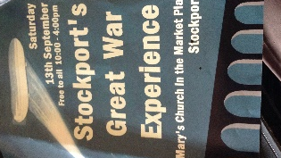
Pick up your detailed leaflet from Stockport Heritage / St Mary’s.
Available from Stockport Heritage Trust – this interesting little booklet showing The First World War Memorials at St Mary’s

At the Nave Café
Tea with a soldier 10.30am / 12.30pm and 2.30pm

Operation Christmas Child

Operation Christmas Child is the largest children’s Christmas project in the world and we at St Mary’s will be supporting it so please will you help by packing a “shoe box”. It is time to start collecting items whilst suitable “back to school” educational supplies are on offer in the shops. Leaflets giving details of how to prepare a box and some empty boxes will be available in the hospitality area near the Nave Café.

The boxes brought to St Mary’s in November 2013 were sent to needy children in Kyrgyzstan showing them they are not forgotten and God loves them.

Approximately 36.000 boxes from the Manchester area were distributed to children also in Rwanda, Swaziland, Uganda and Belarus.
More details in the October magazine.
Margaret Forster

The Wellspring Harvest Wish List

Tinned meat for sandwiches (corned beef, ham, luncheon meat)
Tinned meat for use in soups etc (stewed meats, hot dogs and meat balls)
Tinned savoury pies
Vegetable and meat soups
Tinned potatoes
Tinned fruit
Pie fillings – sweet and savoury
Pickle
Brown sauce / Tomato sauce
Sugar
Tinned rice pudding
Tinned or packaged custard
Biscuits
Shower gel and (liquid) soap
Shaving foam, razors, toothpaste
Roll on deodorants (no spray cans)
Coffee
The Wellspring respectfully suggest that they have sufficient stocks of:

Baked Beans / Kidney Beans / Chick Peas / Grapefruit / Prunes / Tinned tomatoes/ Sweet corn / Tinned salmon / Marmalade & Jam / Packets of Pasta and Rice and tinned spaghetti.

A letter
To Roger Scoones
Thank you for your sermon today about women bishops.
I had an old friend called Noelle Fletcher; I started to become her friend when she was eighty. She was a missionary doctor in India, telling me that was where God had sent her. Noelle, as I called her, would be delighted that women had got this far.
Noelle was a deacon, and she told me that she would like women to become curates, and perhaps one day vicars: she prayed most days for this to happen.
Well, Dr Noelle Fletcher in heaven, it has!
Christine Knight
Have you viewed our web-site recently?

It is all very encouraging to know that in the 30 day analysis (shown above) our main “home” page had 523 hits. Our “events” page viewed by 93 on-line surfers with “contact us” having 130 viewers. We aim to keep the web-site as up-to-date as we can, so please spread the word that we can be found on:

www.stmarysinthemarketplace.com
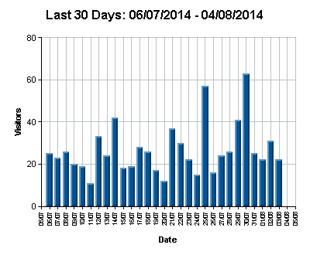

CROSSWORD
Clues Across
1 ‘Through [Christ] we have gained — by faith into this grace’
(Romans 5:2) (6)
4 Deprives of sight (Deuteronomy 16:19) (6)
8 The words of a hymn do this (mostly) (5)
9 Faithful allegiance (1 Chronicles 12:33) (7)
10 Belgium’s chief port (7)
11 Where John was baptizing ‘because there was plenty of water’
(John 3:23) (5)
12 Imposing height (Psalm 48:2) (9)
17 Jesus’ tempter in the wilderness (Mark 1:13) (5)
19 Comes between Amos and Jonah (7)
21 ‘Your will be done — — as it is in heaven’ (Matthew 6:10) (2,5)
22 Gale (Matthew 8:24) (5)
23 Axle, eh? (anag.) (6)
24 ‘Out of the — I cry to you, O Lord’ (Psalm 130:1) (6)

Clues Down
1 Popular Christian author and humorist, — Plass (6)
2 Transparent ice-like mineral (Revelation 4:6) (7)
3 Method of compelling surrender by surrounding target of attack
(2 Chronicles 32:1) (5)
5 Expose (Isaiah 52:10) (3,4)
6 Lonny (anag.) (5)
7 Utterance (1 Timothy 1:15) (6)
9 Husband of Deborah, the prophetess (Judges 4:4) (9)
13 Burial service (Jeremiah 34:5) (7)
14 What Christ threatened to do to the lukewarm church in Laodicea
(Revelation 3:16) (4,3)
15 ‘Simon Peter climbed aboard and dragged the net — ’ (John 21:11) (6)
16 His response to Jesus’ decision to return to Judea was ‘Let us also
go, that we may die with him’ (John 11:16) (6)
18 ‘There will be weeping and gnashing of — ’ (Matthew 8:12) (5)
20 Walkway between rows of pews in a church (5)

