Nutrition Plus, Inc.
121 Mays Rd., Winfield, KS. 67156
Emily Roark Patti Brenn Susan Morrell
(620) 221-2777 (620) 218-1811 (785) 230-7441
roark2@cox.net pattibrenn@cox.net smorrell12@gmail.com
www.nutritionplusinc.com
January is:
4th – National Spaghetti Day
6th – National Bean Day
9th – National Apricot Day
14th – National Hot Pastrami Sandwich Day
15th – National Bagel Day
18th – Martin Luther King, Jr. Day
19th – National Popcorn Day
20th – National Cheese Lover’s Day
24th – National Peanut Butter Day
28th - National Blueberry Pancake Day
29th – National Corn Chip Day

Important dates:

29th – Checks/Direct Deposits go out

Resources for you:

The Institute of Child Nutrition has a wonderful resource for home daycare providers called the Child Nutrition Recipe Box.

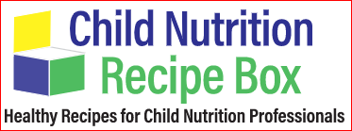

theicn.org/cnrb/recipes-for-child-care/recipes-for-homes

These standardized recipes provide you with delicious, kid-friendly dishes in small batches that meet the meal pattern requirements, while also providing crediting information for easy menu planning. These recipes are for 6 servings. They are broken down into groups for easy searching.
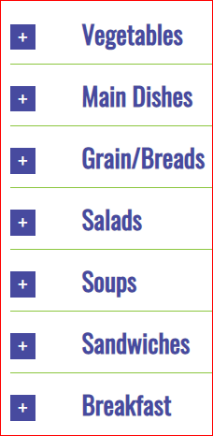
Each recipe is downloadable and printable.
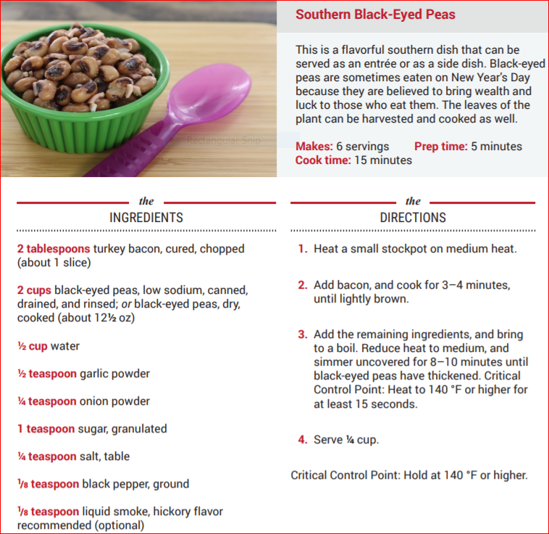
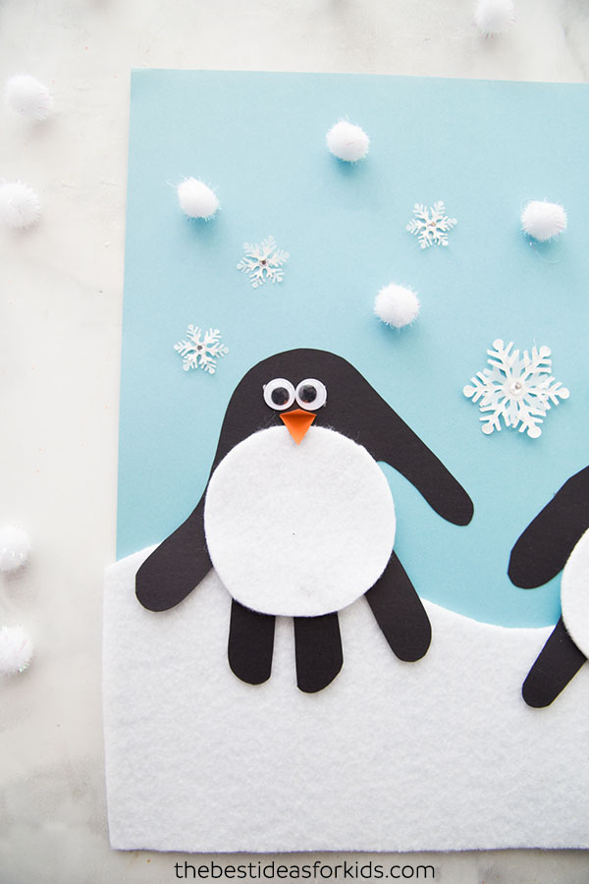
Handprint Penguin Craft

You will need:
Glue
Blue cardstock or construction paper
White felt or construction paper
Black cardstock or construction paper
Orange cardstock or construction paper
(Post-it notes will do in a pinch!)
Googly eyes
White pom-poms, snowflake stickers, fabric embellishments (cut up paper pieces will also work)

First cut out some white felt to the size of your paper. Make a wave pattern to make it look like snow on the ground. Glue to blue cardstock.

Trace both hands or trace the same hand twice and round the bottom of the handprint which will make the top of the penguin head. Cut out your handprints and glue them to the blue cardstock.

Trace a circle on the felt or white paper around a cup about the right size. Add the belly and googly eyes. Cut out a diamond shape and fold it in half for the beak. Glue these all to your penguin craft.

Now the final part is to decorate your sky with snowflakes! Suggestions are white pom-poms, sticker snowflakes, or even little bits of cut out white paper!
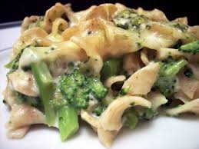
Noodles with Peanut Butter Sauce
Ingredients:
1 cup water
3 ounces spaghetti noodles, whole grain–rich,
11 ounces diced chicken breast, boneless, skinless
3 cups broccoli, frozen, cut
3 tablespoons peanut butter, smooth
3 tablespoons water
3 tablespoons soy sauce, low-sodium
1 tablespoon cider vinegar
1 tablespoon sugar, granulated
½ teaspoon ginger, fresh, grated
1 clove garlic, fresh, minced
(1 clove is about ½ teaspoon minced)
1/8 teaspoon red pepper flakes
1 teaspoon cornstarch
2 tablespoons green onion, chopped (optional)
2 tablespoons cilantro, fresh, chopped (optional)
6 slices lime wedge, fresh (optional)
Nonstick cooking spray

1. Heat water to a rolling boil. Break spaghetti noodles in half. Cook about 8 minutes until al dente and drain well.
2. Coat a medium skillet with nonstick cooking spray. Brown chicken on medium–high heat for 8–10 minutes.
3. Add broccoli, and cook together for another 10 minutes. (chicken internal temperature should be 165°F)
4. Prepare sauce: In a small microwavable bowl, combine peanut butter, 2 Tbsp warm water, soy sauce, cider vinegar, sugar, ginger, garlic, and red pepper flakes. Microwave sauce for 30 seconds; remove, whisk sauce and microwave for 30 more seconds, whisk again. (Note: sauce will look stringy.)
5. In a small bowl, whisk remaining 1 Tbsp warm water with cornstarch to make a thin paste. Be sure cornstarch is fully
dissolved in the water before adding the to the sauce.
6. Slowly whisk cornstarch mixture into the peanut butter
sauce until fully combined. Microwave 30 seconds or until thick. Whisk until sauce is smooth.
7. In a large bowl, toss peanut sauce, chicken & broccoli, and noodles. Garnish each serving with 1 tsp green onions, 1 tsp cilantro, and one lime wedge (optional).
8. Serve ¾ cup. Serve hot or cold. Serves 6. It is delicious!!

We know how hard you are working. Thank you for being so strong for our kids. You are most appreciated!

