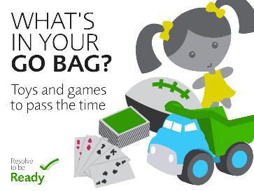 Kids, Help your Family get Prepared!
Your family may not be together if a disaster strikes, so know how you’ll contact one another and get back together if separated. Establish a family meeting place that’s familiar and easy to find. And, don’t forget to think about specific needs in your family. Text, don’t talk. In an emergency, phone lines may be tied up. It may be easier to text and this leaves phone lines open for emergency workers.
Decide on safe, familiar places where your family can go for protection or to reunite. If you have pets think about animal-friendly locations. Consider places in your house, in your neighborhood, and outside of your city or town so you’re prepared for any situation.
Being prepared for an emergency isn't just about staying safe during a storm or a disaster. It's also about how to stay comfortable, clean, fed, and healthy afterwards—when a storm or disaster may have knocked out electricity. Being prepared means having your own food, water, cash, and other supplies to last for at least three days. Remember that your kit will depend on your own needs. Once you take a look at the basic items, consider what unique needs your family might have, such as supplies for pets or seniors. A basic kit list can be found here: https://www.ready.gov/kids/family-emergency-planning/build-a-kit There is also a “build a kit” game for kids at this website.

