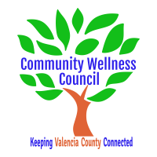
Executive Board Meeting
October 7, 2020
1:00pm-3:00pm
Virtual Meeting

1:00PM-1:10PM

- Call Meeting to Order
- Agenda
- Consent Agenda
  - Minutes of 9/2/2020
  - Treasurer Report
  - Coalition Reports
- Social Media/Website Report
- MRGEDA Update
- LED Update
- Consent Exemptions
Executive Business
- Coordinator’s Report/Grant Deliverable Activities Update (Noelle) 1:10PM-1:20PM
- OSAP Coordinators Update (Linda) 1:20PM-1:30PM
- CRUNCHs/Film Project Update 1:30-1:40PM
- Priorities Calendar review 1:40pm-1:50PM

10 minute break

General Business
- Presentation: All Faiths Wraparound Services 2:00PM-2:30PM
- Introductions 2:30PM-2:40PM
- 100% Community Update 2:40PM-2:50PM
- KAH update 2:50PM-3:00PM

- Adjourn

