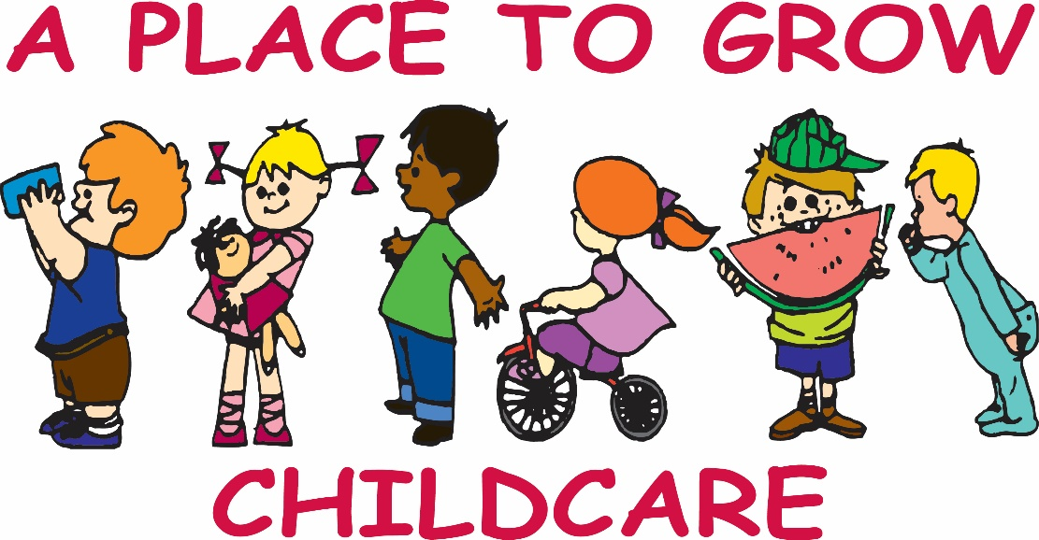

1213 EC Row Ave, Windsor Ont, N8W 1Y6
816 Ellis Street East, Windsor Ont, N8X 2H9
519-252-8707
a_placetogrow@bellnet.ca

Policy Updates

COVID-19 Edition

Effective July 6, 2020 and until the current pandemic is over.

Parent Handbook
COVID-19 Edition

Introduction 3
A. Enrolling Your Child 4
B. Nondiscrimination Policy 4
C. Extra Hygiene Measures and Procedures 4
D. Inclusion Policy 5
E. Fee and Payment Policy 5
F. Admission/Exclusion due to symptoms of illness 6
G. Personal Belongings 6
H. Arrival and Departure Procedures 7
I. Visitors 8
J. Field Trips/Special Events 8
K. Parties and Celebrations 8
L. Food 8

Introduction

Dear Parents,

As we are getting ready to reopen after being closed for nearly 4 months, I want to make sure we are all on the same page. While I know this can be a fearful time since none of us have ever experienced this before, the teachers and administration at A Place to Grow Child Care Centre are committed to providing a quality program that is safe, educational, child-friendly, and fun!

While many things will seem different with new procedures in place for safety of all, this will still be an environment that fosters fun and learning. It is our goal to draw out and inspire the best in our children as we provide them with opportunities to create, explore, and learn.

This handbook will lay out the changes as we enter the next phase from this COVID-19 pandemic. This situation is unprecedented and is constantly evolving, so all changes included in this handbook will remain as the “new normal” until further notice. We will make sure that all changes are realistic and feasible for staff and children by following the Ministry of Education
guidelines as well as those put forth by Windsor-Essex County Health Unit. Please be sure to read through this and sign and return the last page electronically.

Please feel free to contact me if you have any questions about the policies and procedures that are outlined in this Parent Handbook. They are in place to ensure that A Place to Grow Child Care is a safe and enjoyable place for your family.

Lisa Mouawad RECE
Director
A Place to Grow Child Care Centre
a_placetogrow@bellnet.ca

A. Enrolling Your Child
Before enrolling any child, parents or guardians must schedule an appointment with a Supervisor for a possible virtual tour, and the child(ren) can accompany the parents in a virtual online interview. We believe this provides both the parent and the Supervisor the opportunity to clearly convey their expectations of A Place to Grow Child Care Centre and go through our enrollment package one-on-one. Upon the decision to enroll your child, parents or guardians will apply at www.onehsn.com and will be provided with an application, tuition and financial agreement, all health and emergency forms, as well as a copy of our handbook. All forms will be filled out electronically and sent through email or mailed in. We must have your online application and registration package before your child may begin.

In the event of a class being at its full capacity, we will place you on the waiting list for up to six months. We are sorry that we cannot always meet the needs of parents or guardians when requested, however you may call us and find out your place on the list or just submit an application through OneHSN to be placed on a waiting list. You will be called by the Director when an opening becomes available and if you choose to accept you can fill out the registration package at that time.

B. Nondiscrimination Policy
Admissions to A Place to Grow Child Care Centre shall be made without regard to race, color, religious creed, ancestry, national origin, disability, age or gender.

C. Extra Hygiene Measures and Procedures
- Handwashing: As soon as students arrive to the classroom, they will wash their hands with soap and water for at least 20 seconds. Hands will also be washed properly throughout the day and more frequently. Hand sanitizer will be readily available when soap and water is not available. Hand sanitizing stations are located throughout our facility.

- Sanitizing/Disinfecting: All hard surfaces will be wiped down throughout the day, before and after use as well as at the end of each day. Any toys that go into a child’s mouth will be put into the disinfecting process like usual. All surfaces and toys will be sprayed prior to leaving the room throughout the day. All sensory bins, soft toys, pillows, dress-up clothes will be put away during this phase of opening. We use cleaning/disinfecting/sanitizing products recommended by the health unit.

- Mask wearing: Mask wearing will not be mandatory within the centre for all regular attending staff/children, except for the front door screener. Disposable masks and face shields will be made available however to anyone who prefers to wear one. Any non- regularly attending visitors that enter the centre will be required to wear a mask.

- Social distancing: Each class is considered a “cohort.” Each “cohort” will social distance from other “cohorts” to assure safety. Children will not need to wear a mask when they are in their “home” (classroom), on the playground during their designated time, or in the bathroom. Classes will not intermix and will be with the same teachers as much as possible from week to week. When staff and children leave the classroom, if over 2 years old, they will wear a mask to the best of their ability until they get to their destination. Once they reach their destination, masks will be removed and placed in an individual container/bag. All staff will wear masks when not in their personal office/home.

D. Inclusion Policy
To the greatest extent possible, children with disabilities will be included in the full range of activities and services normally provided to children at our center by making necessary modifications to meet the child's special needs.

E. Fee and Payment Policy
A Place to Grow Care Centre enforces the following policies and procedures for tuition payments:

- Part-time and Full-time tuition is required on the first of the month. You may choose to pay half at this time with the remainder due before the 15th of the month.
- A $10.00 per week late fee will be charged when a payment is received.
- There will be a $1.00 charge per child for every one minute elapsed after you scheduled pick-up time. (maximum 10 hours or closing)
- All tuition is due regardless of sickness or behavioral/disciplinary removal.
- Vacation: Each family is granted up to 2 weeks of non-paid time off provided
  - The supervisor requires a 2-week written notice prior to month requested from parents who want to use their vacation week.
  - Your account is paid up to current.
- If you need to terminate your child’s enrollment, a two-week notice is to be given to the centre; otherwise you will be charged your monthly tuition, up to two weeks. (No reimbursement of tuition will be granted).
- If you decide to take an extended leave of absence, we cannot hold your child’s spot during the pandemic. The extended leave of absence does not apply to those who choose to not send their child to school after the reopening from a forced closure, like a pandemic DURING the pandemic. However, after the pandemic ends you will need to decide if you require the space or pay a hold fee that will be reimbursed in your tuition fees on your return.

F. Admission/Exclusion due to symptoms of illness
Children who are obviously ill with any fever, diarrhea, vomiting, green-runny nose, puss/oozing eyes, disease or condition (i.e.- ringworm, head lice, chicken pox, measles, mumps, pink eye, fever over 100 degrees, etc.) will not be admitted to the program. It is a danger to other children and staff members at our facility. If you have any doubts about your child’s health, please call us at 519-252-8707 to be sure they may attend. If your child appears to be sick or has any of the above while at school, we will notify the parent or guardian immediately, and it is necessary that the child be picked up within one hour of notification.

The child will be permitted to return when his/her temperature is normal for 24 hours without aid of fever-reducing medication. Your child must have any prescribed medication, such as antibiotics, in his/her system for at least 24 hours before returning.

Permission for a child to be administered medicine in the school must be approved by the parent utilizing the correct Administration of Medicine form. The medication must be given to the screener in its original bottle, which contains the pharmacist’s directions. The medication form must be signed by the parent at this time and will be kept on file. Children will be given their medication according to the prescription specifications only.

If a child is showing COVID-19 symptoms (fever, cough, shortness of breath) OR if you’ve been in close contact with a person or child testing positive for COVID- 19, we ask you to keep your child home. They must be isolated for a minimum of 7 days after symptom onset, and 72 hours after their fever resolves without fever-reducing medicines. (For example, if symptoms and fever resolve on day 7, the person can return on day 10.) For most, this will be 14 days after the household contact with COVID-19.

We ask that all parents and staff let us know of any potential exposure immediately. A potential exposure means being a household contact or having close contact within 6 feet of an individual with confirmed or suspected COVID- 19 for at least 10 minutes. The timeframe for having contact with an individual includes the period of 48 hours before the individual became symptomatic. If there is a positive case of COVID-19 in a child or an adult who has been present in the childcare center, we will inform Windsor Essex County Health Unit, Ministry of Education and our parents.

G. Personal Belongings
While in this phase of operation, children should not bring in any personal belongings aside from what is necessary. No toys or personal items from home will be permitted at this time. Bedding will be laundered at the centre. We understand some children must bring some comfort items to sleep/soothe. We want children to be as comfortable as possible. Please wash the item and send it in a clean plastic bag. It is recommended that these items stay at the centre for the week. If it is absolutely necessary to take the item back and forth it will be placed in a plastic bag to send home. It is strongly recommended that the item is washed before using at home and it must be rewashed and placed back in a clean plastic bag before returning to school.

H. Arrival and Departure Procedures

Our facility is operational from 6:30am – 5:30pm, Monday through Friday.

Drop-Off Procedures

Infants and Toddlers

You will bring your child into our screening area, which is a tent outside of the centre. All parents MUST wear face covers. Our check-in staff will do a visual assessment before allowing you into our screening tent. Once you enter, please use the hand sanitizer station. You will be asked a series of yes/no questions regarding symptoms and travel. Both the person dropping off and the infant/toddler will get their temperature taken and logged. If either has a fever of 100.0F or higher, the child cannot attend and you must either get tested for COVID-19 and prove the results are negative, or stay out of the centre for a period of 14 days. If it is below, our runner will take your child to his/her classroom. If it is between 99.0F and 99.9F, we will check and record the child’s temperature every 30 minutes.

Twos and Older

You will bring your child into our screening area, which is a tent outside of the centre. All parents MUST wear face covers. Our check-in staff will do a visual assessment before allowing you into our screening tent. Once you enter, please use the hand sanitizer station. You will be asked a series of yes/no questions regarding symptoms and travel. Both the person dropping off and the child will get their temperature taken and logged. If either has a fever of 100.0F or higher, the child cannot attend and you must either get tested for COVID-19 and prove the results are negative, or stay out of the centre for a period of 14 days. If it is below, our runner will take your child to his/her classroom. If it is between 99.0F and 99.9F, we will check and record the child’s temperature every 30 minutes.
Children 2 or older will be given a fabric mask that he/she should wear (to the best of their ability) while walking to their classroom. Once in the classroom, the mask will be placed safely in a bag specific to each child.

We ask that the designated drop-off and pick up person not be a “vulnerable” person (older person such as grandparent or person with a serious underlying medical condition).

Pick-Up Procedures

Pick-up will also happen at the screening tent. Pick-up times will be staggered to allow for safe social distancing. Please abide by this pick-up time. If you see another family being helped, please be patient until it is your turn. Parents/guardians are not allowed into the centre at this time. Anyone entering the screening tent to pick up their infant/toddler must wear a face covering/mask. A runner will bring all children to the outside for pickup. Children 2 or older will wear face coverings (to the best of their ability) while walking to through the centre to get outside. The mask will be collected by the runner and laundered for the next day.

I. Visitors
Visitors will not be permitted at this time. This includes special teachers until further notice. IU instructors (special needs instructors) will be permitted if they pass screening procedures and follow protocol.

J. Field Trips/Special Events
There will be no field trips or special events/gatherings at this time.

K. Food
- Lunch: We provide lunch, NO OUTSIDE FOOD is permitted.
- Snack: A morning and afternoon snack is included in your monthly tuition amount. Snack is provided at 9:00am and 3:00pm daily.
- Food Allergy: We are a peanut-free facility. If your child has an allergy to any foods, please be sure that it has been indicated in your child’s paperwork and put in writing. This should be given to the teacher AND director. All allergies will be posted in the classroom.

A PLACE TO GROW

Parent or Guardian COVID-19 Policy Updates Receipt Form

Parents or Guardians,

Please thoroughly review the Policy Updates”COVID-19” edition for the 2019- 2020 school year, which contains the policies and procedures for A Place to Grow while in the process of reopening. After reading the updates, please complete this form and return it to the school via email as soon as possible. This form will be kept in your child’s file for the duration of the school year.

Thank you in advance for your cooperation.

Sincerely,

NAME
JOB TITLE
CENTER NAME

I, ___________________________________________ (print your name), the parent/guardian of ______________________________________________ (print child’s name), hereby acknowledge receipt of A Place to Grow’s Policy Update COVID-19 edition. I have read and agree to adhere to all the policies and regulations set forth in this handbook.

Parent/Guardian Signature: ______________________________

Date: ________________________________________________

