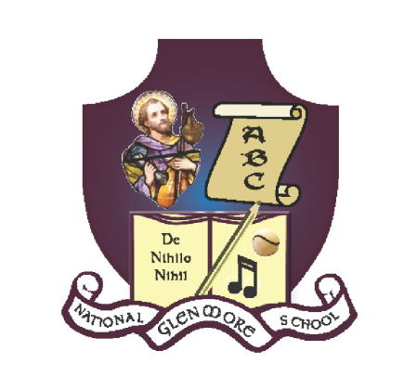

Glenmore N.S.
Newsletter

October 2021.

Welcome back
A very warm welcome back to all our pupils and parents. A special welcome to those who are coming to Glenmore NS for the first time this year.
Thank you for your help, cooperation and support in helping us re-open safely. We hope that this will continue.

Drop off
Drop-off time for all children is from 8.50 am- 9.00 am. Supervision of children starts at 8.50 am. The BOM of Glenmore NS accepts NO responsibility for the health and safety of children on the school grounds before this time. Parents are advised to only drop children off at the allocated time.

Collection.
Junior and Senior Infants will be brought to the gate at 1.40pm
Children who travel by bus will leave the school at 2.25pm.
1st & 2nd class children will be brought to the gate for collection at 2.30pm
3rd & 4th class children will be brought to the gate for collection at 2.35pm
5th & 6th class children will be brought to the gate for collection at 2.40pm
Should there be any change to the normal arrangements for dropping off or collection of your child, please inform the school by sending in a letter or by phone/email.

Parking
Parking at the school is limited. Please park safely and in such way that does not obstruct traffic or pedestrians. If you are using the lined parking spaces, please ‘Reverse in, Drive out’. Please leave the disabled parking space for those that need it. Do not stop at the school gate

Absences and return to school declarations
The school must tell the statutory Educational Welfare Services of the Child and Family Agency if your child has missed 20 days or more in the school year, or if it is concerned that your child is missing too much school. If your child misses school, you must send in an explanatory note on their return. A Return to school declaration must be filled in and returned to the school following ANY absence from school. This can be done by email & is available to download on the school website. Hard copies are available from your child’s class teacher or from the office.

Fees for school year
Fees for the academic year are now overdue. This money covers the cost of providing books on the Book Rental Scheme, photocopying costs and Art & Craft costs. These fees can now be paid online. All outstanding payments have been sent to parents by text message. A reminder text will also be sent. Thank you to those who have already paid. Please contact the principal if you would like to set up a payment plan. Strict confidentiality is assured.

Secretary’s Hours
Our school secretary, Mary Mackey is available in the school at the following times:
Mondays, Tuesdays, Thursdays and Fridays from 9.00 am to 11.30 am.

Future Enrolments
If you, or a family member or neighbour would like to enrol your child for September 2022 or future years, an enrolment form is available to download from the school’s website. Please pass this information on to any interested relatives, neighbours or friends.

Appointments during school time.
We strongly advise parents to make dental and other appointments outside of school time. However, if this is not possible, please inform your child’s teacher prior to the appointment.

Healthy Eating/ Lunches
In Ireland over 20% of children are obese. In an effort to combat this statistic, Glenmore NS operates a Healthy Eating policy.
Sandwiches, fruit, vegetables, cheese and yogurts are recommended for lunches. Water or water with no added sugar cordial is recommended as a drink.
Please avoid giving snacks that have high levels of sugar or salt. Fizzy drinks, sugary drinks, popcorn, crisps are not recommended.
One small treat is allowed on Fridays.

Website
www.glenmorenationalschool.com is our school’s website. Please keep an eye on this for regular new and updates. This, and future newsletters will be available on the website.

Planned school closures for Academic year 2021-22.
October 25th - 29th - Halloween Mid- term.
December 23^{rd –} January 5^{th –} Christmas Holidays. School closes Dec. 23Rd @ 12 noon. School reopens on January 6th @ 9.00am
February 24th & 25th - February Mid-term.
March 17th & 18th - St. Patrick's Day
April 11^{th –} April 22^{nd –} Easter Holidays. School closes 8th April @ 12 noon, reopens Monday April 25th @ 9.00am
May 2nd - school closed, May Bank Holiday weekend.
June 3rd & 6th - school closed, June Bank Holiday weekend.
June 24th - school closes at 12 noon, Summer Holidays

First Confessions and First Holy Communion.
On Thursday 16th September 12 children from Glenmore NS made their First Penance in preparation for First Holy Communion which took place on Saturday 25th September at 2.00pm. It was a beautiful, sunny day and all the children looked very well in their suits and dresses. Sarah Mackey sang beautifully on the day and was accompanied by Noel O’ Regan. A big thank you to Mr. Grant for preparing the children for the big day. Thank you also to Fr. O’ Toole and to all the parents. It was a very special occasion.

GAA Coach.
A big thanks to PJ Ryan, GAA coach, who visited the school on Tuesday 21st September and worked with children from 5th & 6th class. All children really enjoyed the drills and games.

School insurance
Allianz insurance provide insurance cover to primary school children. Each child has received a form. Please return this at your earliest convenience. For €9.00, 24 hour insurance is provided which covers all health and dental related injuries, including trips to the emergency department.

Safety and Control Measures
The BOM, school leadership and staff are very conscious of the paramount need to keep all pupils, staff and visitors safe while in the school. The school is a controlled environment. There are control measures in place to combat the introduction or spread of COVID -19. These are based on:
- Physical Distancing
- Hand Hygiene
- Respiratory and Hygiene Etiquette
- Mask Wearing, by adults at all times on or near the school
grounds.

Covid-19 guidance for collecting / dropping children and visiting the school.
Covid-19 is still with us as we start a new academic year We need to stay alert
and always follow the public health guidance.

All adults must wear a face-covering and practice 2 metre social distancing when collecting or dropping off your child.

There is strictly no entry on to school grounds without first making an appointment. If you are dropping something to school for your child please ring the school to let us know you are dropping the item, leave it on the wall at the front of the school and a member of staff will collect and drop it off to your child.

Computer Classes
Children from 1st class to 6th class will be taking part in computer classes for 12 weeks this term. The aim is to teach children computer skills such as typing, editing and producing documents. There is no charge to parents for these classes this year. They are being funded by an ICT Grant and also subsidised by the Parents’ Association.

Swimming
It is hoped that children from 3rd class to 6th will take part in swimming lessons in the Apex Pool, New Ross after Christmas. More details to follow closer to the start date.

Contact Details.
If your contact details have changed over the summer we would ask you to forward the new details to us so we have the correct ones on file should we need to contact you during school time. New details can be forwarded to the office via email at glenmorens@gmail.com

News from Ms. Keane's Room.
The boys and girls from Junior and Senior Infants have been very busy over the month of September. The new Junior Infants are settling in really well into their new surroundings and into a whole new routine. They have made a great start and have made lots of new friends. Senior Infants have been great helping both Ms. Keane and the Junior Infants out. Not only that, but there are lots of girls and boys taking up swimming, soccer, dance, athletics, hurling and camogie after school. Well done to everyone!

News from Ms. Kelly’s Room.
Last week we had a Blackberry Jam making competition among all the children of 5th and 6th class. We had 9 entries. All the children had the chance to taste all the different jams and vote for their favourite one. Congratulations to Kate Ryan, 6th class who won the overall prize.

The children of 5th and 6th class all took a guess at the final score of the All Ireland Football Final between Mayo and Tyrone.
Well done to Richard Claridge, 5th class whose guess was the closest.
News from Mr. Moore’s Room.
In First and Second Class we completed a project based on Japan. We had originally completed research and lessons on the Olympic Games which led us nicely into an exploration of Tokyo and subsequently Japan. The children all worked together to create the project and the display which is now proudly hanging up in the corridor of our school. They each completed a Fact File on Japan, from which we included information such as the flag and national anthem, history and culture and famous brands of Japan in our final display. Everyone also coloured and designed their own kimono and we learned about traditional dress in Japan. The project was a great success and we are looking forward to completing more projects on different topics in the near future.

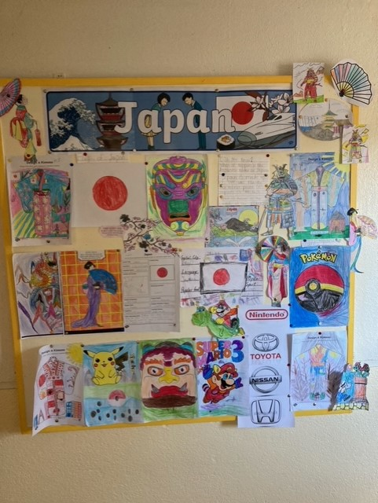

News from Mr. Grant’s Room
The children from 3rd & 4th Class have been busy doing some beautiful art work which included leaf silhouettes and leaf collages. They have also been learning about Origami and how to do it. The children are also reading and researching the Amazon Rainforest. During September the Kilkenny Mobile Library visited the school and the children enjoyed visiting the library and choosing their books.

Dates for your diary.
- Scholastic Book Fair will take place from 15th to 19th November 2021.
- Confirmation for 1st Years will take place on Saturday 23rd October 2021.
- Confirmation for 5th & 6th class will take place in the Spring of 2022.
- First Holy Communion will take place on Saturday 14th May 2022.
- Halloween Dress Up: Friday 22nd October. €2.00 per child funds going towards the school.
- Midterm Break: October 25th - 29th

Hello Everyone!
As we begin a new school year we would like to extend our welcome to all parents and guardians, new and old.
We realise that only a small number of parents are aware of who we are, what we do, what our role is and how important it is for our children that the school can count on parental support and involvement. We would like to raise awareness about Glenmore Parents Association who support our children and school but most of all we would like you to get to know us.
Many of you know our faces from last year but for any of our new parents this is who we are:

Chairperson: Pam Doyle Committee Members: Gemma Doherty; Anita Croarkin;
Secretary: Deirdre Kinsella Claire Mullaly; Karen Byrne;
Treasurer: Anne Hanrahan Mary Mackey.

We are always looking for new members to join our team and would like to extend our invitation to all parents and guardians to join us for our AGM in the school on Tuesday 5th October at 8:15pm. Please come along and meet us all.
In case you are wondering what we do, the official role of the Parents Association is to work with the principal, staff and Board of Management to build effective co-operation and partnership between home and school.
The main focus of the Glenmore Parents Association to date has been fundraising. Last year we were once again restricted by covid 19 but we still managed the following events:
- Christmas raffle which raised €905.70
- Sponsored Walk which raised €1059.50
We are continuously working on effective ways of raising awareness of our school in our local community.
Committee members also organised refreshments for various events including the 6th class graduation, school sports day and Easter treats.
We are always busy helping Ms. Kelly and all our teachers to make our school as welcoming and inclusive for all on a daily basis.
Following a meeting with Ms. Kelly, this year we plan to use funds raised to:
- Purchase Science equipment and resources to be used at all levels within the school.
- Subsidise a computer literacy programme for 1st – 6th Class which is a wonderful initiative that we are delighted to be part of as it will hugely benefit our children.
- Subsidise swimming lessons for children from 3rd – 6th class to lower costs for parents.
- Subsidise 6th class graduation costs
- Funding for miscellaneous resources for the Infant room.
We look forward to another successful year ahead for Glenmore National school and appreciate all your support to date. Please save the date October 5th for our AGM!!

Glenmore Parents Association.

