**Green Tea Tablets 9000mg (60 Tablets) Strongest Legal Green Tea Extract 100% Pure Certified**

* Maximum strength 450mg Green Tea Extract 20:1 (9000mg green tea leaf equivalent) standardised to provide 95% Polyphenols, 45% Catechins (EGCG) & 7% Caffeine.
* Powerful natural antioxidant compounds that has an abundance of health benefits.
* Maximizes weight loss by stimulating and enhancing metabolic function.
* Each component of BioPharmX advanced formulation has been highly refined and exceeds the HIGHEST pharmaceutics purity standards.
* Manufactured in an FDA and MHRA approved facility for your highest level of safety.

## Product Description

### Green Tea Extract Tablets - 60 Tablets (2 Month Supply)

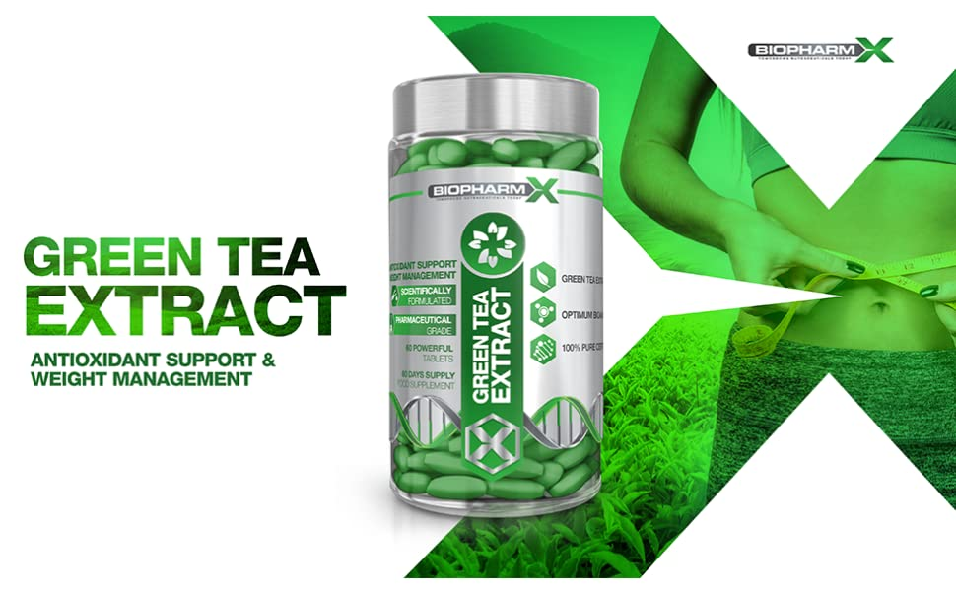

The chemical composition of Green Tea extract is diverse, unique and complex and with many compounds being unique to green tea itself. This duel action fat burner is not just remarkable for weight loss aid but also delivers a wide range of benefits for general health.

Why not just drink Green Tea? Each tablet contains 450mg of ultra-potent, pharmaceutical grade Green Tea Extract 20:1 (9000mg green tea leaf equivalent) standardised to provide 95% Polyphenols, 45% Catechins (EGCG) & 7% Caffeine. In order to achieve the same benefits as 1 BioPharmX Green Tea Extract tablet, one would have to drink an insurmountable of green tea per day.

Essential for:

* Increased Fat Burning for Energy
* Whole Body Antioxidant Support
* Cell Protection from Oxidative Stress
* Powerful Anti-Inflammatory
* Healthy Lipid Profile
* Essential Minerals for Overall Health

### The following benefits have been identified in published studies and clinical reports surrounding Green Tea and its numerous bioactive compounds.

|  |  |  |  |
| --- | --- | --- | --- |
| **green tea extract** | **green tea extract** | **green tea extract** | **green tea extract** |
| Weight Management Green Tea extract contains bioactive compounds polyphenols, EGCG and caffeine - all have been shown to induce thermogenesis, stimulate fat oxidation and significantly boost metabolic rate.  By super charging the metabolism, Green Tea enables the body to break down and burn through fat stores rapidly as well as using consumed calories for energy rather than storing them as fat and other lipids! | Whole Body Antioxidant Support Biochemical analysis has clearly demonstrated Green Tea’s ability to provide whole body antioxidant support as a potent antioxidant to neutralize free radicals.  As you age your naturally defense against free radicals becomes less effective, as cells accumulate free radical damage over time - so that’s why research shows that high levels of antioxidants can prevent many age related diseases by preventing free radicals from oxidizing biological molecules. | Powerful Anti-Inflammatory EGCG has successfully demonstrated its anti-inflammatory effects. The natural anti-inflammatory compound works by targeting multiple diverse steps within the inflammatory pathway and effectively reduces inflammation at a molecular level.  Boosts levels of GABA, serotonin and dopamine: All are important neurotransmitters in the brain that work to regulate mood, emotions, alertness, concentration and sleep. | Mental Health & Well-being L-theanine is an exclusive amino acid found in tea plants which is responsible for the taste of green tea. It acts as a neurotransmitter in the brain which works to promote feelings of relaxation and facilitates a better night’s sleep by stimulating numerous mechanisms within the brain.  Consuming Green Tea during times of stress has been shown to induce relaxation by reducing markers of psychological stress by up to 50%! |

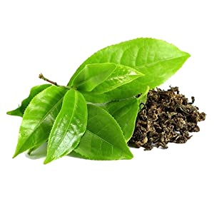

### In order to achieve the same benefits as 1 BioPharmX Green Tea Extract tablet, one would have to drink an insurmountable of green tea per day.

BioPharm-X manufacturing department is an MHRA licensed, GMP certified and ISO accredited, operating within compliance of all relevant laws and regulations.

* Maximum Strength Green Tea Extract
* Pharmaceutical Grade Ingredients
* GMO Free
* Suitable for Vegetarians

### BioPharmX: Superior Standards in Nutritional Supplements

|  |  |  |
| --- | --- | --- |
| **green tea extract** | **green tea extract** | **green tea extract** |
| Leaders in Nutritional Supplements BioPharmX has the goal of enhancing the well-being of their customers around the world by delivering premium quality, best value nutritional supplements.  Each tablet has been formulated to safely provide significantly more then other Green Tea Extract supplements on the market. | Premium Quality Every bottle is manufactured in a fully licensed facility, using only premium graded ingredients.  Rest assured that we would never consider manufacturing an item that did not fully meet these requirements. | Directions for Use Adults: As a supplement begin by taking 1 tablet in the morning on an empty stomach with at least 8fl oz of water.  Do not exceed stated dose in a 24-hour period.  Use only as directed. |

### Ingredients

Green Tea Extract 20:1 (450mg) 95% Polyphenols; 45% EGCG