**The Zero Carbon Bill and Methane: recognising the problem**

Les Jones

[www.climatefirstnz.org](http://www.climatefirstnz.org)

9th September 2018

Summary

This essay investigates the proposal that methane, because it is a short-lived greenhouse gas should be merely stabilized at a lower level than present, while Carbon Dioxide, because it stays in the atmosphere for centuries, needs to be reduced to zero by 2050. Recent publications such as the consultation document on the Zero-Carbon Bill, *The Low-Emissions Economy* by the Productivity Commission and *New Zealand’s Methane Emissions from Livestock* by the Commissioner for the Environment have all focused on this issue, but only the last has modelled actual reductions and their effects.

My research has revealed:

That compared to methane, our net CO2 emissions are very low and had been negative until 1999, only rising because of a big increase in road transport and a collapse in the forest sink, both of which unfortunately, show no signs of stopping.

New Zealand’s methane emissions have been stabilized for the last 26 years since 1990, with rising dairy emissions replacing falling sheep emissions. But these emissions are at too high a level.

The target of zero net emissions by 2050 is inadequate because it only names a level of emissions in a specified year, without accounting for all the accumulated warming that will take place between 2019 and then.

How methane is measured relative to CO2 is a conflicted area, so I have developed a new measurement method called ‘real time’ which I have used to track New Zealand emissions for 100 years from 1950 to 2050. While this metric might be scientifically naïve compared with say Andy Reisinger’s excellent *The contribution of methane emissions from New Zealand’s livestock* (2018), it is straightforward for the public to understand. Two scenarios are modelled – one with steady emissions from 2016 onwards and the other with a 3% year on year reduction in both methane and CO2 from 2019 onwards and the sink remaining at the 2016 level of 22.7 Mtns. This represents a 62.5% reduction in both gases by 2050

The second scenario leads to negative net CO2 emissions from 2030 onwards, thus freeing up sequestration to offset methane emissions. No other report has quantified how our forest sink should be fairly apportioned between offsetting methane and offsetting CO2.

By measuring warming effect in any year the two basket approach is shown to be wrong and even worse, a con, because it counts the short-lived qualities of methane twice – once when bringing it into the Inventory at GWP100 and a second time by intending to treat them more leniently than CO2 into the future.

The warming effect value of methane in 2050 is 1,161 Mtns CO2e while that of net CO2 is only 45 Mtns, 25 times less The conclusion must be that the focus of New Zealand’s climate change efforts should be on methane, not CO2

The Zero Carbon Bill consultation proposes three options:

1. Net zero Carbon Dioxide by 2050, but not other gases
2. Net zero emissions by 2050 of long-lived gases (CO2 and Nitrous Oxide) and stabilized emissions only of short-lived gases (Methane)
3. Net zero emissions by 2050 across all gases

Although these targets appear to be simple choices, they conceal a minefield of problems and questions merely concerning what they mean, let alone how to reach them.

**Option1.** Is too easy. Prior to 1997 New Zealand always had negative net CO2 emissions as can be seen in chart 1. Even in 2016 (the most recent Inventory), our net emissions of CO2 were only 11.76 million tonnes. This represents the difference between our gross emissions of 34.46 Mtns and our forest sink of -22.7 Mtns. Thus CO2 is only one third of our methane emissions of 33.68 Mtns. A reduction from 11.76 to zero over 32 years is a laughably inadequate target.

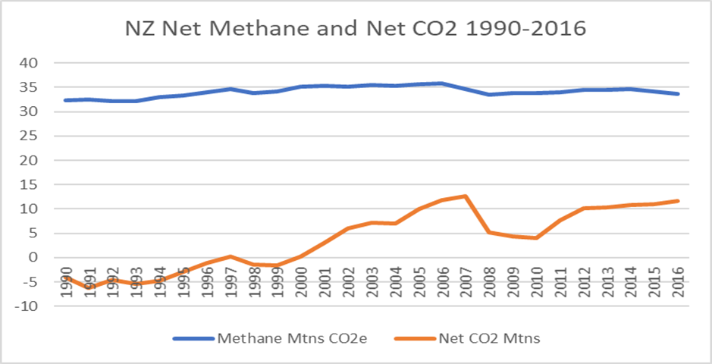Chart 1. NZ methane and net CO2 emissions 1990-2016

**Option 2. Net zero CO2 and merely stabilized methane.**

Option 2 cannot be understood without answering the question. “At what level should methane be stabilized?” Most people don’t know it, but NZ methane levels have been stable for at least 26 years. (Chart 1. Above). In fact, the 2016 level of 33.68 Mtns is exactly the average of the years 1990 to 2016. The problem is that methane is stabilized at too high a level. No matter what level methane is stabilised at, it will still be causing warming.

In turn, the question of the level of stabilization cannot be answered unless we consider three other questions.

1. How do we measure the methane we emit?
2. How do we measure the target?
3. How is the forest sink to be allocated between offsetting CO2 and offsetting methane?

**1. “How do we measure methane emissions anyway?”**

Measuring CO2 is easy; we assign it a global warming potential value of 1, which means that the 34.46 Mtns of CO2 emitted in 2016 caused 34.46Mtns of warming, measured in CO2 equivalents (CO2e). With methane its harder; although NZ produced only 1.2 Mtns of methane in 2016, it is a much more powerful heat-trapping gas in the atmosphere. In the year it is emitted it causes 120 times more warming than CO2. However, an allowance has been made for the fact that unlike CO2 which stays in the atmosphere for centuries, methane is short-lived, breaking down largely in 12 years, after which it has little warming effect. For example, its 10-year warming effect is 105 times CO2, its 20-year effect is 86 times CO2 and its 100-year effect is 28 times CO2. (NZ Productivity Commission) The measurements of these effects are called Global Warming Potential (GWP). Chart 2. shows New Zealand’s emissions of gross CO2 and methane from 1990 to 2016, using both GWP 100 and GWP 32. This shows that methane emissions are much higher than of CO2, measured using GWP32, but similar using GWP100

Chart 2. NZ emissions 1990-2016 for Gross CO2, Methane, both GWP100 and GWP32.

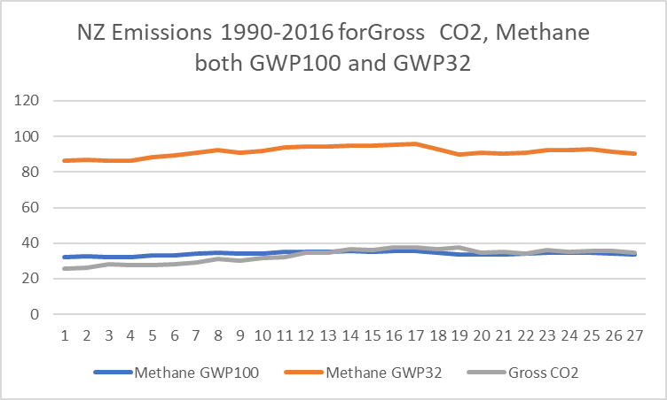

It is the last measure (GWP100) which the international community has chosen by which to report methane’s effect. Thus NZ’s 1.2 Mtns of methane caused 33.68 Mtns (1.2x28) of warming measured in CO2 equivalents (CO2e).

There are four problems with this measure which is an evasion, belittling methane’s true warming effect.

Problem 1. If methane is a short-lived gas, why do we measure it over 100 years when it only lasts 12 years? Consider a parallel illustration: Someone drinks 10 beers and when driving home is stopped by the police and found to have a blood-alcohol level of 120 mg, well over the limit. They say “I want my alcohol reading to be allocated over 10 days, so that it comes out as 12 mg.” We wouldn’t accept this ruse, so why do climate scientists accept it? The alcohol in the blood breaks down over a similar trajectory as methane, but here’s the issue; because methane emissions are stable (i.e. the same amount is emitted each year), it is the equivalent of drinking another 10 beers tomorrow and again the night after that, so the alcohol level will never fall. What we are looking to answer is how many beers the driver can drink the next day and be under the limit.

The NZ Productivity Commission in its recent publication, *The Low-Emissions Economy,* seems very confused. “Some researchers have criticised GWP100 for under-valuing emissions of long-lived gases, and over-valuing emissions of short-lived gases, if the aim is to limit peak warming (Forster et al., 2007; Shine et al., 2007; S. M. Smith et al., 2012). Ocko et al. (2017) also criticised it for under-valuing emissions of short-lived gases, and over-valuing emissions of long-lived gases, in the context of short- and medium-term temperature change.” (P. 252) Surely GWP100 either undervalues methane or it overvalues methane – it can’t be both!

Secondly, the attitude towards methane differs between countries. “GWP was not originally intended to be used in policy. Tanaka et al. (2010) note that it was used in the first IPCC report only to illustrate the difficulties inherent in the concept. One history of GWP also suggests that it was supported as a policy tool because the economies of most countries (especially most developed countries) are based on activities that cause CO2 emissions. So, a metric showing that emissions reductions of other GHGs are worth “more” than CO2 reductions was welcomed because these were likely to be cheaper and easier to abate (Skodvin, 1999).” (P.252). New Zealand, on the other hand , because it emits more methane, has a vested interest in downplaying methane, hence the attraction of GWP100 rather than GWP32. The confusion mentioned in the previous paragraph leaves NZ clearly agreeing with the first camp, which to me is wrong. GWP obviously under-values the warming effect of methane in the short term.

**Problem 2**. Humanity does not have 100 years to fix climate change. If we don’t act in the next 10 years, it will be too late to stop 2 degrees C of warming, and the earth’s climate will switch to a state which is not conducive to human survival. Therefore, we need to measure methane’s effect over a shorter time i.e. 32 years, in which case its effect is 75 times CO2 and NZ’s methane emissions become 90 Mtns, not 33 Mtns.

**Problem 3**. This government has chosen 2050 as a target year to get our emissions under control. Surely it would be more honest to measure methane’s warming effect over the 32 years to 2050.

**Problem 4.** This is the evasion involved in the offhand description of methane as a short-lived gas, giving the impressions that it somehow fades away after a few years and we don’t have to worry about it too much. This is wrong because its short-lived quality has already been accounted for by giving it a GWP of 28 times CO2. That means that methane emitted in a certain year, instead of being counted at 120 times CO2, is only measured at 28 times, because it breaks down quickly. The conclusion must be that methane is to be treated as the equivalent of CO2; in other words, because it is expressed in CO2e, it must be reduced as much as CO2 is. Therefore, option 2 of the zero-carbon bill is a sleight-of-hand, counting methane’s short-livedness twice! Once when bringing it into the Inventory, using GWP of 28, and then again in proposing to treat it more leniently because it is “short-lived”.

**2.How do we measure the target**

Our target only measures emissions in the 2050 year but does not consider the effect on the atmosphere of all the accumulated emissions between now and 2050. The zero-carbon bill is aware of this and on page 13 of the consultation document it mentions emissions budgets – “They set out how much greenhouse gas we can emit over a period of time, for example five or six years” Unfortunately this contradicts the idea of a target of “zero net emissions by 2050.” If it was serious about having a budget it would be expressed as say “Emit no more than 600 Mtns CO2e between now and 2050.” I imagine their budgets will be in the form of “net emissions of 56Mtns by 2018, 40 Mtns by 2030, 20 Mtns by 2040 and zero by 2050. In fact, it is the warming caused by the accumulated gases in the atmosphere, not the amount emitted in 2050, which will determine whether we stay under 2 degrees of warming.

In order to investigate the true extent of methane’s warming so that both a measuring system and a target definition can be arrived at, I have run two scenarios tracking emissions of methane and CO2 over 100 years from 1950 to 2050. In the first I assume that levels stay steady at the 2016 level from 2019 through to 2050. In the second a 3% year on year reduction in both gases is modelled. Determining the emissions in the 2050 year is easy. In scenario 1 they are the 2016 values of 34Mtns for CO2 and 33Mtns for methane. In scenario 2 with the 3% annual reduction applied the values are 12.2 for methane and 12.7 Mtns for CO2. Obviously, a sink of 24.9 Mtns, well below our 1999 sink of 33.4Mtns, would lead to zero net ghg emissions in that year. However, if one wants to measure the warming effect in 2050, one has to consider more than one year’s emissions. In fact, all the ghg still in the atmosphere from the last 100 years is adding to the warming, and this is much more complex to measure. To accomplish this I have used three measuring systems for methane: “real- time measuring”, cumulative GWP100 and cumulative GWP32. For CO2, which lasts more than 100 years, I have simply added all the annual values together

**Scenario One: Both CO2 and methane emissions remaining constant at 2016 levels through to 2050**

First, we need a breakdown trajectory for methane over 100 years, Table 1.

Notes: This trajectory is not scientifically derived. It merely reconciles four factors: “methane breaks down in 10-12 years,” Dr David Frame’s observation that “after 50 years there is 5% of the methane left”, “ GWP 100 is 28” and “GWP20 is 86”. My GWP values, taken from table 2 are GWP100 = 16.9, GWP20 = 62.2, well below the standard. Thus, my postulated trajectory is very conservative, still well below 28. As a consequence, any result using this trajectory will understate the true effect of methane,

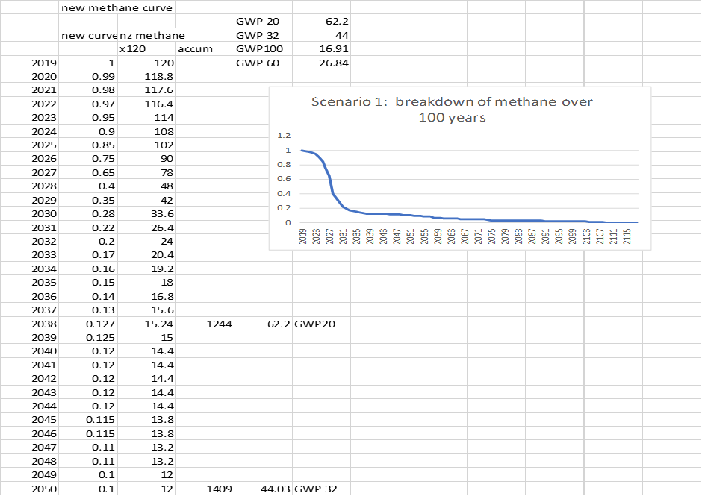**Table 1. The postulated breakdown of methane, the first 32 years.** Note the full table (not shown here) spans 100 years and thus gives a value for GWP 100 as well.

The point of fixing future methane emissions is to demonstrate that unless there is a drop in methane emissions its warming effect will not reduce. Table 2 is the beginning of the methane spreadsheet which covers 100 years.

Table 2.(Extract). New Zealand’s accumulated annual methane emissions 1950-1961



Note that this is only the first 12 years of the table which tracks methane over 100 years. The full spreadsheet can be found at <https://www.climatefirstnz.org/>

**Explanation of Table 2.**

Column one is the generic breakdown trajectory of 1 unit of methane over its first 24 years, as explainedabove in the presumed methane breakdown curve, Table 1. Note that after 12 years it has reduced to 22% of its original value.

Column two tracks the .9 Million tonnes of methane emitted by NZ in 1950 as it breaks down over 12 years, while column three tracks the .9 Mtns emitted in 1951 over its first 11 years.

Each horizontal row, on the other hand, calculates the amount of methane present in the atmosphere for any year. For example, in 1950 there was only .9 Mtns. But in 1951 a new .9 Mtns was added to the .89 still remaining from 1950. Similarly, in 1952 there were three amounts – the current year plus the previous two years. One could argue that in 1950 there were in fact all the residues from the previous 100 years. However, we have to start somewhere, and the whole purpose of tracking methane over 100 years is to get a realistic picture of what happens to methane over the long term, i.e. by 2050. I call this the ‘real time’ method.

**Table 3. NZ methane and CO2 emissions tracked over 100 years from 1950 to 2050 with assumed constant levels of both gases from 2019 onwards. Note. This table is the result of the complete Table 1950-2050.**



Explanation for Table 3.

Column one gives the methane in the air from NZ emissions in any one year in millions of tonnes of methane, as calculated by the complete spreadsheet, using what I call the real-time method

Column two gives the warming effect of this in any one year, by multiplying by 120, the global warming effect of methane compared to CO2 in the year that it is emitted. Note that in the 2050 year the warming effect of all the methane emitted in NZ over the last 100 years is 2012.7 Mtns CO2e. This is far greater than the methane emissions from that year alone of 144 Mtns CO2e!

Column three gives NZ’s annual net CO2 emissions, (the gross emissions less the sequestering of CO2 by the forest sink).

Column four gives the warming effect in any year based on accumulated emissions still in the air. Note that in the 2050 year, the total warming effect of all the net CO2 sitting in the atmosphere since 1950 (498.84 Mtns) is less than a quarter of the warming effect of the methane in the atmosphere in the same year.

Column five represents the annual gross CO2 emissions.

Column 6 shows the accumulated gross CO2 levels, with the warming effect in 2050 being the equivalent of 2670 Mtns of CO2e.

Column seven gives the annual size of NZ’s forest sink, where known. Note the post 2019 value is the 2016 value of22.7. The 1990-2016 values are from the 2018 Inventory. The pre-1990 value is difficult to establish, however, it is assumed, considering that there were large forest plantings in the 30’s and 50’s and the 1990 value is 29 Mtns, that the sink was large enough to ensure negative net CO2 values pre 1990. Thus, the net CO2 emissions from 1950 to 1989 are rated at zero.

Column eight gives the annual methane emissions using GWP100.

Column nine gives the accumulated warming effect of the annual emissions from column 8. The 2050 figure of 3,101 seems very high compared to the real time figure of 2,012 which must cast doubt on the legitimacy of simply adding up all the annual emissions. While the accumulation process is very straightforward for CO2 (simple accumulation), calculating the accumulated effect of methane using GWP100 is very hard to visualise. However, there is no doubt that in using the GWP100 multiplier 28x instead of the one-year multiplier of 120x, the breaking down of methane must have been taken into account.

Column ten gives the annual value of methane for 32 years (i.e. 2019 to 2050) using GWP32

Column eleven gives the accumulated warming effect of column ten’s emissions over 32 years

Conclusions.

I wanted to establish that the way to calculate accumulated warming of methane was to simply add up all the annual values, as long as the period concerned was 100 years. By doing the real time calculation (column 1 and 2) I had a way to test this idea. The result of accumulated warming in the 2050 year using real time was 2,012 Mtns while the accumulated GWP100 was 3,101 Mtns and the GWP32 accumulated warming was 2,886 Mtns over 32 years. However, my GWP100 value was 16.9x compared to the standard of 28x. If we correct for this (2012 x 28/16.9 = 3,333) the value is too large. Given that my supposed breakdown graph is an approximation (Table 2), this result is probably accurate enough.

The accumulated CO2 result in 2050 is 2670 (Column 4)

Therefore, I conclude that in 2050 if methane and CO2 levels remain steady at 2016 levels through to 2050, the warming effect on the atmosphere of both gases will be similar, of the order of 2670 -3100 Mtns. This is an alarming amount of warming, however this is cumulative warming, not annual warming in the year 2050 in which terms the government’s target is framed. The question then needs to be asked as to whether accumulated warming of this magnitude is compatible with keeping the world under 2 degrees of warming.

**Scenario 2.**

**Table 4. Methane and CO2 tracked from 1950 to 2016 and modelled forward to 2050, assuming a year-on-year reduction of 3% from 2019 onwards in both gases**. The complete spreadsheet from which the table is derived can be found at www.climatefirstnz.org





**Explanation for table 4.**

**Column one** shows the amount of methane in million tonnes of methane in the atmosphere in any one year. As explained above, for 2050 for example, it includes all the residual methane remaining in the atmosphere from the last 100 years.

**Column two** shows the actual warming effect of the amount of methane in column one. This is calculated by multiplying by 120, the number of times stronger methane is than Co2 as a warming agent in the year that it is emitted. Thus in 2050, the warming caused by all the methane emitted by NZ over the last 100 years is the equivalent of 1161.86 million tonnes of CO2. In other words, 92 times more than the warming effect of the actual 0.45 Mtns (12.6 Mtns CO2e) emitted in 2050 alone!

**Column three** shows annual gross CO2 emissions.

**Column four** is those annual emissions accumulated. Thus in 2050, the warming effect of all the gross CO2 from the last 100 years is 2217.87 million tonnes, double the warming effect of methane in that year, due to the 3% a year reduction in methane from 2019 onwards.

**Column five** is the forest sink as far as it is known.

**Column six** shows our annual net CO2 emissions. Note that by retaining the sink at the 2016 value of 22.7 Mtns, the 3% annual reduction in gross CO2 emissions results in negative CO2 emissions from 2030 onwards. This shows how easy achieving net zero CO2 emissions is compared to doing something about methane.

**Column seven** shows the cumulative net CO2 emissions which are rapidly approaching zero too.

**Column eight** gives, by way of comparison with column 1 the annual methane emissions according to GWP 100 (i.e. x28).

**Column nine** calculation gives a warming effect in 2050 of 2,702.04 million tonnes of CO2e. Note that this calculation method gives a different result to the real time calculation of column two. This is because the annual methane emissions have merely been totaled similar to CO2. While this produced similar values if methane and CO2 were kept at the 2016 value through to 2050, (See Table 3). When the gases are reduced, this is no longer a satisfactory method of aggregating the accumulated methane.

**Column ten** gives the annual emissions using GWP32

**Column 11** gives column 10, totalled over 32 years.

**Conclusions:**

There is some doubt whether annual amounts of methane, calculated using GWP, can be simply aggregated in order to arrive a total warming effect value for an individual year.

The ‘real time’ method was developed to test this and, in some situations, produces similar results.

Running the three measuring systems over both scenarios gives a more powerful calculation of the effect of both the stable emissions and the 3% reduction outcome.

While GWP gives a satisfactory reading for methane emissions in a single year (If agreement can be reached over the time span used!), it is perhaps unsuited to producing a reliable figure for total warming effect in that year. If so, then it is no use for measuring any target emission level except the single year one proposed by the Zero Carbon Bill. Therefore, in proposing a target which takes into account accumulated warming, I use in the first instance the ‘real time’ methane calculation method.

Summary of results from scenario 1 and 2. Total warming effect in 2050

|  |  |  |
| --- | --- | --- |
| **Methane** | **Scenario 1** | **Scenario 2** |
| Real time | 2012 | 1161 |
| GWP100 | 3101 | 2702 |
| GWP32 | 2886 | 1816 |
| **CO2** | 2670 | 2217 |

These results show that, as expected, a 3% reduction in methane has a much bigger effect, because of methane’s shorter lifetime, than a 3% reduction in CO2.

**How to allocate the forest sink to offset methane and offset CO2**

with option b) and c), a call as to by how much to reduce methane cannot be made until it is decided how the CO2 sequestered by the sink is to be shared between offsetting each gas.

It seems unfair that in Chart 1, all the sequestration by the forest sink is allocated against gross CO2, especially as much of the forests would be on rural land, where the methane release happens. Therefore, in developing a pathway for ghg reductions through to 2050, there seems to be a case to use the sink to reduce CO2 to zero, then use the surplus to offset some of the methane. This is only fair if a reasonable reduction in CO2 emissions is made too. This in turn depends on how you measure methane as discussed above, therefore I have adopted real time measure to calculate methane’s warming. The results of scenario 2 are interesting. Taking CO2 alone over 100 years, the total warming effect of all the accumulated net CO2 is only 45.85 Mtns or less, which is astonishing, whereas methane’s effect in 2050 is 1,161 Mtns, giving a total for all gases of 1,207.71 Mtns.

If the target is the annual amount emitted in 2050 the results are 12.71 Mtns for methane plus -10.47 for CO2 = +2.24 using GWP100. Or 34 + -10.47 = 23.53. (using GWP32)

Thus, it can be seen that the definition of the target is crucial, and that planning a trajectory for 2050 cannot begin until these doubts are sorted out.