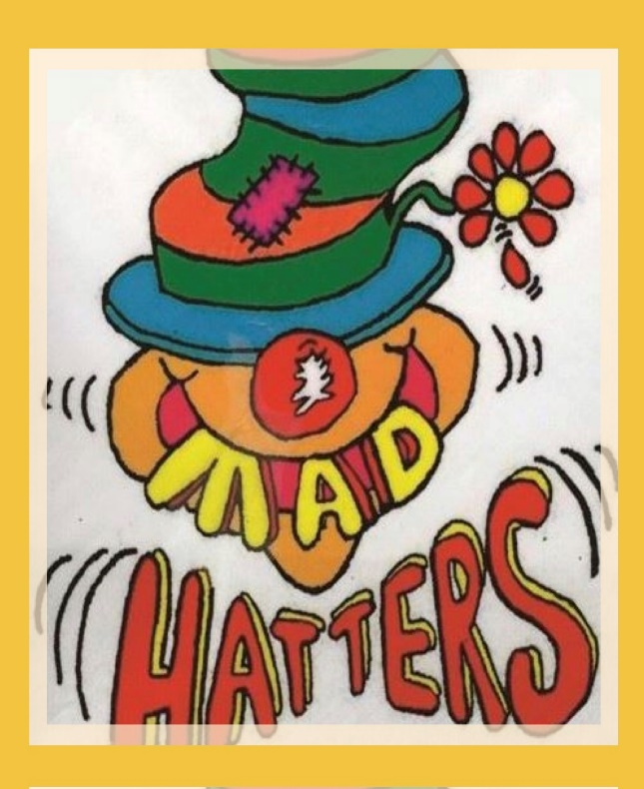

COVID-19 precautions

information for parents/carers.

September 2020

Dear Parents/Carers,

The purpose of this document is to give you a brief outline of the changes we are making to make the Mad Hatters as safe a place as possible for your children and our staff.

Our Risk Assessment is also attached to give a more in-depth outline.

**Operational times**

Change of operational times, to carry out the enhanced cleaning and preparations,

they are as follows:

* BREAKFAST CLUB: Opening time 8am
* AFTER SCHOOL CLUB: Closing time 5:30pm

We would be grateful if you could discuss what is covered here with your children before they return to the Club in order to prepare them for some of the changes we have made and reassure them that the Club is a safe place for them to be.

Staff will also be talking to the children about the new precautions throughout the first couple of weeks (or later if a child does not start coming to us until further on in the term) and be consistently reinforcing the new arrangements throughout this time of change.

If you have any questions about anything we have covered here (or anything else) please do not hesitate to get in touch.

**Bubbles**

Initially, our bubbles will be as follow:

* Bubble 1 will be Foundation Stage and Year One.
* Bubble 2 Year Two.
* Bubble 3 Siblings of the children in the 1st and 2nd Bubbles, from the Junior School Years 3 and Year 4. Junior year Key parents’ children.

All Bubbles will always be kept socially distanced from each other, unless there is an emergency, in which case the safety of children and staff will take priority over maintaining social distancing. Each Bubble will have their own allocated area inside and an allocated area outside for them to play in. Each bubble will also have their own selection of play resources/equipment which will be cleaned regularly. If equipment or resources are to be moved between groups, we will make sure they are either cleaned or ‘quarantined’ for 72 hours between uses.

**Dropping off/picking up**

* To limit risk of infection parents/carers will not currently be allowed to enter the Club buildings, so we will collect your child from you or drop them to you at the front door. We would also ask that only one adult come to drop off/pick up a child, that you maintain social distancing at all times if there is more than one family waiting at the door (the school have provided clear social distancing markers).
* Where possible can you please avoid lift sharing when travelling to/from school to help maintain appropriate social distancing.
* As you will not currently be able to enter the building, a member of club staff will sign your child in/out for you.

**Staff dropping off/picking up children from their classes.**

Children being escorted to and from the Junior site will walk in pairs with a another in their bubble. Bubble 2 and 3 will walk a safe distance apart from each other. They will not be wearing the clubs High Vis jackets at this time. The staff will wear their own allocated High Vis jackets to high light the group walking.

Infant school

* Staff will be taking children to their classrooms in the mornings at the designated time, making sure social distancing is maintained.
* In the afternoons we will collect the children from their classrooms.

Year Two

* Children will be escorted to and from the club to the designated place inside the gates, which is a safe distance away from other people collecting their children.

Junior School

* Children/young people will be escorted to and from the club to the designated place, a safe distance from other people collecting their children/young people.

**Hand hygiene**

All children and staff will be expected to wash or sanitise their hands on arrival at a session.

* We will be providing extra opportunities for hand washing/sanitising as appropriate, including, but not limited to after snack, toileting, playing outside and after coughing or sneezing.
* When lots of children will be needing to wash their hands at the same time (e.g. before afternoon snack) each bubble will have their own ‘handwashing station’ with soap, water and paper towels.

**Respiratory hygiene**

We will be promoting the ‘catch it, bin it, kill it’ strategy,

* Each Bubble will be provided with a box of tissues and a lidded bin to dispose of them.
* After using a tissue/coughing/sneezing children will be asked to wash their hands.

**Social distancing**

* We are putting various strategies in place to help ensure social distancing between the Bubbles.
* If a child is struggling with maintaining/understanding social distancing we will have a chat with them explaining what it is, and why it is important.
* If the child still struggles, we will inform the child’s parent/carer and ask them to have a talk with their child about it.
* If the child is still having difficulty maintaining social distancing after this, we may have to consider suspending the child’s place for now in order to ensure the safety of the other children and staff.

**Cleaning**

* Equipment/resources/tables etc will be cleaned regularly.
* We have introduced an Enhanced Cleaning regime for all the areas, to be used alongside our Daily Environment Checklist.

**Toys from home**

* We are asking that children do not bring in toys from home until further notice.

**Children attending multiple settings/groups**

* In order to reduce the risk of virus transmission as much as possible, we ask that, where possible, you limit the number of settings your children attend.

**Self-isolation guidance**

* We expect all families to follow the current government guidance re: self-isolating if someone in the household is showing COVID-19 symptoms, has tested positive or has recently returned from certain other countries (Government information about international travel can be found here: <https://www.gov.uk/foreign-travel-advice>). (The NHS page giving information about when and how to self-isolate can be found here: <https://www.nhs.uk/conditions/coronavirus-covid-19/self-isolation-and-treatment/when-to-self-isolate-and-what-to-do/>)
* If your child is ill or is starting to develop symptoms, please do not send them in to the club.
* If your child will not be attending a session because they are ill or self-isolating, please let us know asap.

**Government documents**

* The government have produced some guidance for parents and carers of children attending out-of-school settings during the coronavirus (COVID-19) outbreak, which you may wish to read. The link to find it is: <https://www.gov.uk/government/publications/guidance-for-parents-and-carers-of-children-attending-out-of-school-settings-during-the-coronavirus-covid-19-outbreak/guidance-for-parents-and-carers-of-children-attending-out-of-school-settings-during-the-coronavirus-covid-19-outbreak>

**Please note that all arrangements are subject to change depending on government guidance or a change in circumstances. If we make any significant changes to what is written here, we will inform you as soon as possible.**

**Look forward to seeing you all,**

**Sue Fisher**