Auerstaedt : a typical game, and its alternate victory choice

Auerstaedt is not only the first game I ever made, more than 30 years ago, it is also the most fast-paced, well balanced, “everything can change in one turn” battle I know. Both sides have good (and very good) troops, bigger units and better average morale on the French side and more cavalry on the other. The Prussians start with the odds, but are quite limited on what they can do : no forward movement of the first column, and their cavalry start disordered. The French only have one division on the board.

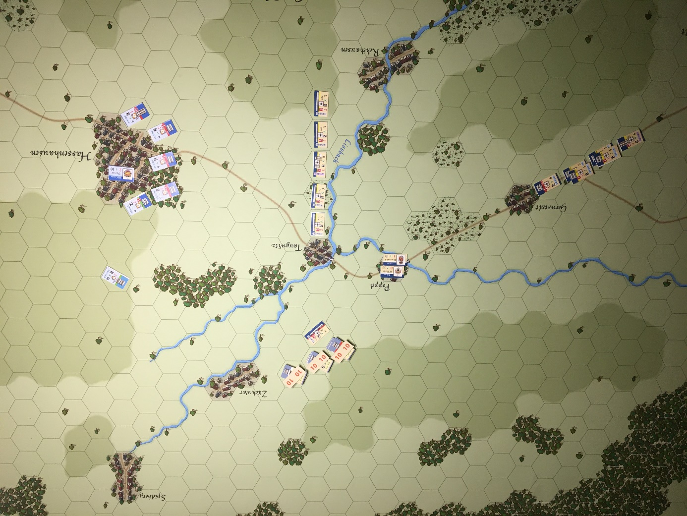
The initial set up is quite conservative: the disordered cavalry is out of reach of the French, for now, and can rally at the end of the next turn.
I just realize that the grenadiers unit of the second column should be “west of the crossroads”, per the rules, and not just before Gernstedt. Oh well.
I chose for this simple demo to use none of the command and control rules.
At this stage, the Prussian do not have much choice, they have to wait for their second column to be available, and bit by bit their cavalry. The French would probably not wait at this time, and attack right away. I would. But waiting for reinforcements is also possible, as they know the Prussians are not a threat in the first couple of turns.
Let’s see two turns later.
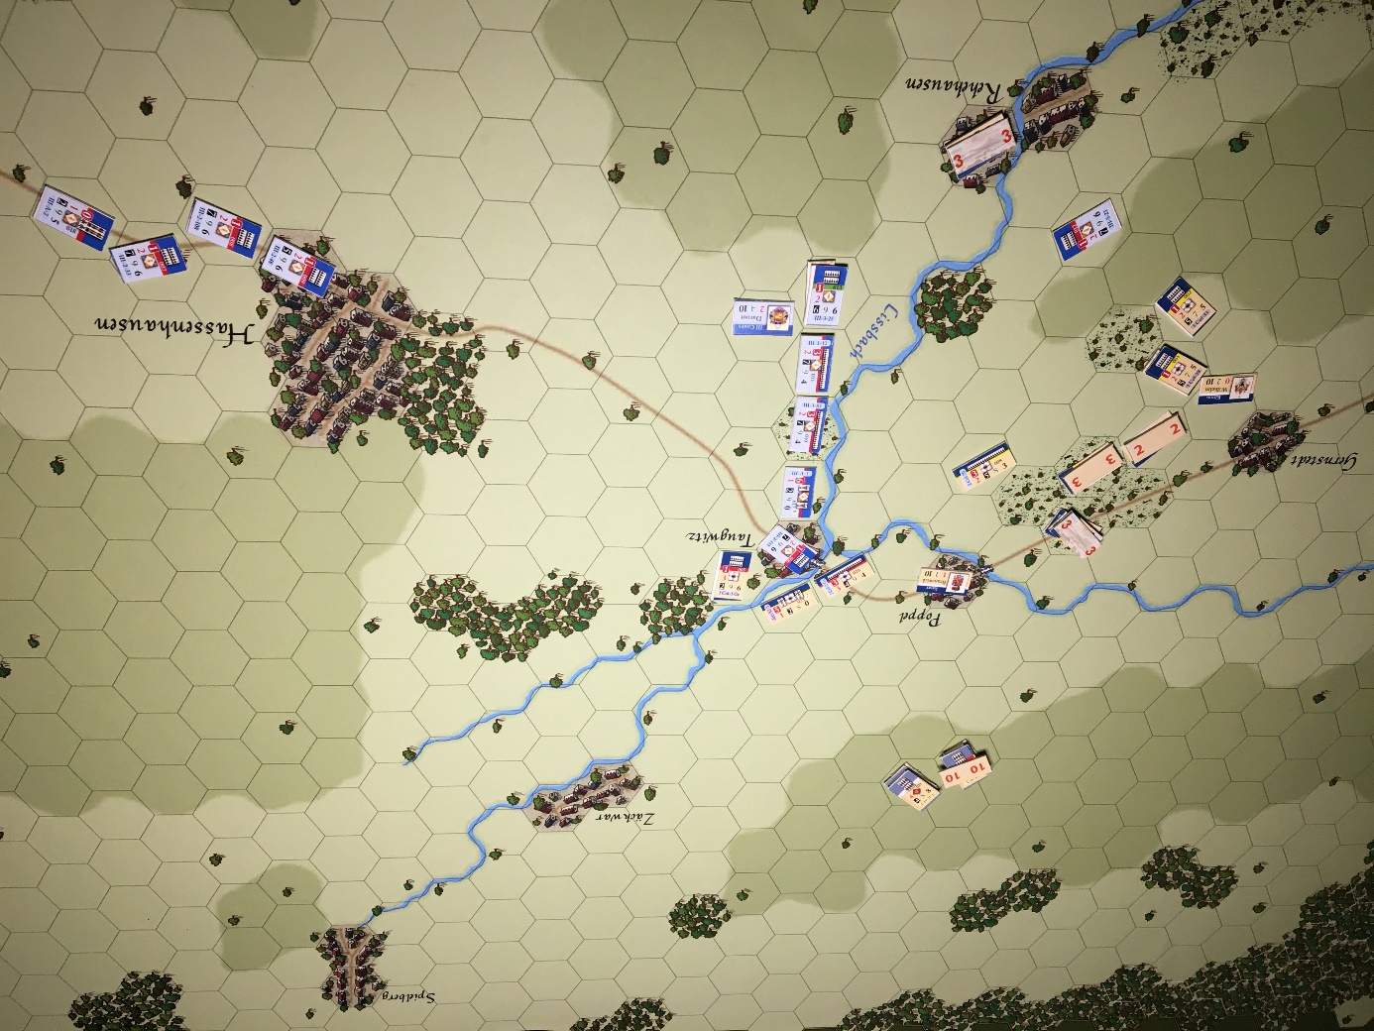
At the end of turn 3, the initial French attack paid off, 4 of the first line Prussians are now in disorder and the second column needs to plug holes, already. And the second French division is now entering the field.
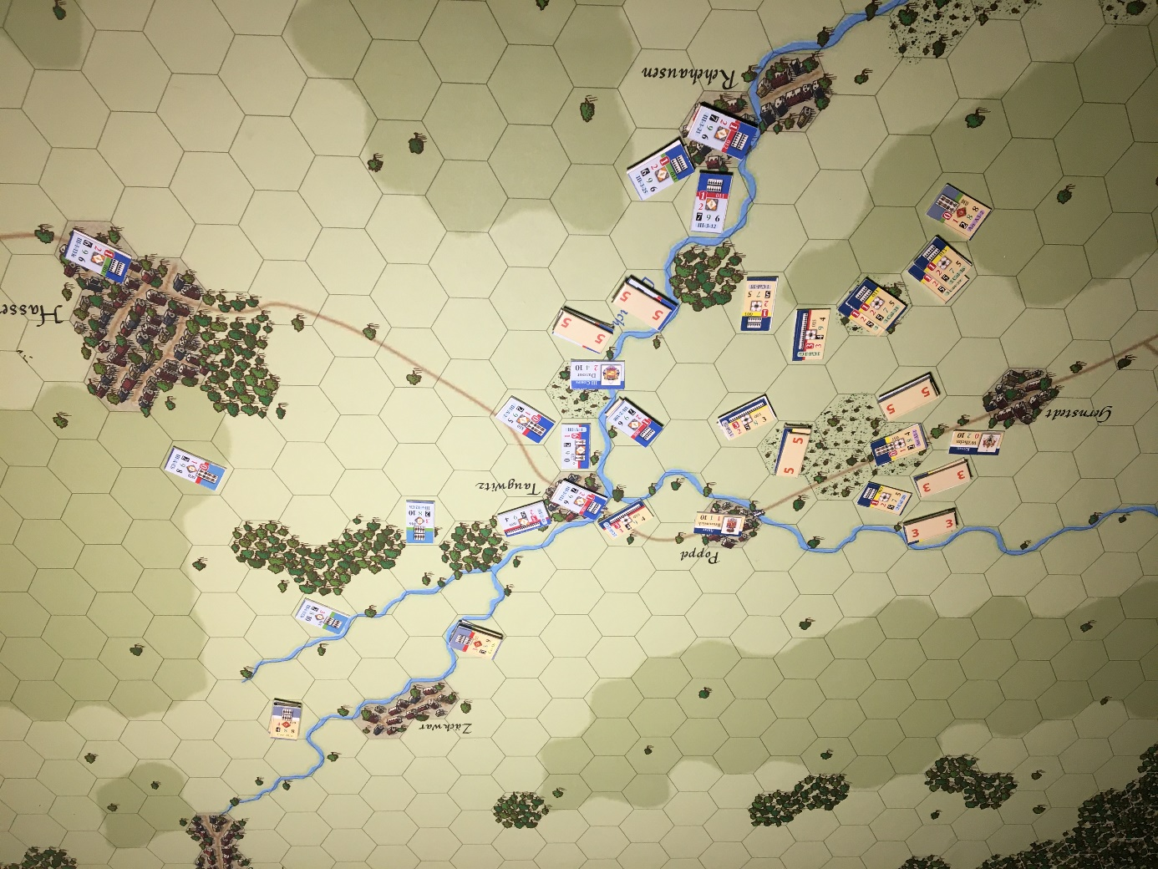
End of turn 5. A classical problem for the French, they attacked a little too much, and two of their best regiments are now disordered (marker 5 in the center). And therefore the problem is, the French have no reserve units to plug this new hole. In the north, they are holding, for now, the prussians cavalry which is back on line.

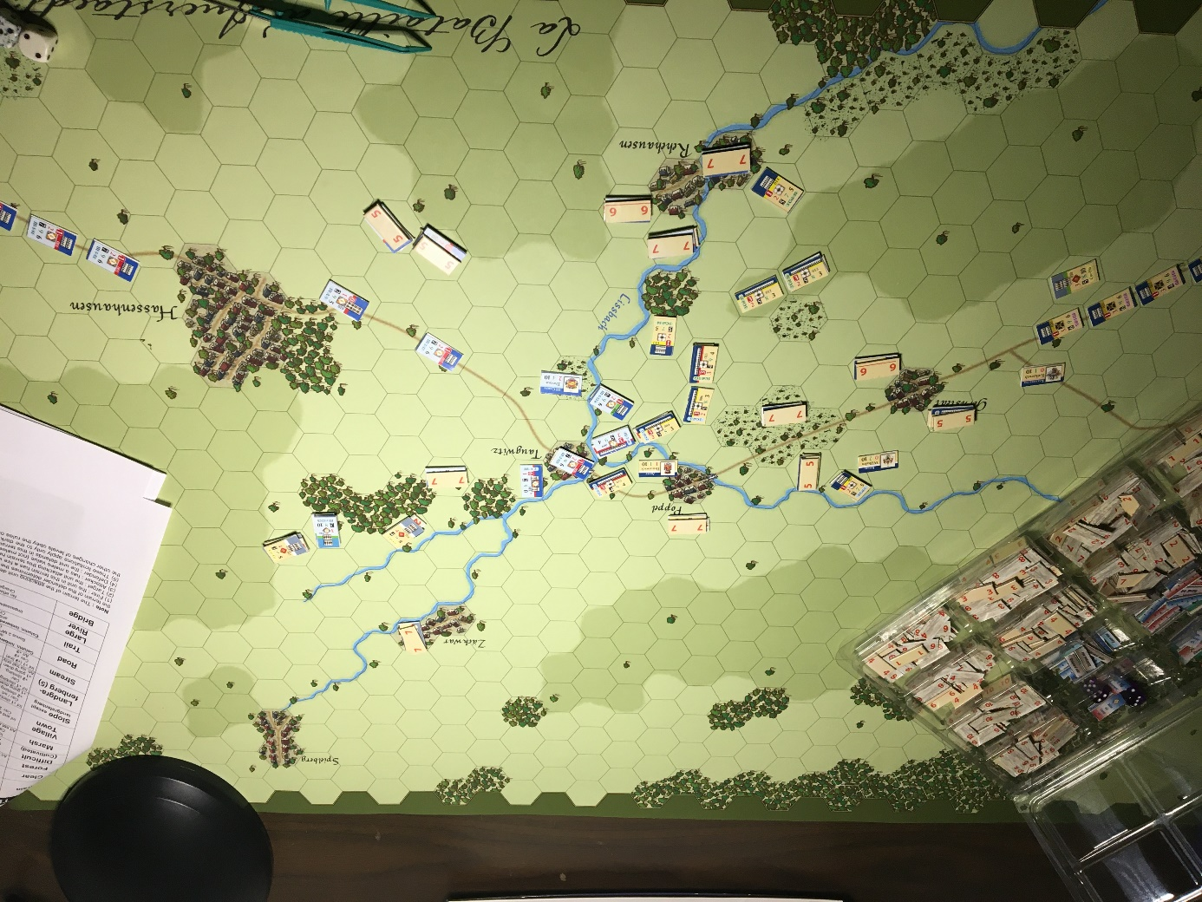
End of turn 7 : in one of the many back and forth movements, depending on which side gets a temporary advantage, the Prussians now have a strong position. All the south part of the field is theirs, the cavalry keeps being a threat in the north, and their center is quite strong. On the positive side, the French last division is now entering the field.

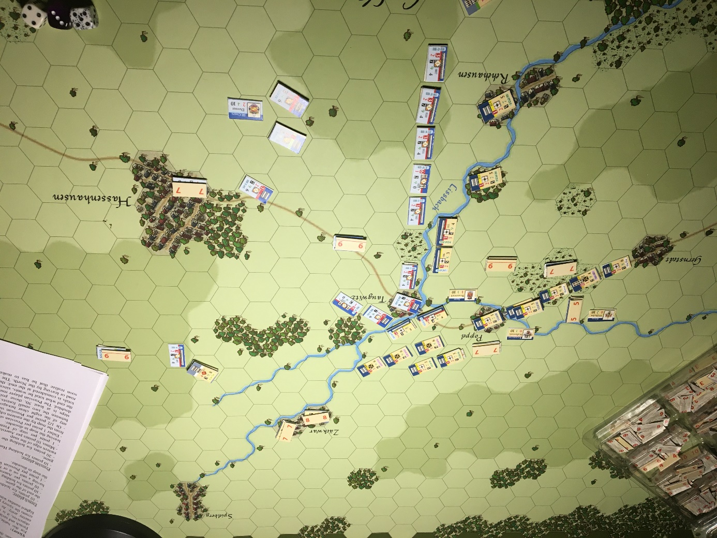
End of turn 9 : the situation has changed, once again, as the French could fill the southern part, which looks now out of danger. Most of their disordered units now have recovered (thanks to Davout), but for the Prussians this is the time of the choice. They have two intact divisions right behind the center, including the mighty Prussian Guard, and the northern part of the French position is quite weak. But look at the victory conditions. At this point, the Prussian can either force his way through Davout’s corps and try to exit by the eastern road, or move north-north-east and exit the map, but with less victory points for each step that can get out.
So let’s explore first the escape route north and see what happens. Then we will come back to this turn 9.

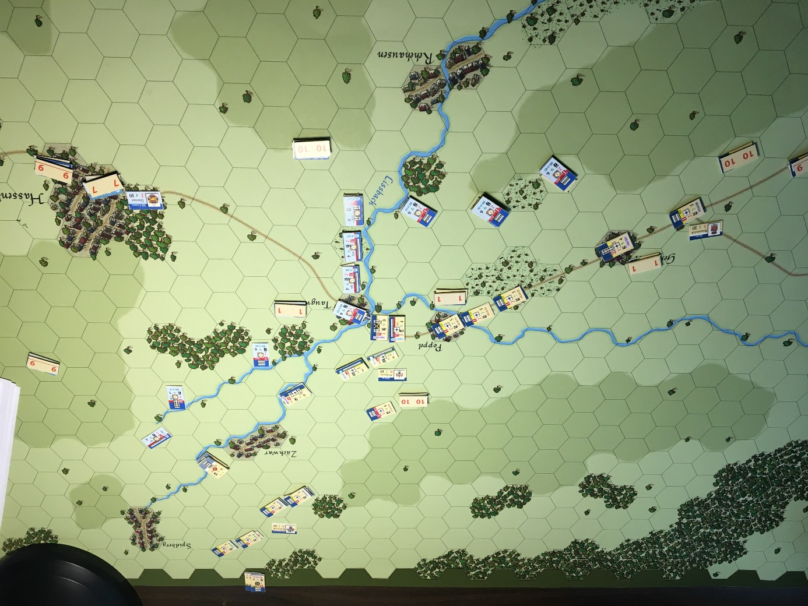

End of turn 11: as planned, the Prussian Guard and some of the following column move north, and there is nothing the French can do about it. Except that by cutting the road around Poppel, and attacking in the back the units moving north, the French have a good chance to disorganize some of them.
Remember that the Prussian line of communication is still the road of Apolda, at the south-west corner of the map. Therefore disorganized Prussian units must withdraw in that direction, and not toward their road of safety. Also, disorganized units retreating out of the map would count as losses, not as victory points.
The French in fact have at least three good infantry units able to do just that.

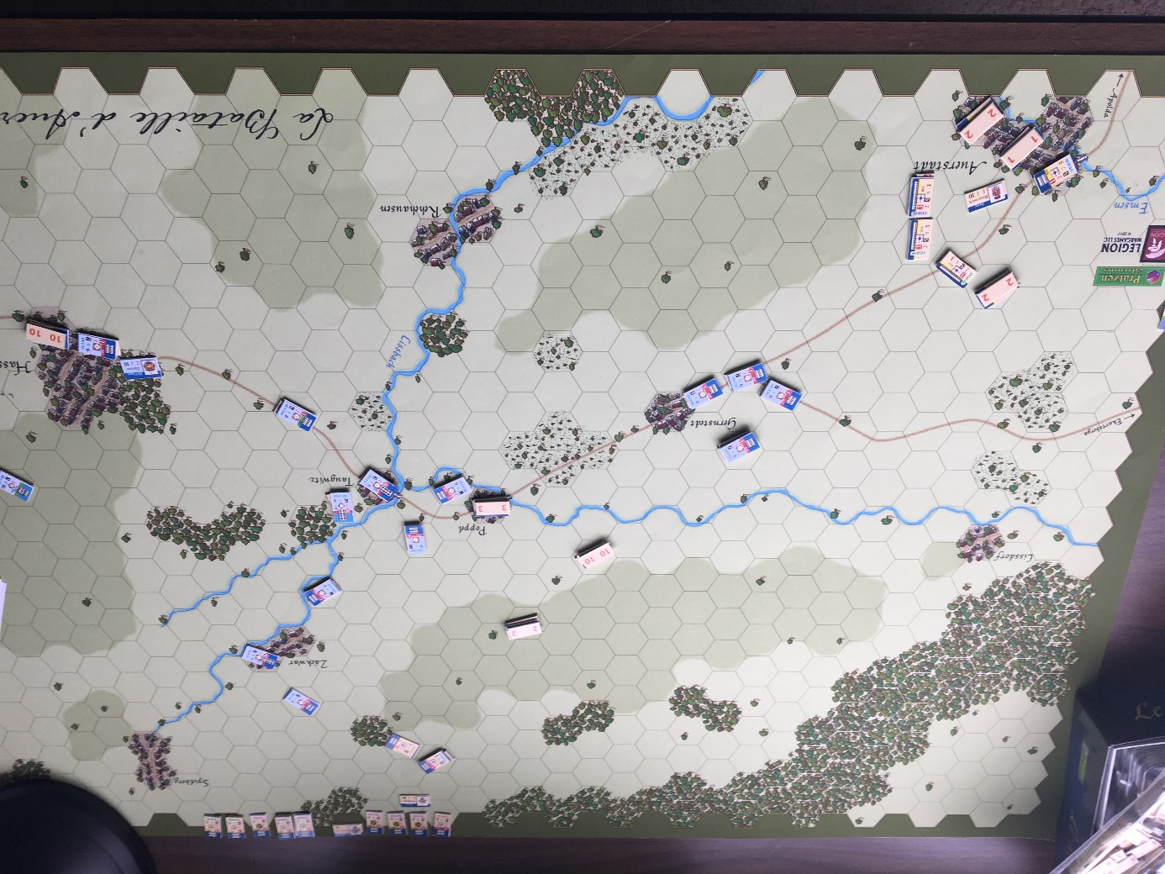
End of turn 13. The effect is spectacular. By cutting the main road, the French force the Prussians to form a defensive position around Auerstaedt, where the rest of the victory points are. Once again it is also their line of communication, where disorganized units retreat and rally. As not much else has to be done in the north, the French now focus on that south-west corner.

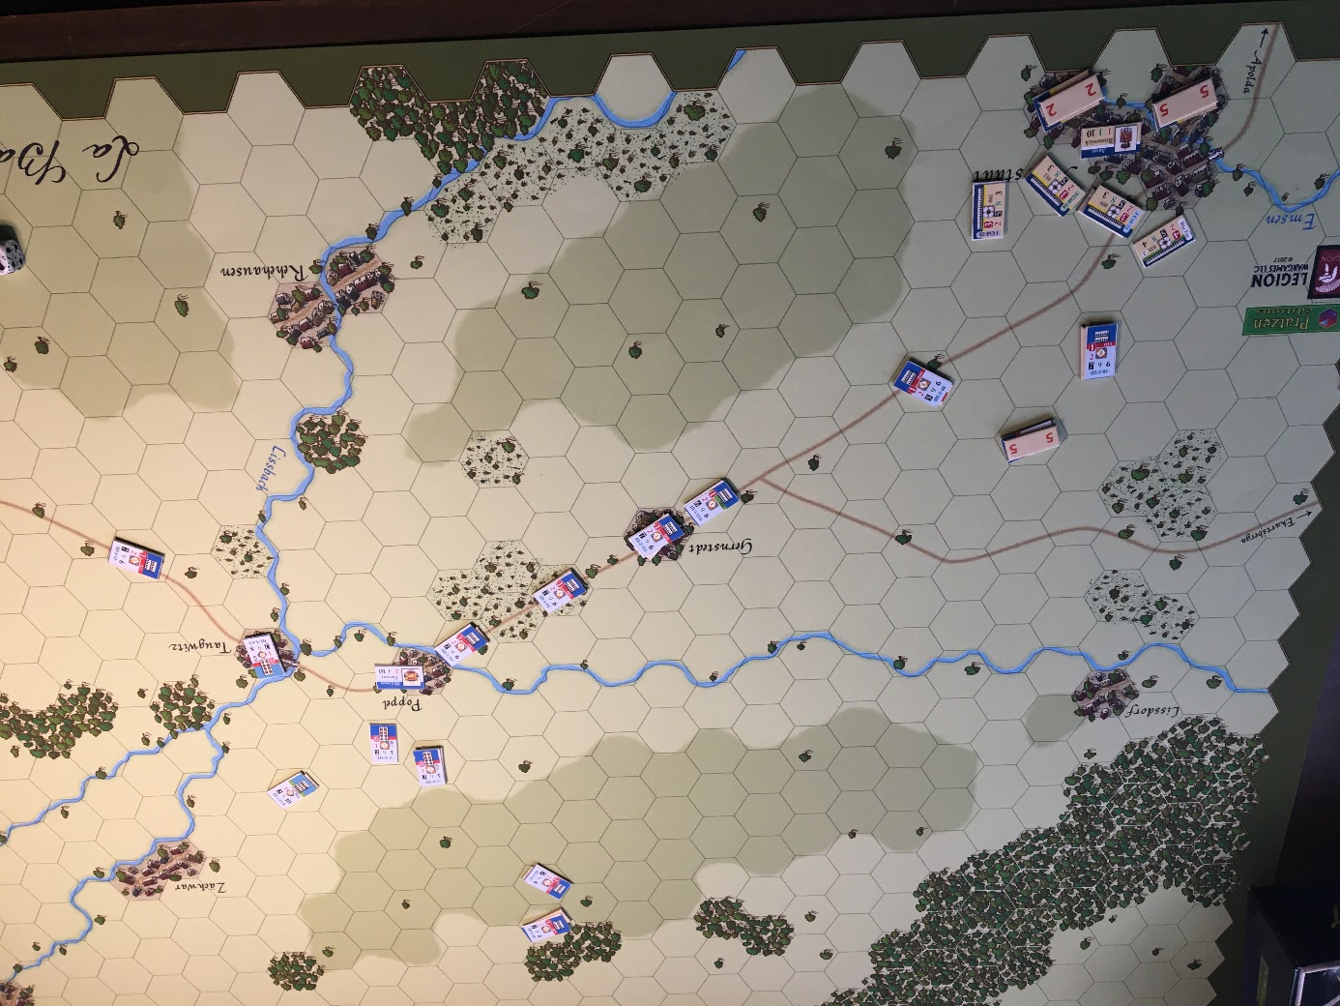
End of turn 15. It takes a couple of turns to gather a “final push” on the Auerstaedt redoubt. In fact, a close looks shows that some presomptuous French rushed a little too fast and got bashed. Soooo, let’s gather first, then attack.

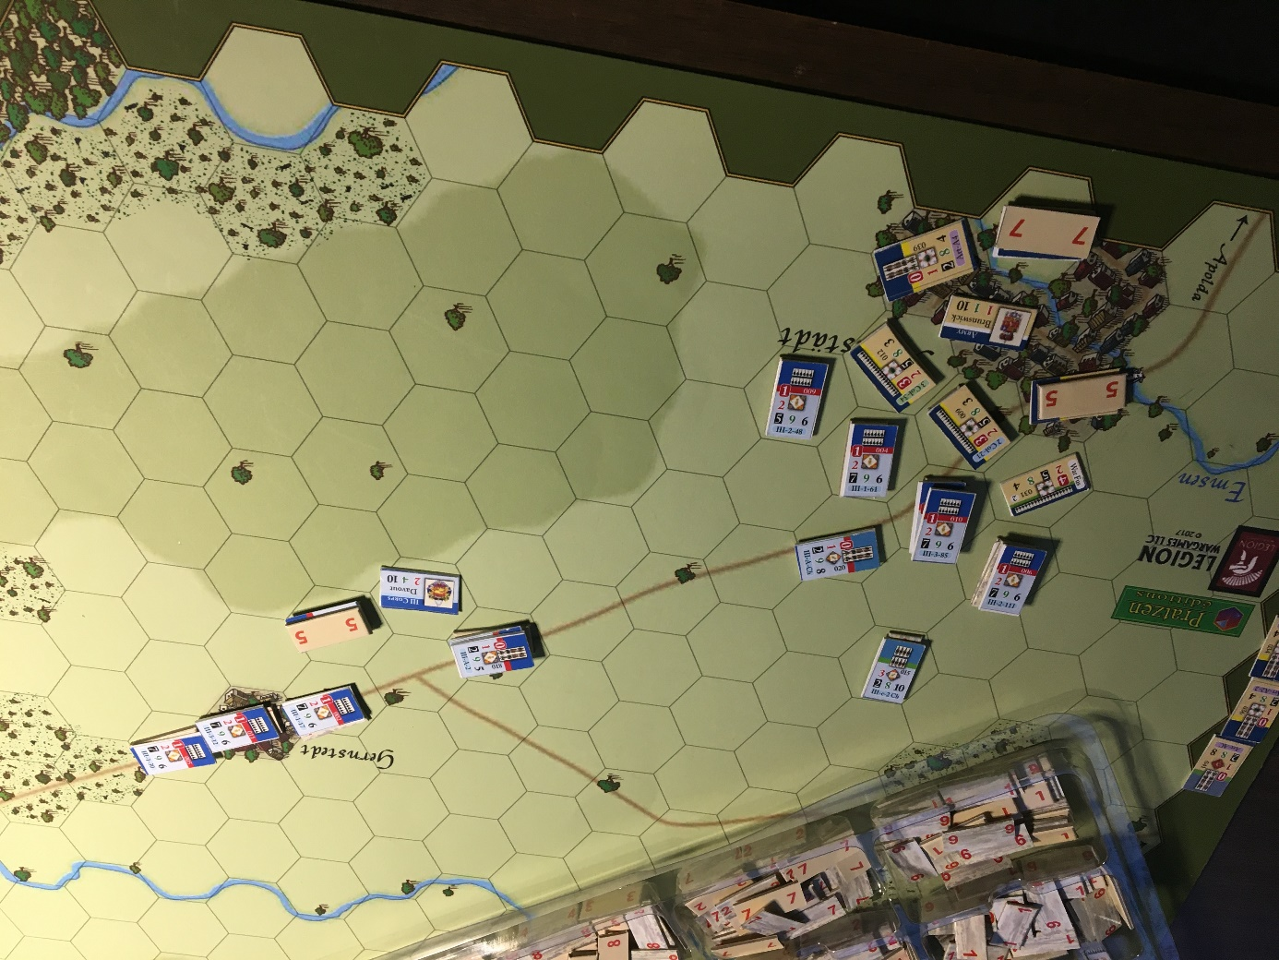
End of turn 17. Now that is better. But as there are only three turns left, a line of Prussians in front of the village, then the village to conquer, it is time to attack.

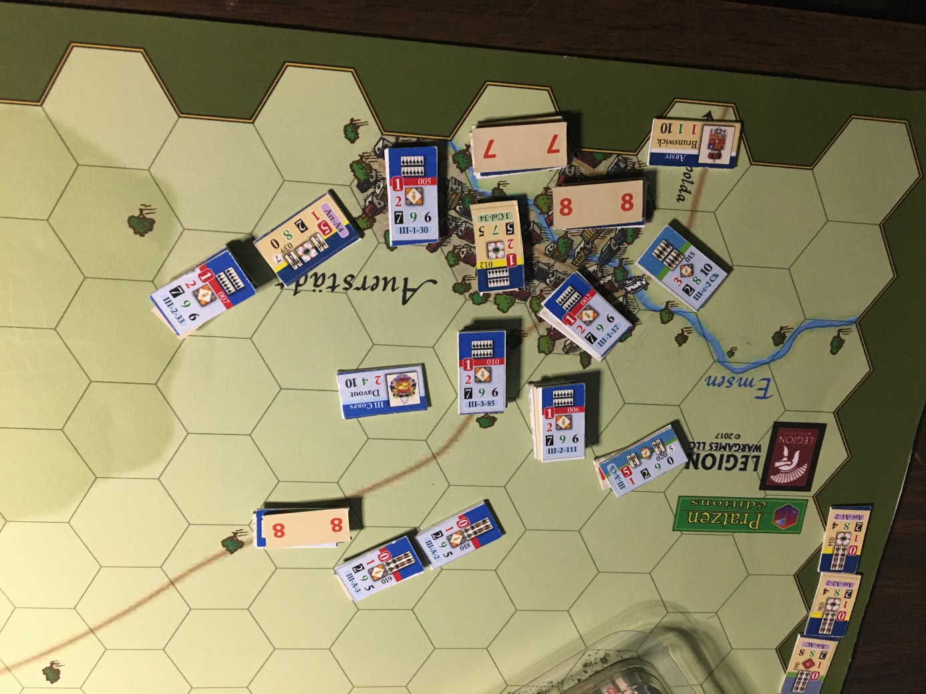
Last turn, at the end of the turn 19. Pretty efficient, but not enough time to clear the village, with two hexes still hold.

Victory points plan 1 :
French : 10 for Hassenhausen, 10 for Taugwitz, 20 for 2 hexes at Auerstaedt, 100 for the Prussian losses. Total 140 PV.
Prussians : 72 for French losses, 41 steps by the north is 20 VP; -20 for 2 hexes lost at Auerstaedt, total 72 PV
Of note, if the Prussians had exited 10 more steps, that would have doubled to 51 VP, or 103 total. One more turn keeping the French out of Auerstaedt would have been French 120 VP and Prussians 123 VP. As often, everything could have been decided on a single turn. The turn where the decision is taken cannot really be earlier (the Guard is still on the road around Poppel), or later, as it gives less time to exit the map, and less time for the French to capture whatever is left. That said, Poppel is only 15 hexes away from the exit, three turns. It may therefore be possible to wait a few more turns before moving north, but that gives the time for the French to rearrange their forces and “see it coming”.

Alternate strategy : push push push
If we come back to the situation turn 9, a different strategy can lead to very different results. I set up back the game, roughly, but this time the Prussians are to push east to force their way.

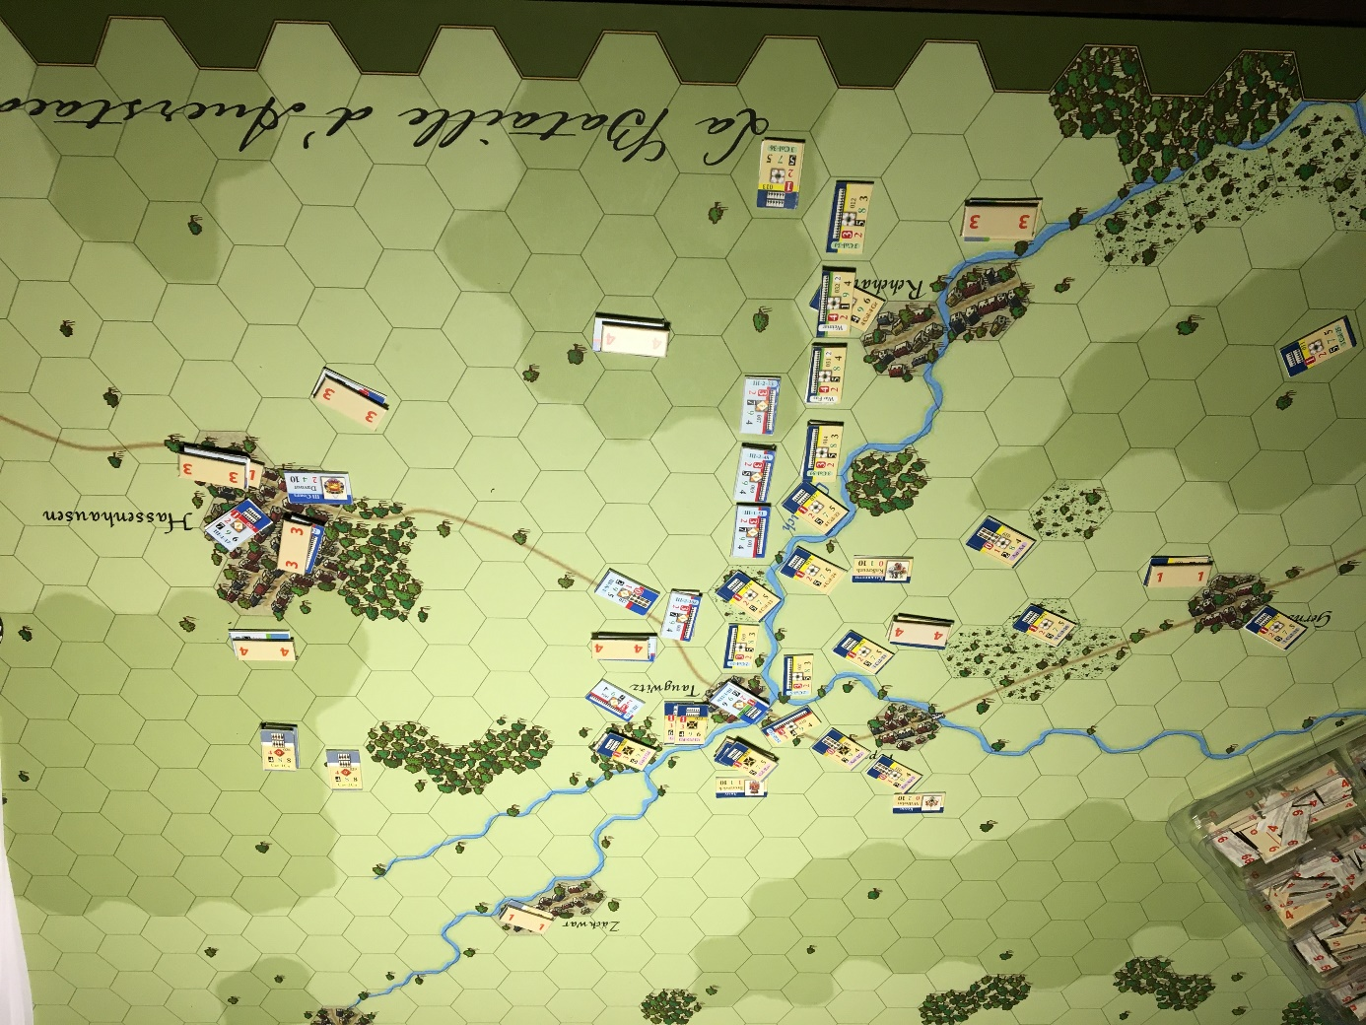
Turn “4” of the alternative plan. As I reset the game, I started again numbering the turns with 1. I probably forgot to reset a few losses on each side.
Four turns later, the situation has drastically changed. The powerful Guard overlaps the north flank and threatens Taugwitz, while the rest including the light troops deploy to the south. The cavalry is also clearly threatening Hassenhausen, full of mostly disorganized French troops. As this stage, the French do not have much choice but to retreat to a better position around Hassenhausen.

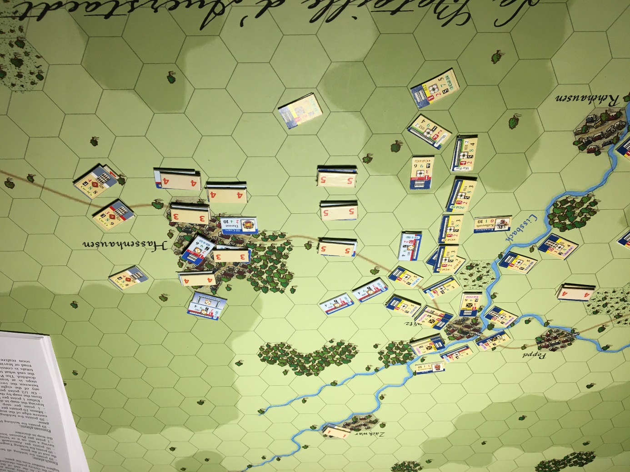
Turn 5 of alternative strategy. Without cavalry or enough units in good order, the French cannot really protect their south flank, where the Prussian light troops, with 6 MP each, and the Grenadiers of the fourth column, can outflank units turn after turn. To make matters worse, Prussian cavarly is now behind the town. I know, for a French player this is painful to watch...

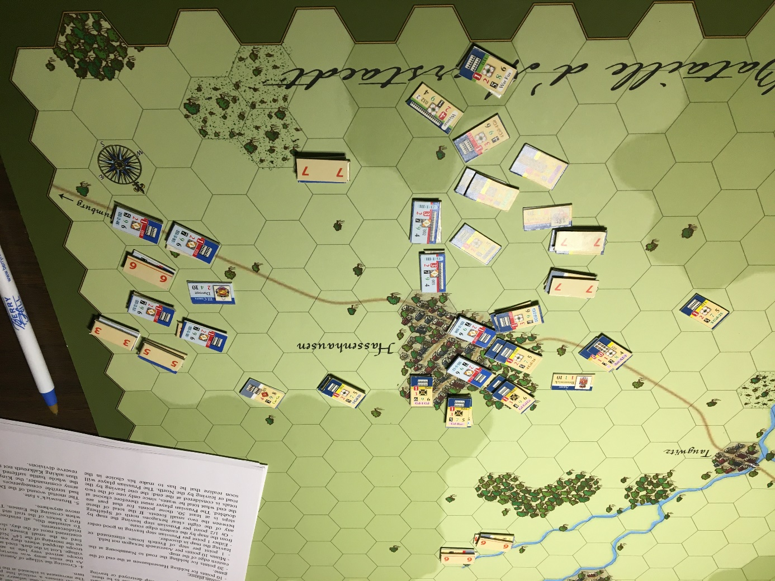
Turn 7 of alternative strategy. Davout had to use all his skills, and luck, to clear the way, his last units in good order force the cavalry back, but only two hexes of hassenhausen are still occupied. Of note, on a tactical level, a single Prussian cavalry, maximum melee value of 18 (all units at start already have one loss), cannot easily beat an intact French infantry, whith a melee value of 14. Good and strong infantry may not hesitate moving toward cavalry, it is a calculated risk. But there are still 4 turns left.

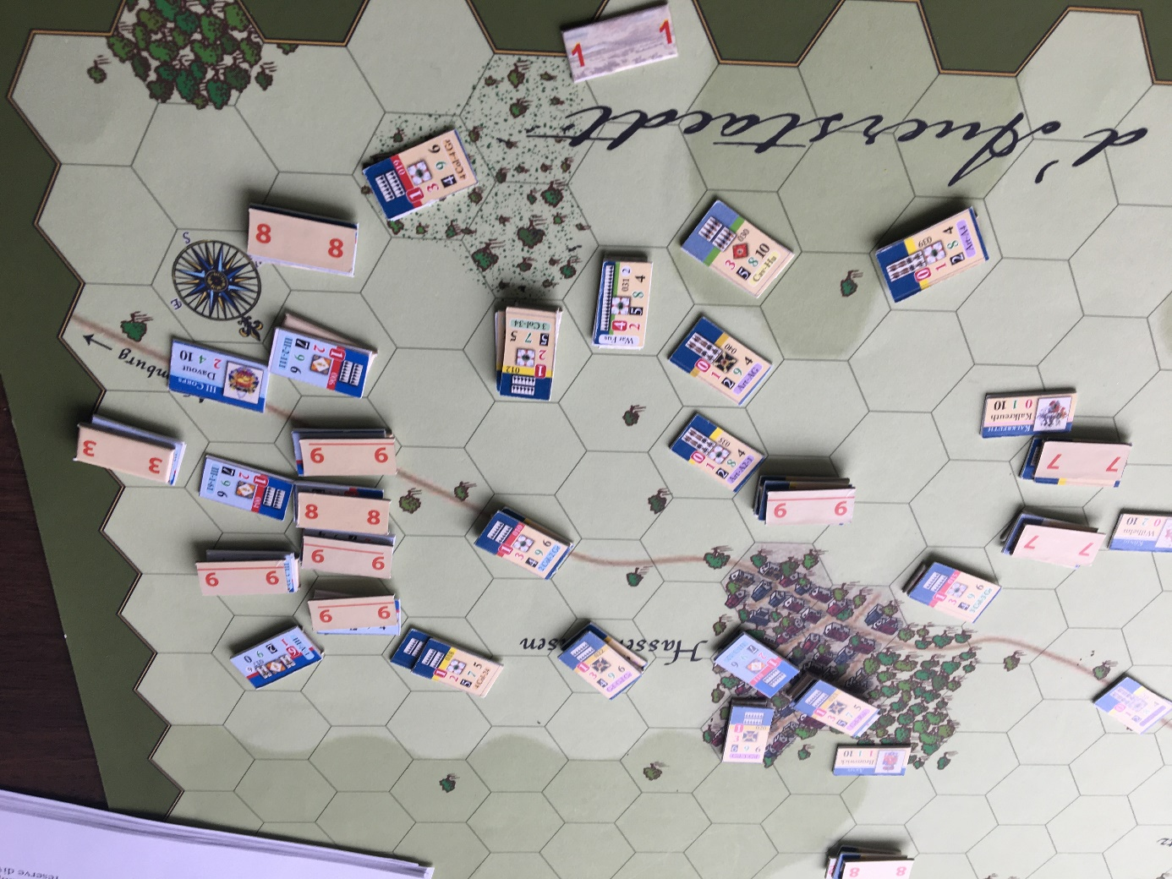
At the end of the Turn 9, there is really no hope left for the French, they cannot rally fast enough to face several (mostly) intact Prussian columns, with a melee value of 30 or so (10 points time three in column), and even more for Guard units. Hassehausen gets free of French, the Prussian have enough troops to attack units in good order AND disorganized. Units that cannot rally have to retreat off map by the road and count as losses. At the end of the last turn, there is no French left on the map and the Prussians start pouring troops by the road.
Victory points plan 2 :
French : 60 VP for Prussian losses.
Prussians : 10 for Hassenhausen, 20 for the road of Naumbourg, 101 for French losses, and 50 points exited by the road. Total 181 VP. It is of course a clear Prussian victory.
Out of the 101 French losses, more than 30 are not losses but had to exit in disorder by the road, their line of communication. They count as losses.

Discussion.
No, no, no, I am not giving the winning strategy for the Prussians. These are two quite extreme situations, and things can of course go very differently, regardless of the choice the Prussian player makes. Several time during both games, the flow went back and forth and the advantage swiched sides. And of course different players may have made different choices.
More generally, there is a critical time during most napoleonic battles, we call it the “decision”. This is the event that makes one general says “we win”, and the other one, “we lose”. Look at the picture under “Turn 4 of the alternative plan”, Davout knows at this point that he is losing the battle, all he needs to do is to save “victory points” by keeping the road to Naumbourg and as many troops he can, that means he may still win the game, but he will lose the battle.
Of course, sometimes the events are different, because of bad tactical skills, reinforcements (did someone say Bernadotte?), or simply bad luck. Generals can try to reverse the course of the battle, like Charles engaging his reserve of Grenadiers at Wagram, while Napoléon knows he is winning the battle. Probably also Wellington at first sight of the Prussians (he is supposed to have said earlier “give me Blucher or the night”). And sometimes generals don’t see the decision, don’t understand it, or don’t accept it. Also, sometimes a decision is not made before the night, or the next day, Benningsen after Eylau for example. And sometimes, the decision is made before the battle starts, like in Austerlitz.
Talking about generals, I chose here to use no command and control rules as I wanted to show the general flow of the battle, but I encourage their use. With these rules come the fate of Brunswick, who will die at some point during the battle, thus petrifying the King with responsabilities out of his skills. The French players should not be fooled, having only one leader, (even as good as Davout) may limit their boldest moves.
The God of dice knows how much I love big battles, but small battles have a charming balance, making the players focus on every unit (try to do that while playing Leipzig...) and getting the most of its use. That includes Quatre Bras, and many individual scenarios, pieces of Austerlitz for example, and then medium size battles like Salamanca, Eckmühl, with less time for subtle moves but enough granularity to make things really interesting.

A last example.
I ran a third game, and tried to capture this “back and forth” moment. Up to the turn 10, things are going well for the French, pushing wave after wave, even forcing the Prussians to retreat a few hexes. But then the horrible turn 10 arrived, with 4 stacks going in disorder.
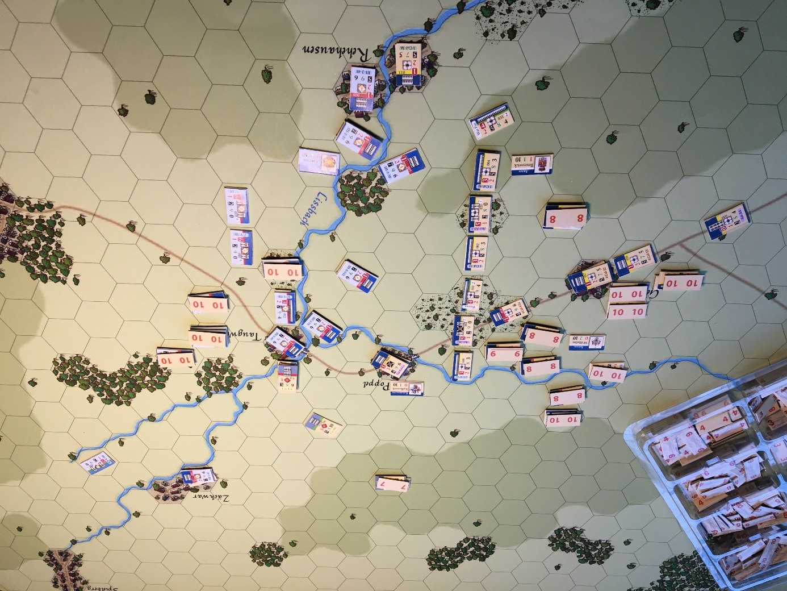
Turn 10 new game : That would not be too terrible if the Prussians were passive, but on the following turn they go on the attack. This is when the tide turns.

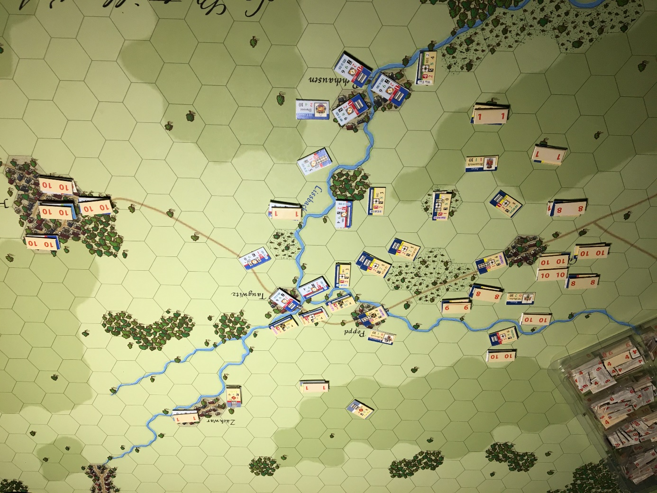
Turn 11 new game: Even if the Prussians have many units also in disorder, they can afford it. The French can’t. At this point Davout has to decide to die where he is, or retreat toward Hassenhausen. remember also that a side that loses the initiative has less chances to inflict losses and more chances to lose units.

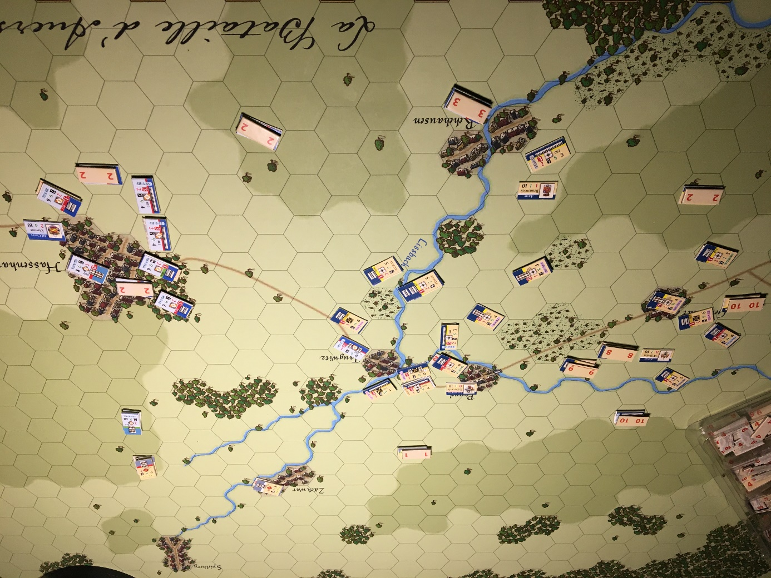
Turn 13 new game : Two turns later, the battle will be a Prussian victory. But there are still 6 turns to go. For that particular game, Davout still holds the last hex of road at the end of the last turn, but all the rest is gone. That gives 76 VP for the French, and 100 for the Prussians (10 for Hassenhausen, 90 French losses). A short Prussian victory. Once again, around the turn 9-10, things could have turned very differently.

Not two games alike... Well, that is what we like, right ?

Didier Rouy, 2020

