JANUARY/FEBRUARY 2022
Winter is passing as evidenced by our already celebrating Valentine’s Day on February 14th! However you celebrated, we hope it brought a “spring” to your step, a twinkling to your eyes, & love in your heart! Here are a few funny lines about Valentine’s Day that may bring a smile to your face:

“How can you save money on Valentine’s gifts? Stay single!

Man: “Honey, on this Valentine’s Day, I want to tell you that I am not rich like Jack; I don’t have a Porsche like Martin. But I do love you & want to marry you.” Woman: “Oh, dear, I love you too! What was that you said about Martin?” And,

What’s the difference between a $20 steak and a $55 steak? February 14th!

♥ ♥ ♥ ♥ ♥ ♥ ♥ ♥ ♥ ♥ ♥ ♥ ♥ ♥ ♥ ♥ ♥ ♥

Sadly, this newsletter reports the passing of yet three more members of the Class of ‘67:
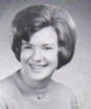
Darlene Winkler Ondi, 73, passed away January 11, 2022. During high school, she was active in Choir, G.A.A., Future Secretary, Booster Club, Block “G”, Tri-Hi-Y, Intramurals, Leaders, and was a Homeroom Officer, on the Yearbook Sales Staff, and a Teacher’s Secretary. She is survived by husband of 53 years, Stephen, four children, Stephanie, Joseph, Jennifer & David, and six grandchildren.

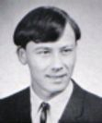
Richard R. Trende, 74, whose death occurred January 15, 2022. After graduation from GHHS, Rich was a Letter Carrier for 29 years with the United States Postal Service, and a proud veteran of the U.S. Army. His hobbies were bowling, woodworking, home improvement & motorcycle riding. He was always quick with stories of road trips, the best being when he and wife, Dawn, rode to Las Vegas to get married. Rich is survived by his wife, one step-daughter, a step-grandson, and brother & cousin, Eugene & Bobby Trende.

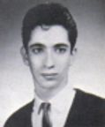
Bernard Masseria, 73, dying January 19, 2022. While at GHHS, Bernard was a Homeroom Officer & participated in Intramurals. He was loved & cherished by many including his sister, Nina, who graduated from GHHS in 1969.
Our sympathies are extended to Darlene, Rich & Bernard’s families and friends.
They will certainly be missed!

On January 25, 2022, the Class of ’67 awarded yet another $500.00 grant that was issued to the GHHS Counseling Department for Social Emotional Development. The objective of this project is to create a safe space for students to come to when they are feeling anxious, stressed and/or overwhelmed and to have an opportunity to practice self-regulation & effective coping strategies. This will not only improve a student’s ability to focus in class but also affects his or her overall academic success & behavior. Some of the items needed to create this area would be mind puzzles, bean bag chairs, a Salt lamp, rolling storage cart tools, fidget tools & stress ball pack, a Beta aquarium, LED lights, healthy snacks, and a variety of stickers, coloring books, stencils for the room, an area rug, etc. While the proposed room already is equipped with a large screen TV, it would also include meditation music, and aromatherapy & sensory equipment. This project is under the direction of Guidance Counselors Robin Castagnoia, Bobbie Marksberry & Sherri Williams. The Class of ’67 is happy to support your project and we wish you well in this endeavor!


Our travelling alumni consisted of Barbara Filipski Bunsey who returned to Colonial Williamsburg the end of November/beginning of December. She and husband, Chris (deceased) traveled there every year. During this time, a friend of Barbara’s who lost her husband last year, decided to keep the tradition alive and they spent time laughing, crying & making new memories. She says they had a wonderful time! While in Williamsburg, Barbara even gave another demonstration regarding painting, and has been teaching classes on Zoom the last few months.

AND, Floyd & Gayle Glowick Konet returned to the USA on January 18, 2022, from a wonderful trip to Tortola & Smugglers Cove Beach!

Kudos to: Bud & Cindy Ruggerio Rifici celebrated their 51st wedding anniversary on January 2, 2022.

Gail Russler Meyer with hubby, Barry, welcomed their first grandchild, a girl, Rayla Jules Meyer Margolin, born in California on January 17, 2022,

A special birthday greeting to former faculty member, William Toneff, who celebrated his 103rd birthday on February 22, 2022! If you are interested in sending him a belated birthday card, his address is: William Toneff, Crown Center, Laurel Lake Community, 200 Laurel Lake Drive, Room A2, Hudson, OH 44236.
AND, we just heard that Chuck Pflueger is fully retired! He has now completed docent training & certification for the Holocaust Museum in Houston, TX. He is certified to conduct school tours for middle & high school students, and has even had some college students sign up for tours as well. Chuck says this will now enable him to put his 60 plus years of reading about and visiting WWII sites & museums worldwide to practical use, as he has seen so much! Chuck was able to visit Auschwitz in Poland in 1995 along with more sites in Germany & England over the years. He has included in his “hobby” President Roosevelt’s library in Hyde Park & Truman’s library in Independence, Missouri. And, COVID permitting, is planning to visit the WWII museum in New Orleans soon with some museum colleagues. Have fun with this “new” hobby, Chuck!
Thinking of: Marleen Krzywkowski Sooy’s son, Travis, who is still recovering from sepsis. Good news was shared in that the sepsis did not attack his stomach but rather his gut has only been sleeping & is now beginning to wake! Things are still draining but are slowing down which means they are healing!
Barry Meyer, husband of Gail Russler Meyer, who is recovering from yet another surgical procedure done in mid-January, and Gail who is coping with a bout of vertigo.

Rosie Martinovich Spatny who is going crazy after having to wear a boot & scooter for 8 weeks and now is told there will be 3 more weeks of it! Rosie fractured her #5 metatarsal three days before Christmas.

And, Audrey Sopko, whose daughter, Keleigh, was taken ill and admitted to Cleveland Clinic Hospital. Keleigh has major blood work anomalies, and Audrey feared congestive heart failure, however, a formal diagnosis has not yet been reached. Keleigh has been discharged from the hospital and is at home.

Wishing all of you a speedy recovery!

Condolences to: Sharon Travagliante Weitzman and husband, Paul (Skip), upon the death December 25, 2021, of Paul’s brother, Jerome Weitzman. Jerome had been a quality control lab technician at American Spring Wire Corp before graduation at Nordonia High School. He was to spend 34 years rising to IT Manager, even though he was not a programmer. After a company downsize in 2002, he returned to school and became a respiratory therapist, retiring from Hillcrest Hospital in 2016. Jerome served in the Army Security Agency at Ft. Clayton in the former Panama Canal Zone, and finished his military obligation in the National Guard. He was a 40-year member of Hope UMC in Bedford, he loved live theatre & blues music, sports, & cooking to name just a few. Jerome is survived by his wife of 52 years, Carol, a father of three children, and brother of three brothers and one sister who is deceased.

Ted Badalamenti & family upon the passing of Ted’s brother, Fred Badalamenti, Jr., 77, mid-January, 2022. Fred was formerly an owner of Badalamenti Construction Services. He is survived by wife, Donna Lee, a father of four, grandfather of ten, and great-grandfather of two with one on the way, and brother of Ted and Betty Sciko.

And, Tom Tylicki and family upon the mid-January, 2022, death of Tom’s brother, Daniel D. Tylicki. Daniel is survived by wife, Kathy, was a father of two, a grandfather of one, and brother of three (Tom, Bob who is deceased, and Gary.

Our thoughts are with all of you!

A REMINDER…. The“Lady Bulldogs” continue to meet for lunch at 1pm at Danny Boy’s in Broadview Heights. Their FIRST luncheon of the New Year was on January 22, 2022! Those who participated were: Leslie Mroz Readinger, Sue Baranovic Slesnick, Kathy Schneider Nowack, Karen Soika Palker, Jan Wroblewski Hola, Audrey Sopko, Nancy Levis Knowlton, Linda Wike Calkins and Gayle Glowick Konet. The next luncheon will be March 12th.

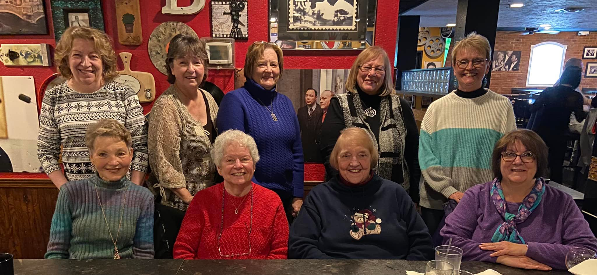

And Ken Zielaskiewicz offered the following tidbits that should put on smile on your face:



And that, folks, is this newsletter! Please keep us informed of any new contact info for you, and if you have some news to share, please tell us about it! Until our next issue, GO BULLDOGS!

Your loyal editor,

Gail Russler Meyer

