**Cinders Cleaners**

**Covid-19 2020**

**Protecting our Cleaners and Clients**

**With effect of May 12th, 2020 the government advised that domestic cleaning services could resume with safety measures being a key priority for all involved. Please see below for our temporary**

**provisions and policies regarding using our services during this time.**

# Stop and Think Keep your distance

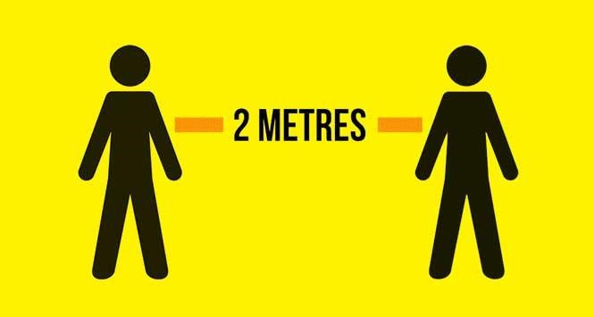

***Be responsible & know your symptoms:***

## If either the cleaner or client suspect symptoms, then please postpone the appointment and keep everyone protected

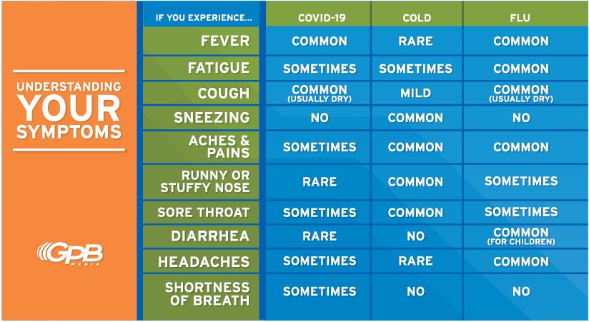

***We will continue to follow government guidelines and adjust***

## accordingly

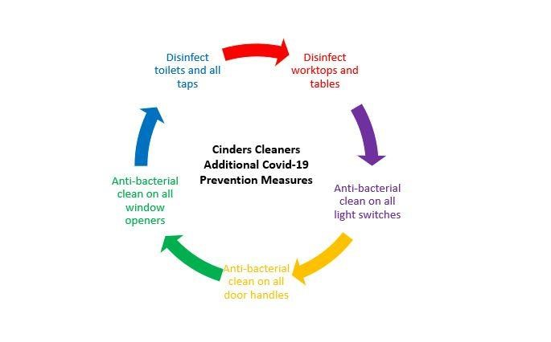

***We will provide our cleaners with single use face masks, single use gloves and training on appropriate hand washing***

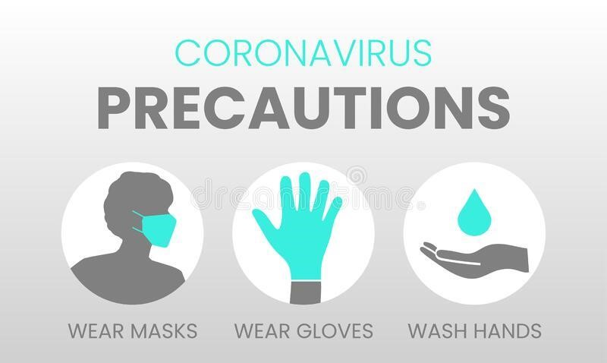

**In accordance with the government guidelines regularly disinfecting and cleaning areas that are used frequently can help reduce the spread of Covid-19. The cleaners are not asked to wear masks during the actual clean due to the physicality of the tasks, so we ask for social distancing to be maintained during the clean itself.**

**Attached is the Covid-19 specific tasks sheet, these are the high priority areas that we have trained our cleaners to focus on however if you have any other requests please speak to your Area Manager in the first instance.**

### Those Shielding and Self-Isolating

**Unfortunately, currently we are unable to help you in accordance with government guidelines. We will closely monitor this and amend as soon as the advice or recommendation is it is safe to do so for you.**

**In the interim if you have any questions please contact your area manager and be happy to discuss your needs in advance**

