Back inside…..
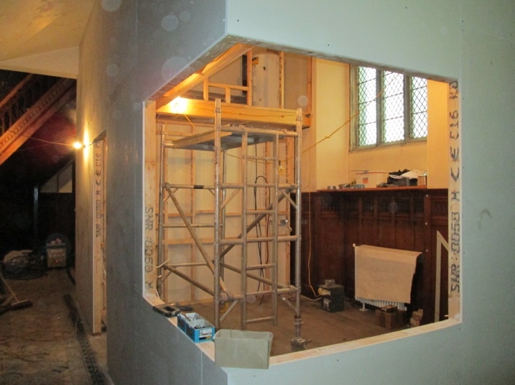
This is just about as exciting as its gets, for those of us with an interest in the new catering arrangements – as shown here the shell is well under construction and we can’t wait for the units to arrive for our semi-commercial kitchen. Well, alright, it has a long way to go yet before we are serving refreshments – but this is progress…. You just need a little imagination…
And on ground level… The foundations for the toilets are also taking shape.
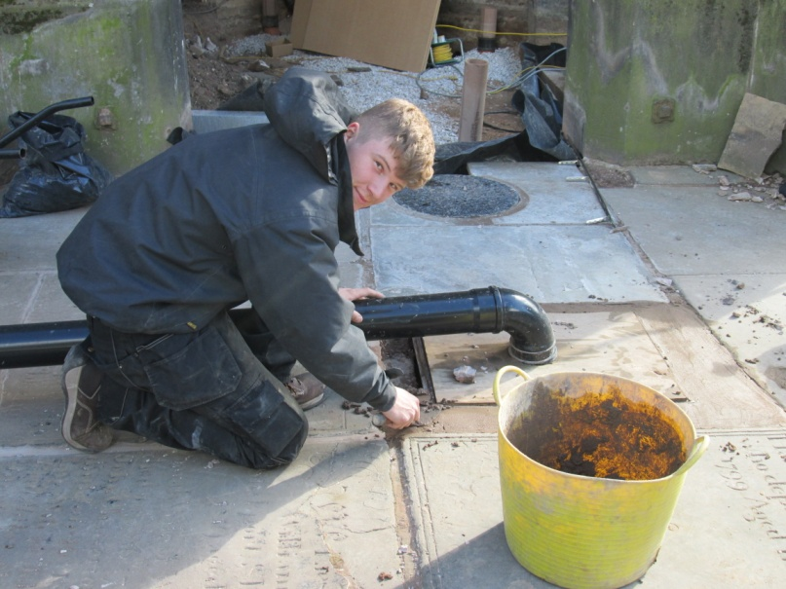
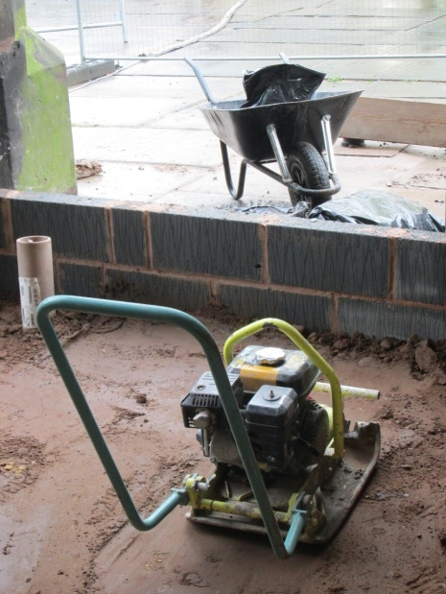

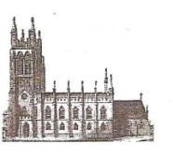
St Mary’s in the Marketplace.

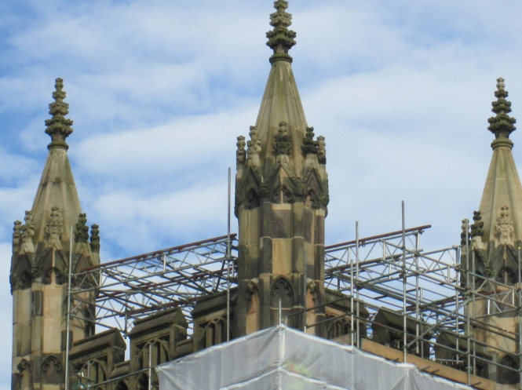
Issue No 10 (23rd September 2012)
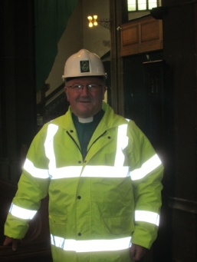

Photographs Roger Scoones
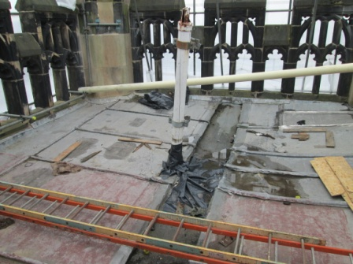
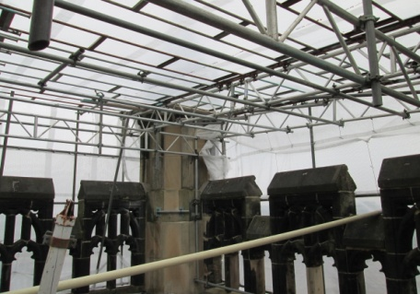
We are fortunately this week to be able to have a peep as to what is happening on the tower roof and along the scaffolding. We could see from below that the framework for the temporary cover was taking shape and here it is photographed from the actual tower roof. The top portion of the flag pole is down ands can been seen resting on the stonework – it is the base that is causing a little concern at present. The whole structure is heavy and bulky and will take a bit of shifting whilst the new roof is put in place. There are (as you would expect with anything of timber construction taking the worst of Stockport weather for a number of years) areas of the lower pole that need some “TLC” before going back – if not replacing altogether. Just think how much stress “the mast of our ship” must take - the length of the entire pole, the flag and just how windy it must get up there!
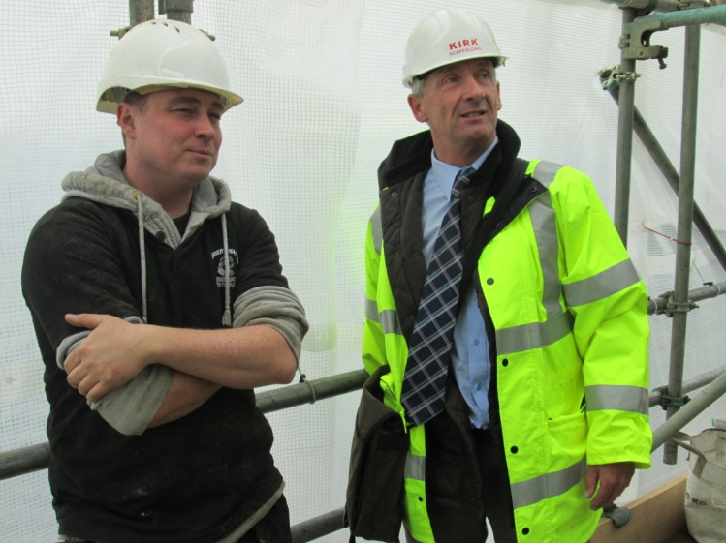
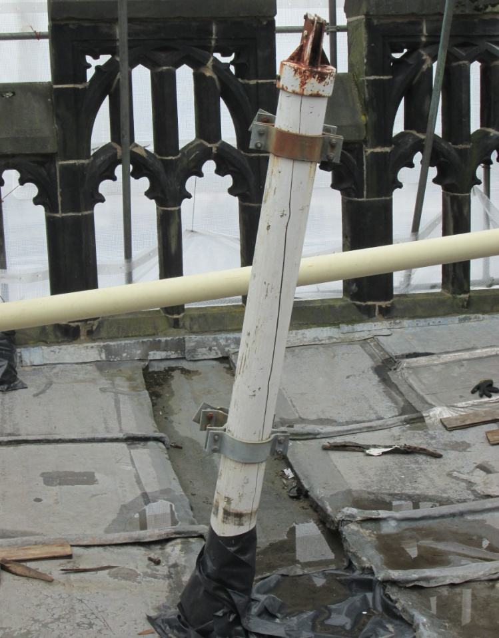
We can’t get much higher than this to look at what is going on above our heads
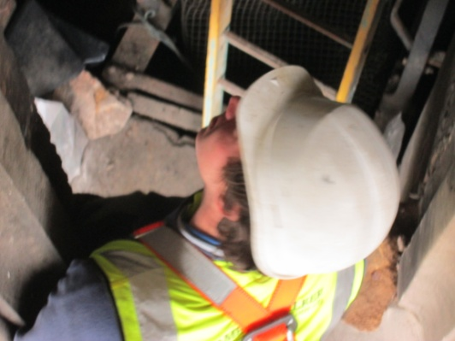

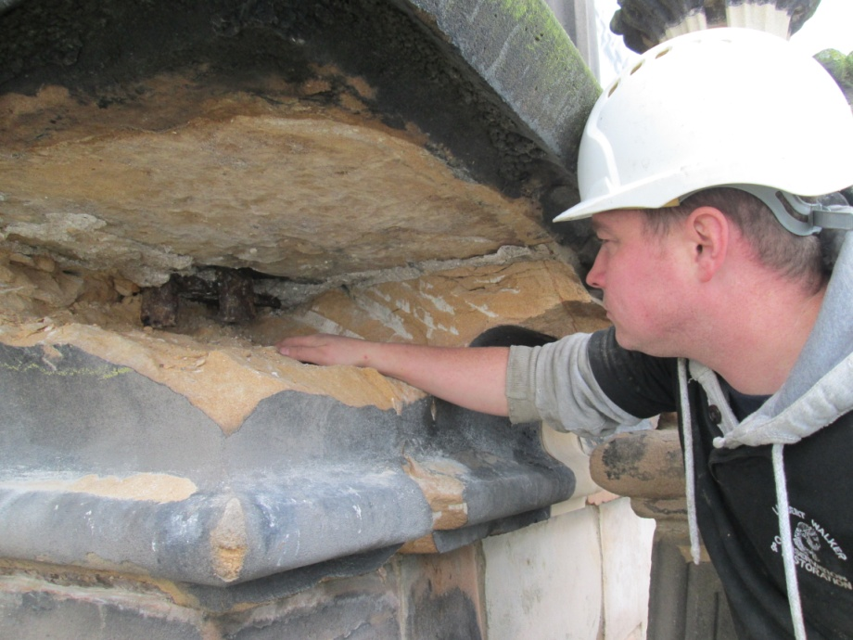
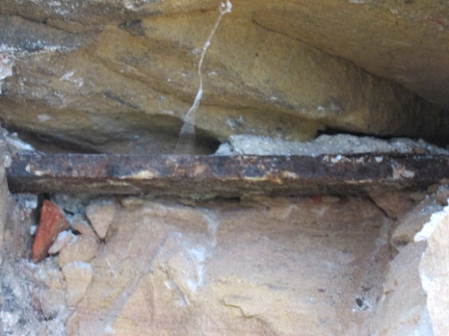
A chance now to look at areas of damaged stonework where our task of conservation continues on the east face of the tower. This is where we value most our guys from Lambert Walker (specialists in this area of work) as they start to put things right for us once again.

