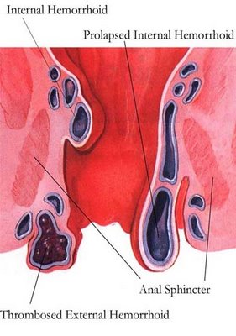

Hemorrhoids

Hemorrhoids, also called piles, are varicose veins around the anus and in the rectum (the very lowest portion of the colon). Some may protrude from the anus.

They enlarge and lose their elasticity, resulting in saclike protrusions.

They are a common cause of rectal bleeding and discomfort, and are aggravated by constipation and straining to pass feces.

Causes:
- eating processed food (white flour products)
- lack of liver detoxification
- lack of magnesium
- constipation … usually caused by insufficient consumption of water & fibre
- straining during elimination
- constipation during pregnancy, as well as straining in delivery

What to do:
- Increase water intake
- Increase fibre intake
- Use Alfalfa
- Use Herbal-Laxative
- Use Optiflora daily
- Many find VitalMag very beneficial to reduce constipation

If surgery is required, the Kuzee method is recommended.

