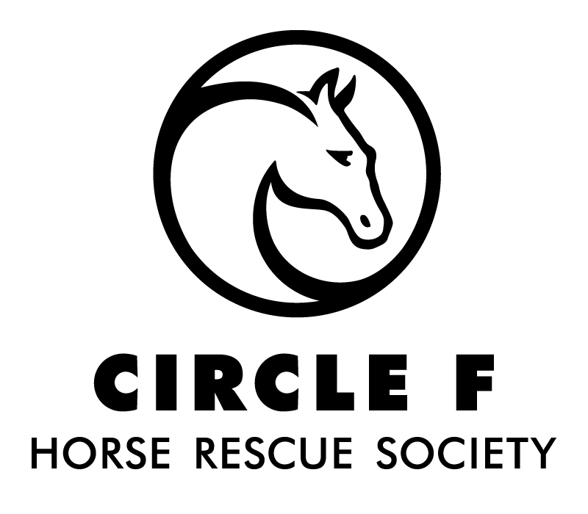
Box 174 Mt. Lehman Stn.
Abbotsford, BC V4X 2P7
www.circle-f.org Email: Circlef.horserescue@outlook.com

VOLUNTEER MEMBERSHIP APPLICATION AND WAIVER
(Please print all information legibly)

Personal Information

NAME HOME PHONE

ADDRESS CELL PHONE

CITY POSTAL CODE

BIRTHDATE EMAIL

Reference or Sponsorship

NAME PHONE

Equine History and Experience
Please describe your equestrian experience e.g. farm, owner, training taken, certificates held, levels achieved.

Please describe some of your work and volunteer experiences and some of your special interests and skills.

I want to volunteer in one or more of the following areas (areas will be assigned as feasible):
 | Horse Care & Handling |  | Horse Conditioning |  | Facility Care & Maintenance |  | Adoption Assessments |  | Site Assessments
 | Communication & Social Media |  | Administrative Assistance |  | Fund Development |  | Event Coordination |  | Volunteer Management

When are you available for volunteering? Days of Week: Mon Tues Wed Thu Fri Sat Sun AM PM

ACKNOWLEDGMENT OF RISK AND RELEASE OF LIABILITY
THIS AGREEMENT WILL AFFECT YOUR LEGAL RIGHTS. READ IT CAREFULLY!
Every Person Must Read and Understand this Waiver Before Participating in Equine Activities. The following waiver of all claims, release from all liability, assumption of all risks, agreement not to sue and other terms of this agreement are entered into by me (the Participant) with and for the benefit of Circle F Horse Rescue Society, its directors, officers, employees, volunteers, business operators, agents and site property owners or lessees (collectively the "Host"). Without limiting the generality of the foregoing, "Equine Activities" includes but is not limited to handling, riding, care & maintenance of horses on the property of or at the behest of the "Host".
Initial each Item below after reading and understanding each item:
_______1. I am aware that there are inherent dangers, hazards and risks (collectively "Risks") associated with "Equine Activities" and injuries resulting from these "Risks" are a common occurrence. I am aware that the "Risks" of "Equine Activities" mean those dangerous conditions which are an integral part of "Equine Activities", including but not limited to: (a) the propensity of any equine to behave in ways that may result in injury, harm or death to persons on or around them and to potentially collide with, bite or kick other animals, people or objects;
(b) the unpredictability of an equine's reaction to such things as sounds, sudden movement, tremors, vibrations, unfamiliar objects, persons or other animals and hazards such as subsurface objects;
(c) the potential for other participants to behave in a negligent manner that may contribute to injury to themselves or others, including failing to act within their abilities to maintain control over an equine.
_______2. I freely accept and fully assume all responsibility for all "Risks" and possibilities of personal injury, death, property damage or loss resulting from my participation in "Equine Activities".
_______3. I agree that although the "Host" has taken steps to reduce the "Risks" and increase the safety of the "Equine Activities", it is not possible for the "Host" to make the "Equine Activities" completely safe. I accept these "Risks" and agree to the terms of this waiver even if the "Host" is found to be negligent or in breach of any duty of care or any obligation to me in my participation in "Equine Activities".
_______4. In addition to consideration given to the "Host" for my participation in "Equine Activities", I and my heirs, next of kin, executors, administrators and assigns (collectively my "Legal Representatives") agree:
(a) to waive all claims that I have or may have in the future against the "Host";
(b) to release and forever discharge the "Host" from all liability for any personal injury, death, property damage, or loss resulting from my participation in the equine activity due to any cause, including but not limited to negligence (failure to use such care as a reasonably prudent and careful person would use under similar circumstances), breach of any duty imposed by law, breach of contract or mistake or error in judgment of the "Host"; and
(c) to be liable for and to hold harmless and indemnify the "Host" from all actions, proceedings, claims, damages, costs demands, including court costs and costs on a solicitor and own client basis, and liabilities of whatsoever nature or kind arising out of or in any way connected with my participation in "Equine Activities".
_______5. I agree that this waiver and all terms contained herein are governed exclusively and in all respects by the laws of the Province of British Columbia or Canada in which the "Equine Activities" are provided by the "Host". I hereby irrevocably submit to the exclusive jurisdiction of the courts of that Province of BC or Canada and I agree that no other court can exercise jurisdiction over the terms and claims referred to herein. Any litigation to enforce this waiver will be instituted in the Province of BC or Canada in which the "Equine Activities" are provided by the "Host".
_______6. I confirm that I have had sufficient time to read and understand this waiver in its entirety. I understand that this agreement represents the entire agreement between myself and the "Host", and it is binding on myself and my "Legal Representatives".
_______7. I confirm that I have reached the age of majority in the province in which I am participating in "Equine Activities".
_______8. I confirm that I have not reached the age of majority in the province in which I am participating in "Equine Activities". My parent or legal guardian’s name & signature appears below, granting their permission for me to engage in the activities as outlined above.

Participant Name: Parent/Guardian’s Name:
Participant’s Signature: Parent/Guardian’s Signature:
Date Signed: Witnessed By:

Name of Circle F representative witnessing this document:

COVID-19 Agreement

All Members/Volunteers agree to abide by the following points when entering Circle F Horse Rescue Society Property under the COVID-19 Response plan:

___ I agree to COVID 19 symptom screening checks, and I will let Circle F personnel know if I have experienced any COVID 19 symptoms in the last 14 days.

___ I agree to stay home if I am feeling sick, and I will not attempt to return to the facility for 14 days if experiencing COVID-19 symptoms.

___ I agree to sanitize my hands with soap or sanitizer upon entering and exiting the facility.

___ I agree to sanitize the equipment I use throughout my volunteer shift with approved cleaning products provided by Circle F Horse Rescue Society.

___ I agree to follow social distancing protocols of staying at least 2m away from others for the duration of my shift or any other time spent at the Circle F facilities.

___ I agree to not share any equipment during shift times, and I will sanitize/clean that equipment after I have finished using it.

___ I agree to abide by all of Circle F Horse Rescue Society’s COVID-19 Policies and Guidelines as provided.

___ I understand that if I do not abide by the aforementioned policies/guidelines, I may be asked to leave for up to 14 days to help protect myself and others around me.

___ I acknowledge that continued contravention of these policies and/or guidelines may result in temporary suspension of my Circle F Horse Rescue Society membership/volunteer participation opportunities.

___ I acknowledge that there are risks associated with entering Circle F Horse Rescue Society’s facilities and/or participating in any and all Circle F related activities and that the measures taken by the Society and its participants, including those set out above and under the COVID-19 Response Plan, will not entirely eliminate those risks.

