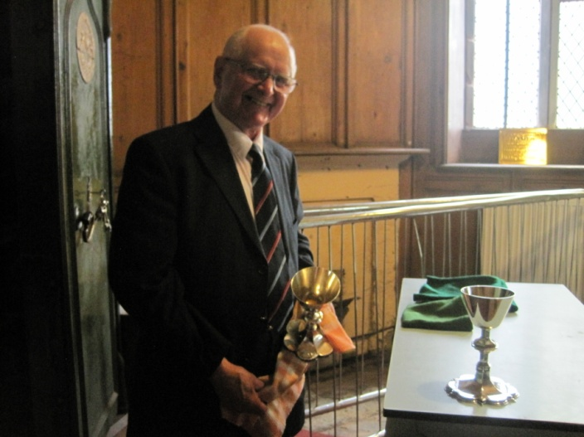
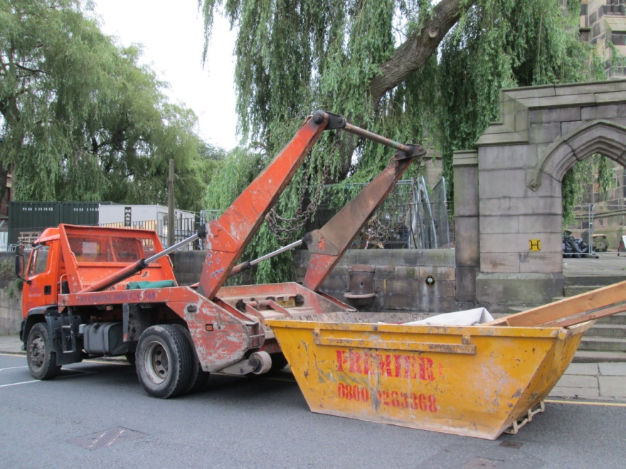
We still have access to the Rectors Vestry, but some of the floorboards are up whilst pipe-work is being traced and radiators moved – the Treasurer awaits the lifting of the grids in the Nave to see how many coins have fallen down over the years – a mini income stream maybe!

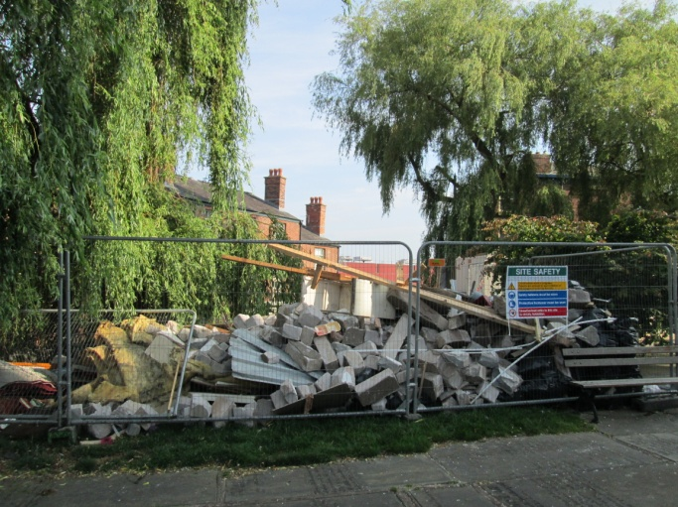
Away with the
rubbish – not an
easy task given our location.
And…. We say goodbye to the
rubble and rubbish – not an easy task given our
location!

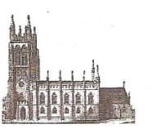
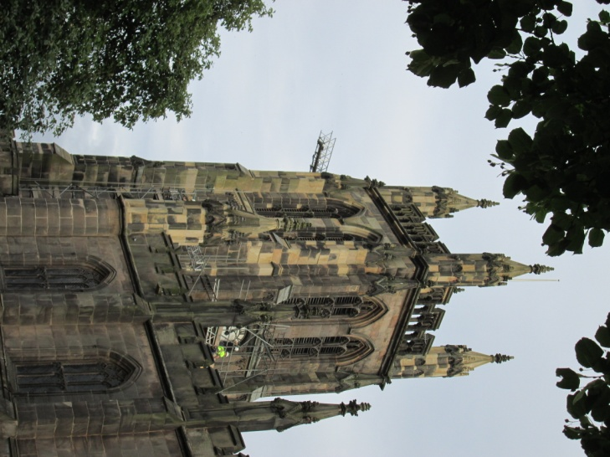
St Mary’s in the Marketplace
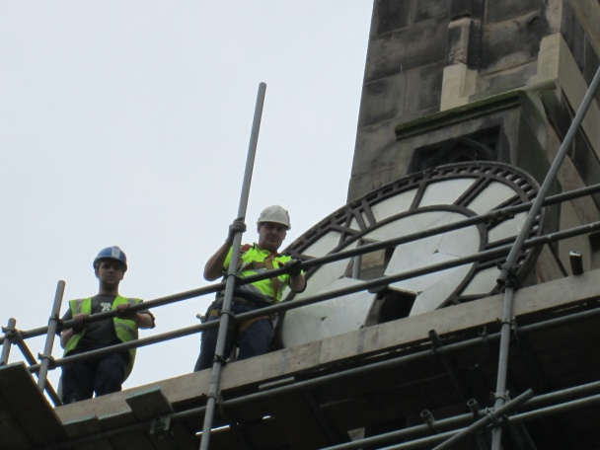
No 6 [26th August]

Going Down….
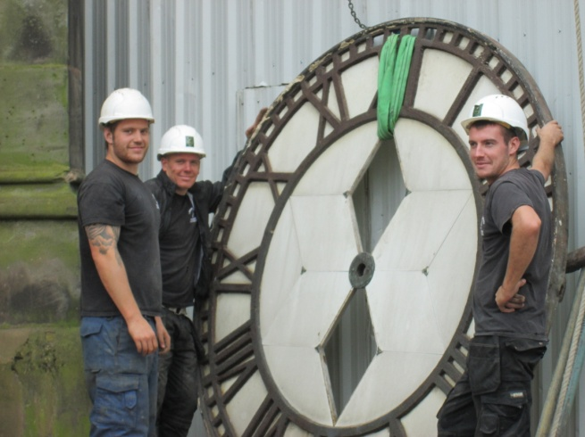
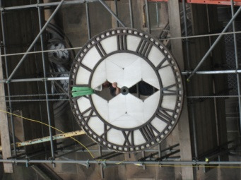

The big event of the week must
be the removal of the clock face
from the east elevation of the
Tower. Quite a task!
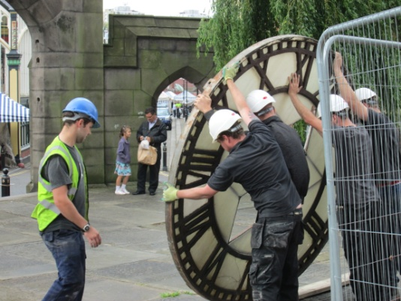
In professional manner, down it came ready for transportation by our clock-makers Smith of Derby. It will be shot-blast, painted and repaired as necessary before being returned to us later on in the project.
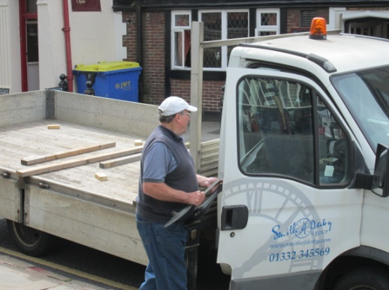
The hands of the clock are packed in the van - that was the easy bit!
Then the main clock face….
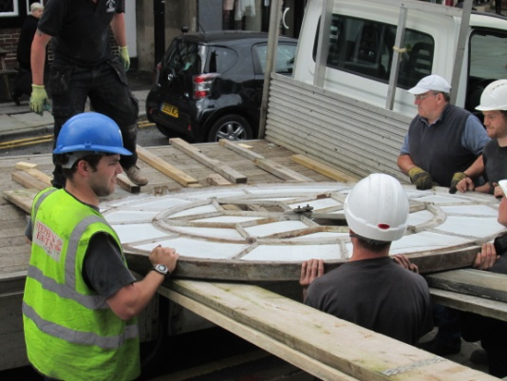
As the UK’s leading clock
repairers, restorers and
conservation specialists,
Smith of Derby are proud
to have been serving the
horological community for
over 150 years.
Throughout this time they have been creating and caring for the world’s greatest public clocks; from small parish church tower clocks to some of the most celebrated cathedral, commercial and private clocks.
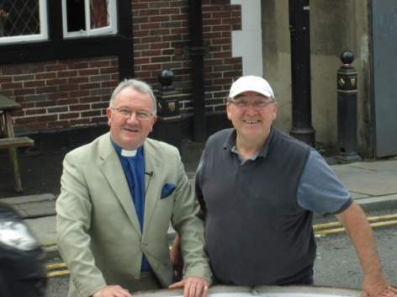
Whether it be a tower clock, turret clock, pillar clock, projecting clock, floral clock or wall clock, the Smith of Derby team of service engineers carefully maintain 4,500 remarkable clocks in the UK and around the world annually; their production team create and install some of the world's latest innovations in time-telling. Smith of Derby understand that a clock represents the heartbeat of the community and take the preservation of its longevity very seriously to enable future generations to enjoy time-telling.
All aboard and ready to go -
Roger takes a last look at the
clock face with Lance from
Smith of Derby.
The weekend brought a baptism and a large number of visitors to St Mary’s – again how fortunate to have so much space around the font for family and friends.
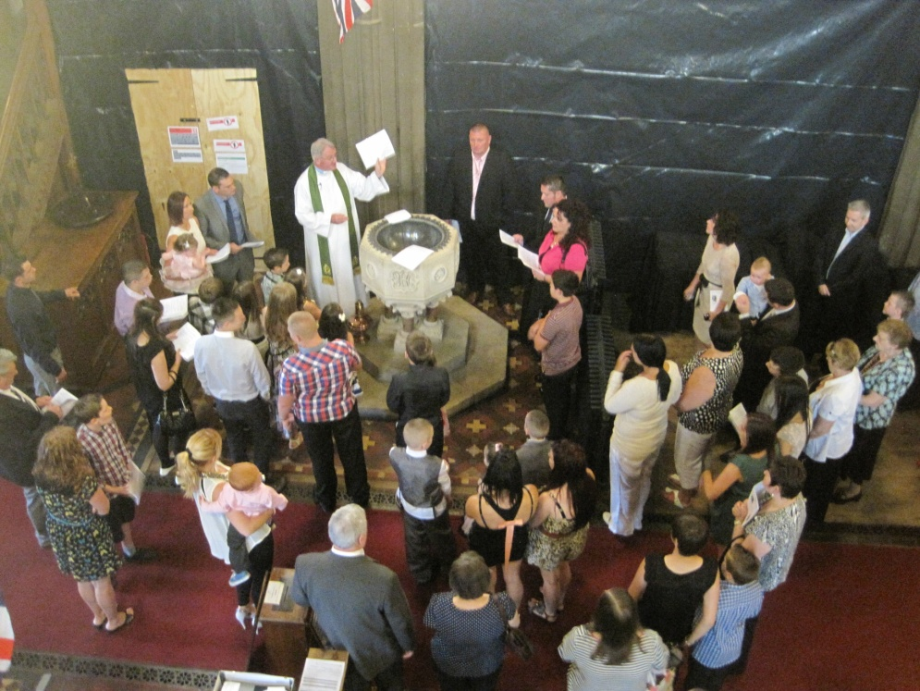

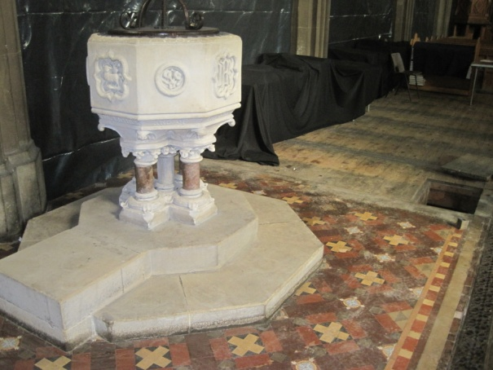
But the next baptism will have a different feel again with the removal of the radiator – both back radiators having now been taken out ready for re-positioning later
on.
Our mechanical engineers are
busy planning the re-routing of
pipe-work and the re-location
of the central heating controls.
Works continues at quite a pace.

