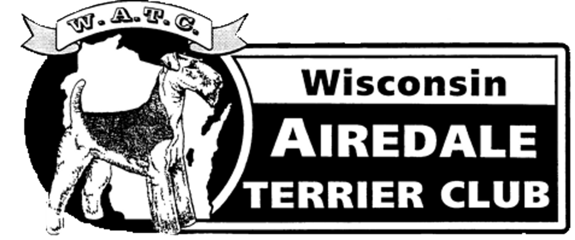

Winter Newsletter
January 2019

Greetings!

I hope everyone is staying warm. In case you do not have time to read this entire update, I’ll start with a few announcements:

- The Handstripping Workshop is all set for February 24th at Lisa’s K-9 Hair Care in Whitewater. If you haven’t signed up yet, please do so. The details were sent recently, and they are also attached to this newsletter email.
- Our Christmas Party concluded with a date set for the club’s annual meeting. It will be held on March 31st at the beautiful home of Craig Larrabee and Mike Bernklau. Additional details will be forthcoming.
- Pheasants Forever's National Pheasant Fest is Friday, February 22nd through Sunday, February 24th in Schaumburg, IL. Airedale Terriers will be well-represented within the group of approximately 30 gun dog breeds participating, and they will be the first breed in the Gun Dog Parade Friday morning.
Here is the link: https://pheasantsforever.org/Pheasant-Fest.aspx
- ATCA Floating National Specialty - March 16, 2019 - Louisville, Kentucky. Join your friends at the ATCA National Floating Specialty in Louisville Kentucky on March 16, 2019. The floater is part of a four show weekend at the Kentuckiana Cluster of Dog Shows. There will be something for every Airedale enthusiast! https://www.atcafloater2019.com/

Additional news and reviews include:

From the archives: The WATC 2018 Specialty Show was held in conjunction with the Waukesha All Breed Kennel Club Show on the weekend of July 28th, 2018. It was a resounding success for both members and exhibitors who came to support both shows. Everything went smoothly and the weather cooperated beautifully! We had 16 entries with majors in both dogs and bitches.

We look forward to doing it again in 2019 with our Specialty show on Saturday, July 27th and our Supported Entry on Sunday, July 28th. Diane Schlicht will be our Specialty judge for Saturday. We have
chosen Martha Graham to be our Sweepstakes judge (agreed upon during our April 2018 annual meeting).

Additionally, the club held its annual Christmas Party on Sunday, December 16th, 2018. Once again, we were blessed to have perfect weather! It was sunny, mild and dry, and about 16 of us were able to meet at the Water Street Brewery in Grafton, Wisconsin. Excellent Bloody Marys were enjoyed as well as great companionship. We have many talented members, and the gift exchange included beautifully hand-crafted Airedale items.

At the end of the meeting, we held a brief business meeting led by club President, Lisa Berglin. We decided upon the 2019 dates for the Handstripping Seminar (February 24th) as well as the Annual Meeting (March 31st).

Our club treasurer, Sandi Cooley, is looking forward to receiving your membership dues for 2019! A copy of the membership renewal form will also be attached to this newsletter email.

Thank you all for your patience with your new club secretary! I look forward to seeing you all at our upcoming events.

Respectfully submitted,

Sara J. Walker
WATC Secretary
January 27, 2019

